**Name 1: Pronoy D’sa Student Number: 2952742**

**Name 2: Gaurav Singh Student Number: 2957104**

|  |  |
| --- | --- |
| **Course** | MSCBD-DMAT |
| **Stage / Year** | 1 |
| **Module** | Data Mining Algorithms & Techniques |
| **Semester** | 2 |
| **Assignment** | Project |
| **Date of Title Issue** | 13th April |
| **Assignment Deadline** | 6th May |
| **Assignment Submission** | Upload to Moodle |
| **Assignment Weighting** | 30% of module |

# **Group Project**

Group members:

1) Pronoy D’sa - 2952742

2) Gaurav Singh - 2957104

# **Deliverables**

A single zip called firstName1_lastName1_studentNumber1_firstName2_lastName2_studentNumber2_project.zip to be uploaded to moodle containing the following files:

· This file edited to contain the results of your investigation. Each of the **NUMBERED HEADINGS IN RED** should be expanded to satisfy the requirements of the section.

· A set of supporting files including but not limited to the following, which should be clearly referenced from your documentation. You only need to submit the files relevant the techniques you have explored.

o The original dataset file

o dataset.arff

o trainingSet.arff

o testingSet.arff

o j48tree.arff

o associationrules.arff

o kmeans.arff

o dbscan.arff

o mlp.arff

o The research paper.

## **1. Description of your dataset and findings – 20%**

· **Title**: Health Insurance and Hours Worked By Wives

· **Data description:** A cross-section from 1993, number of observations : 22272, observation : individuals, country : United States, description of the data in detail under the following subheadings:

o The problem domain: A comparison of parametric and semiparametric estimates of the effect of spousal health insurance coverage on weekly hours worked by wives

o The source of the data:

Source: Journal of Applied Econometrics, Vol. 13, No. 5, Special Issue: Application of Semiparametric Methods for Micro-Data (Sep. - Oct., 1998), pp. 543-565

Stable URL: http://www.jstor.org/stable/223224

o The agencies working with the data

In the JAE Data Archive - Olson, Craig A. (1998) “A comparison of parametric and semiparametric estimates of the effect of spousal health insurance coverage on weekly hours worked by wives”, is hosted by a server belonging to the Economics Department of Queen's University.The author, Craig A. Olson of the School of Business & Industrial Relations Research Institute, University of Wisconsin-Madison with the help of John Wiley & Sons, who collaborate with JSTOR to digitize, preserve & extend access to Journal of Applied Econometrics.

o The intended use of the data

In USA, health insurance is provided as a side benefit that is received by an adult family member as part of his or her compensation package from one’s employer. This typically requires that a worker is a full-time employee. In husband-wife households health insurance is more likely to be part of the husband's compensation package than the wife's compensation package. Thus, we can say that spousal health insurance coverage for wives is predicted to influence their labour supply decisions. The following data shall be used to estimate the relationship between a husband's health insurance benefits and his wife's labour supply decision.

o The attribute types of the data

* Id: (Numeric Type)

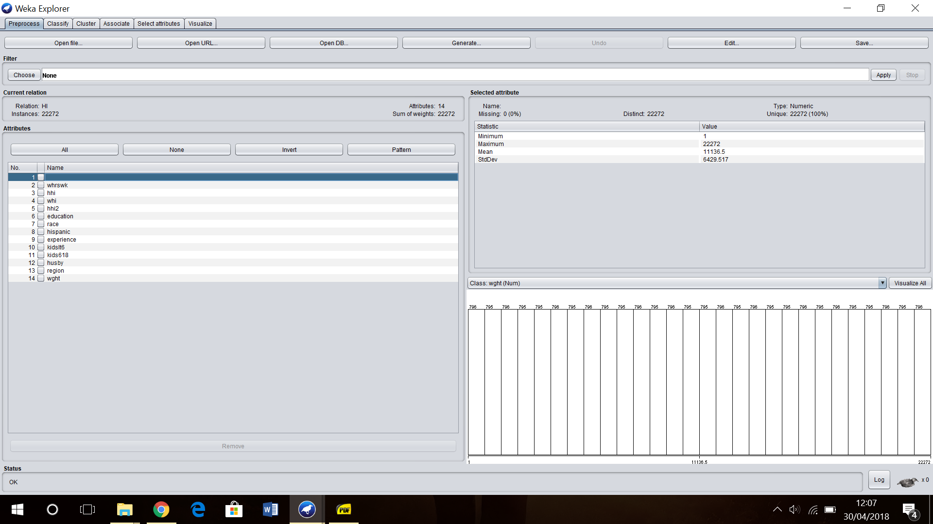

* whrswk: (Numeric Type) hours worked per week by wife

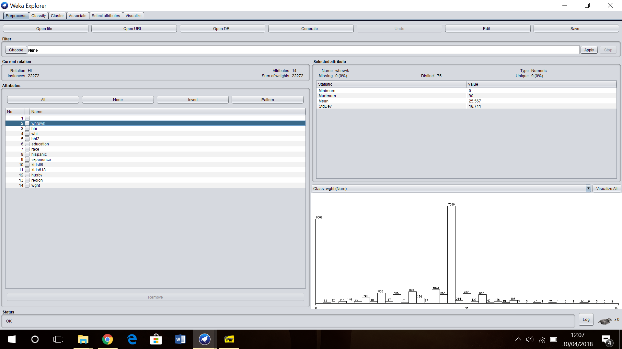

* Hhi: (Nominal Type) is wife covered by husband's health insurance?

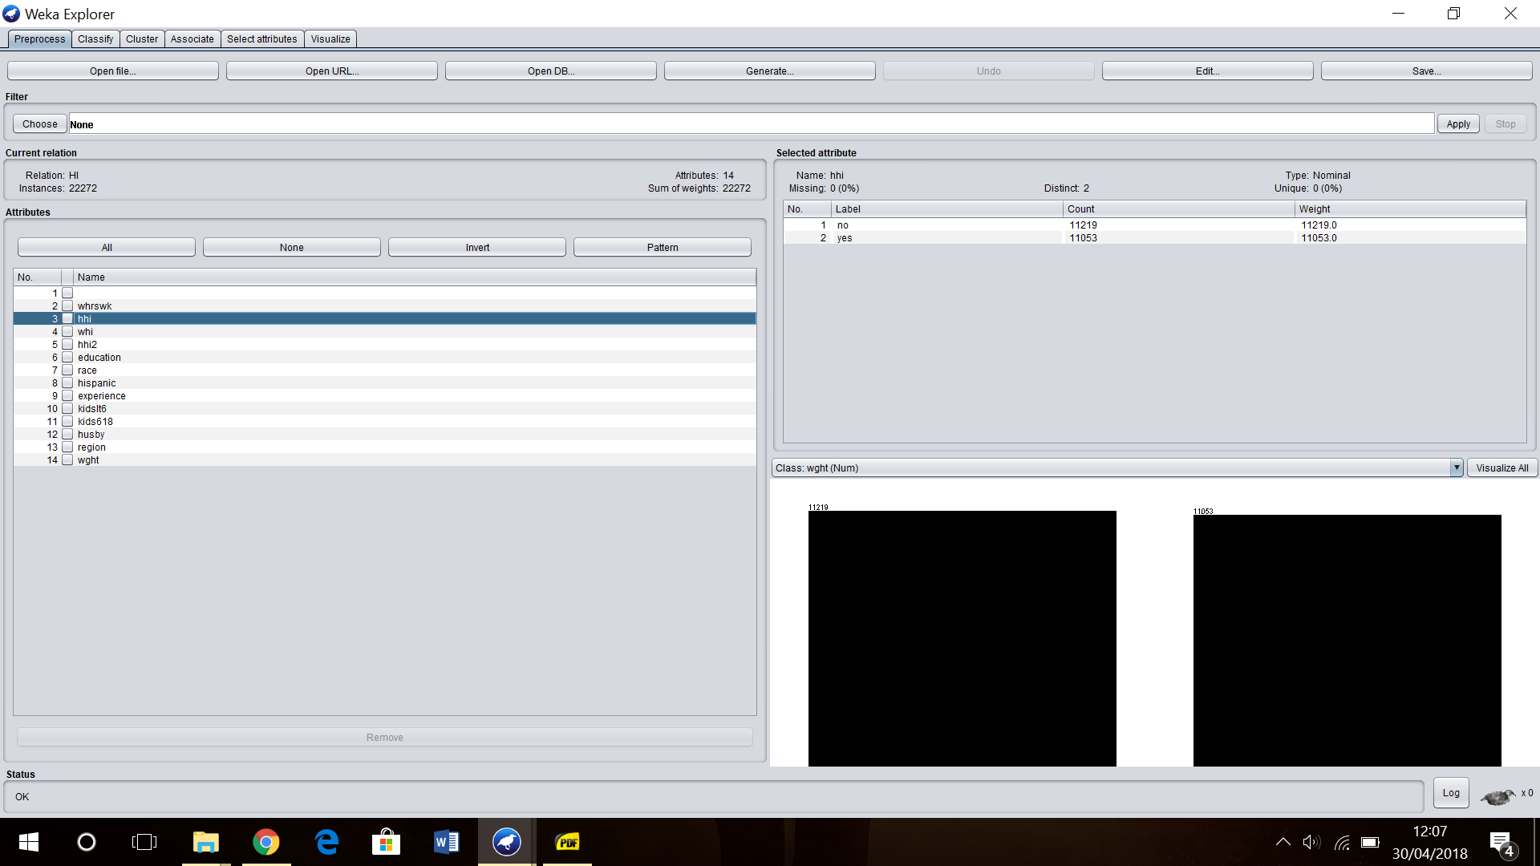

* whi: (Nominal Type) does wife have health insurance through her job?

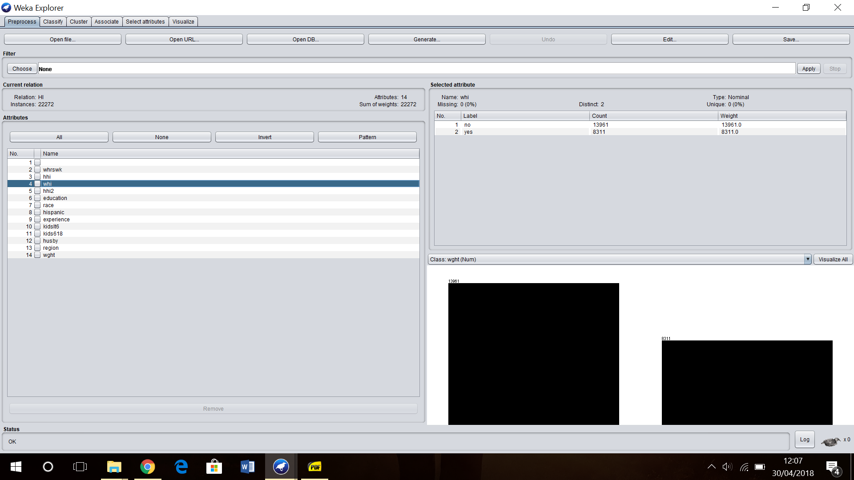

* hhi2: (Nominal Type) does husband have health insurance through his own job?

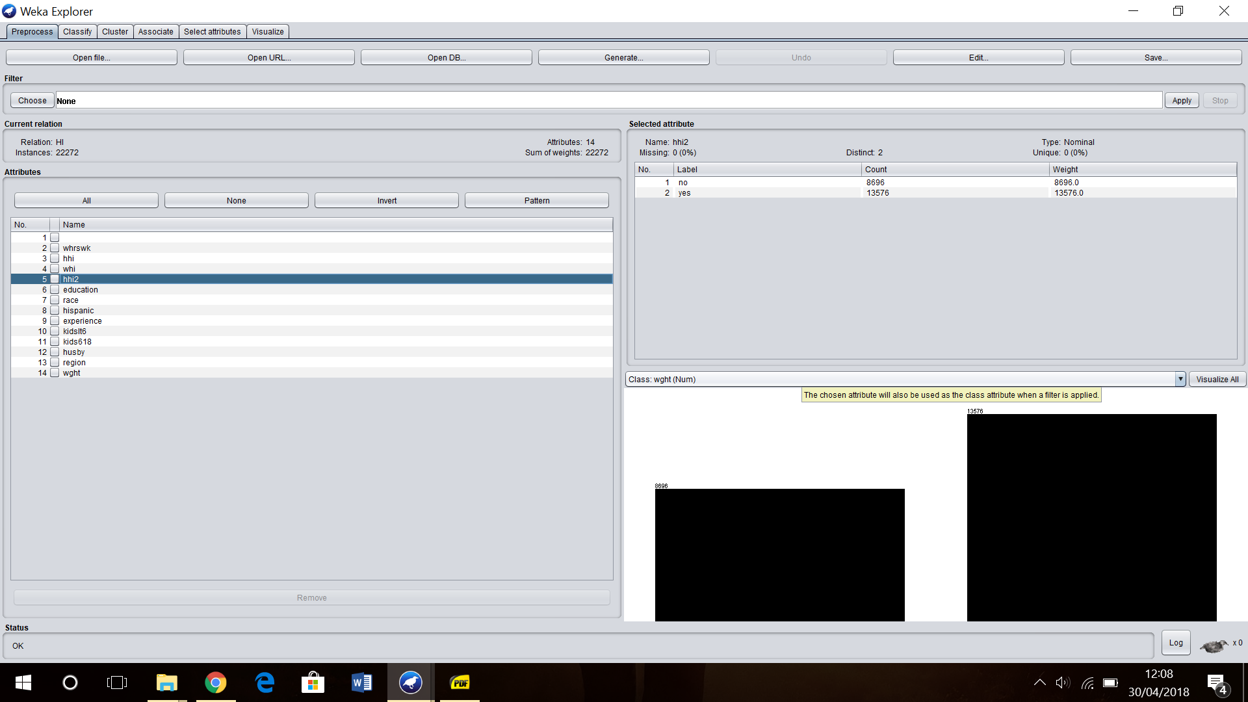

* Education: (Nominal Type) a factor with education levels in years, "<9years", "9-11years", "12years", "13-15years", "16years", ">16years"

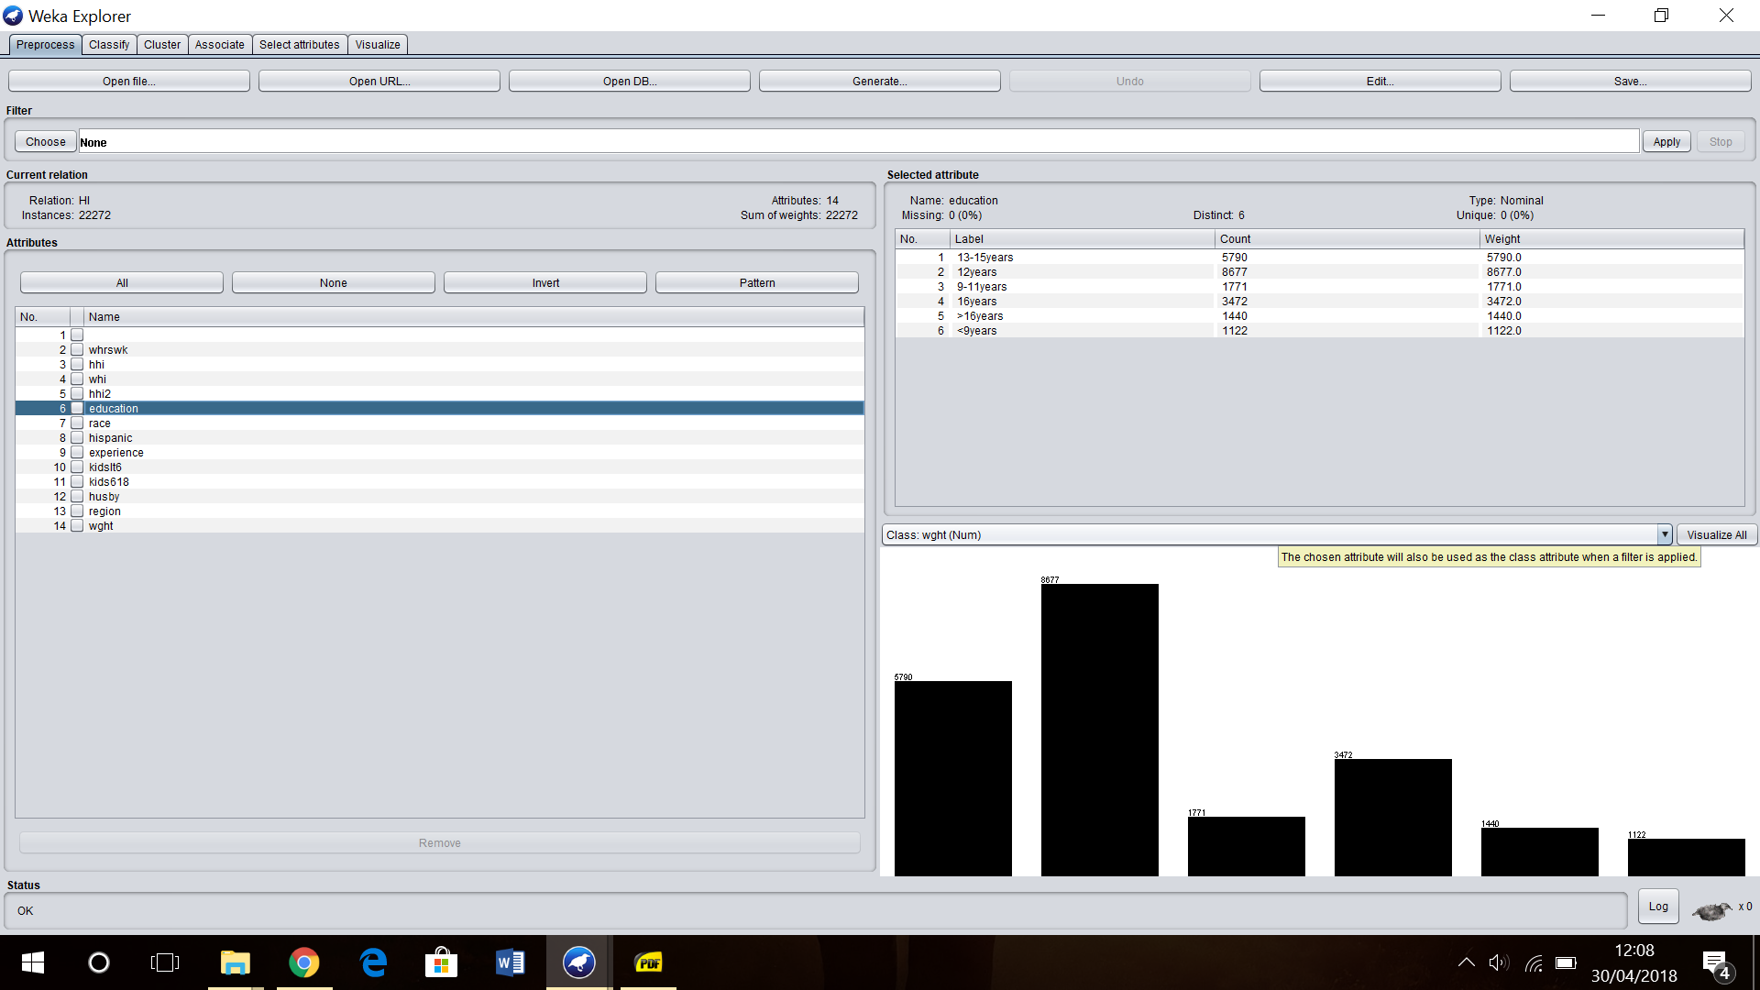

* race: (Nominal Type) distinguished by physical characteristics.

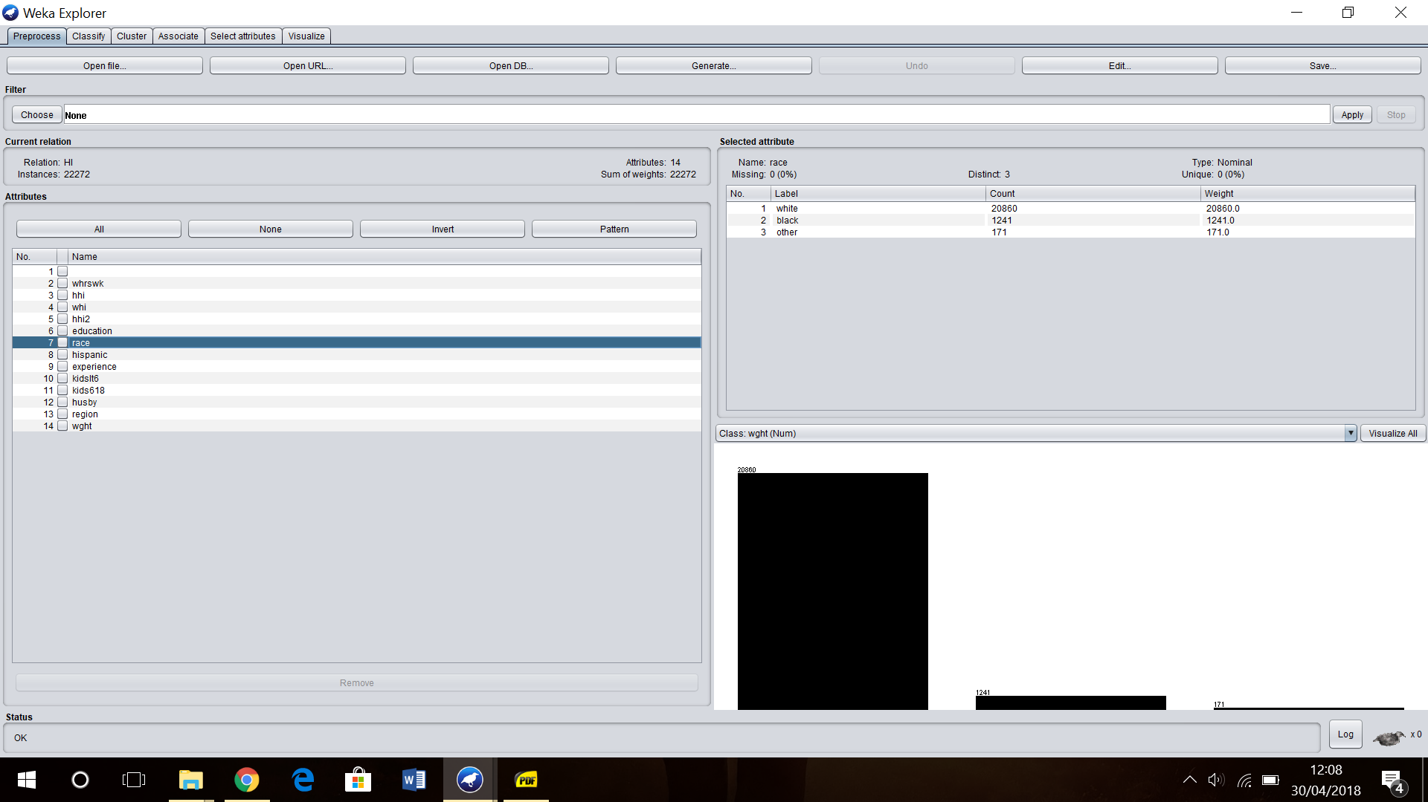

* hispanic: (Nominal Type) is a Spanish-speaking person, especially one of Latin American descent

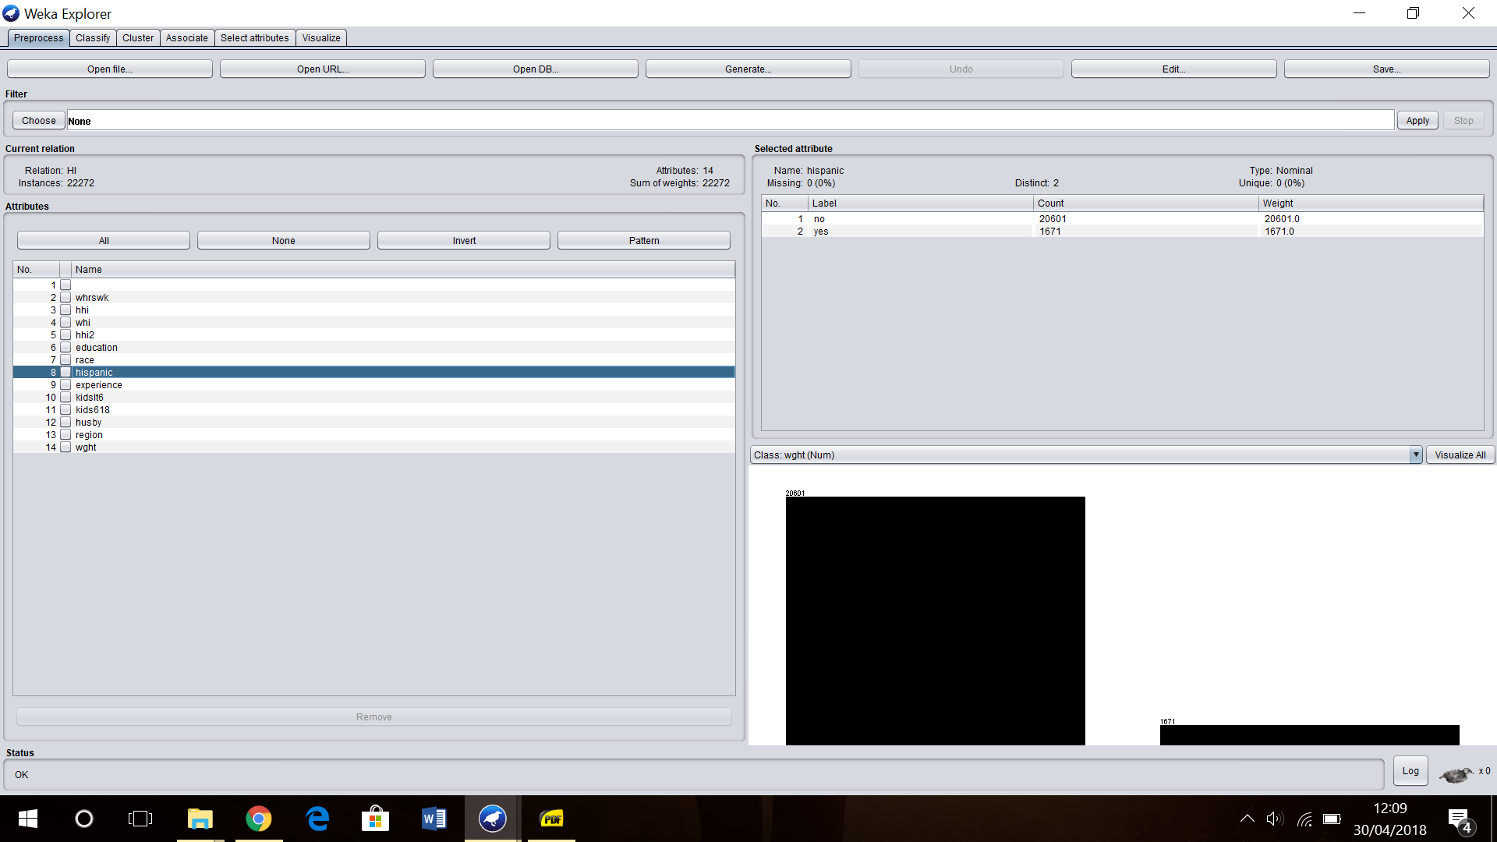

* experience: (Numeric Type) years of potential work experience

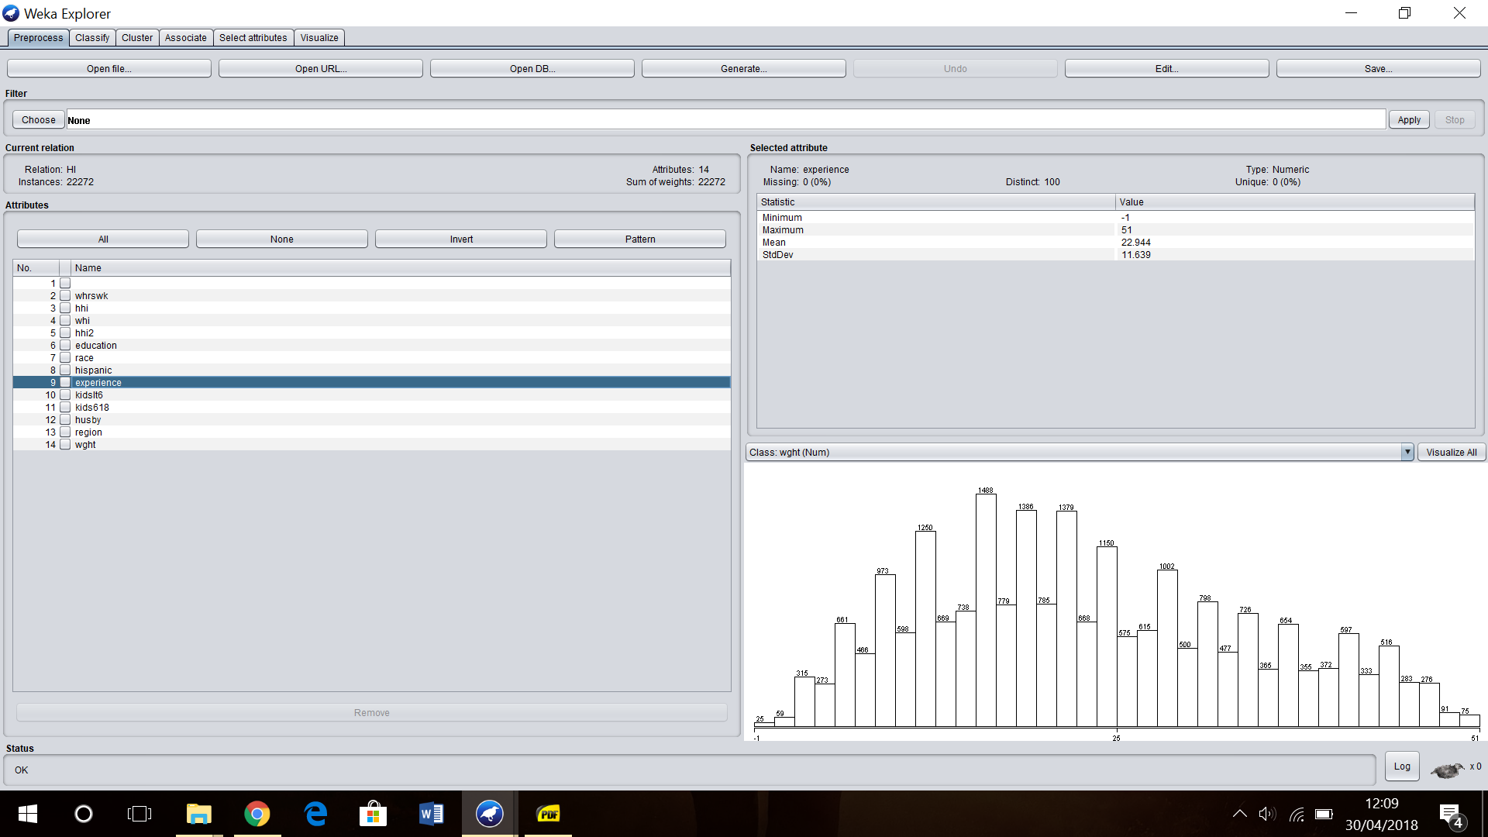

* kidslt6: (Numeric Type) number of kids under age of 6

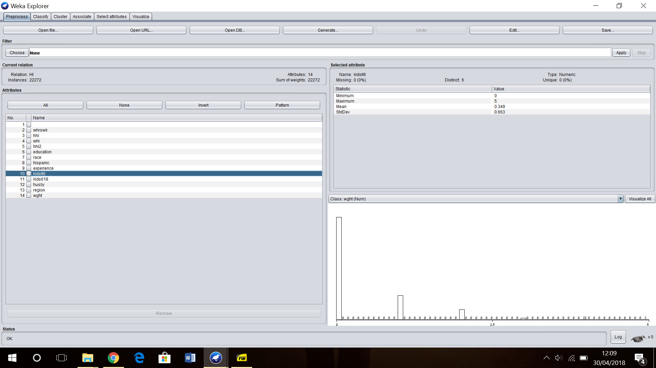

* kids618: (Numeric Type) number of kids 6–18 years old

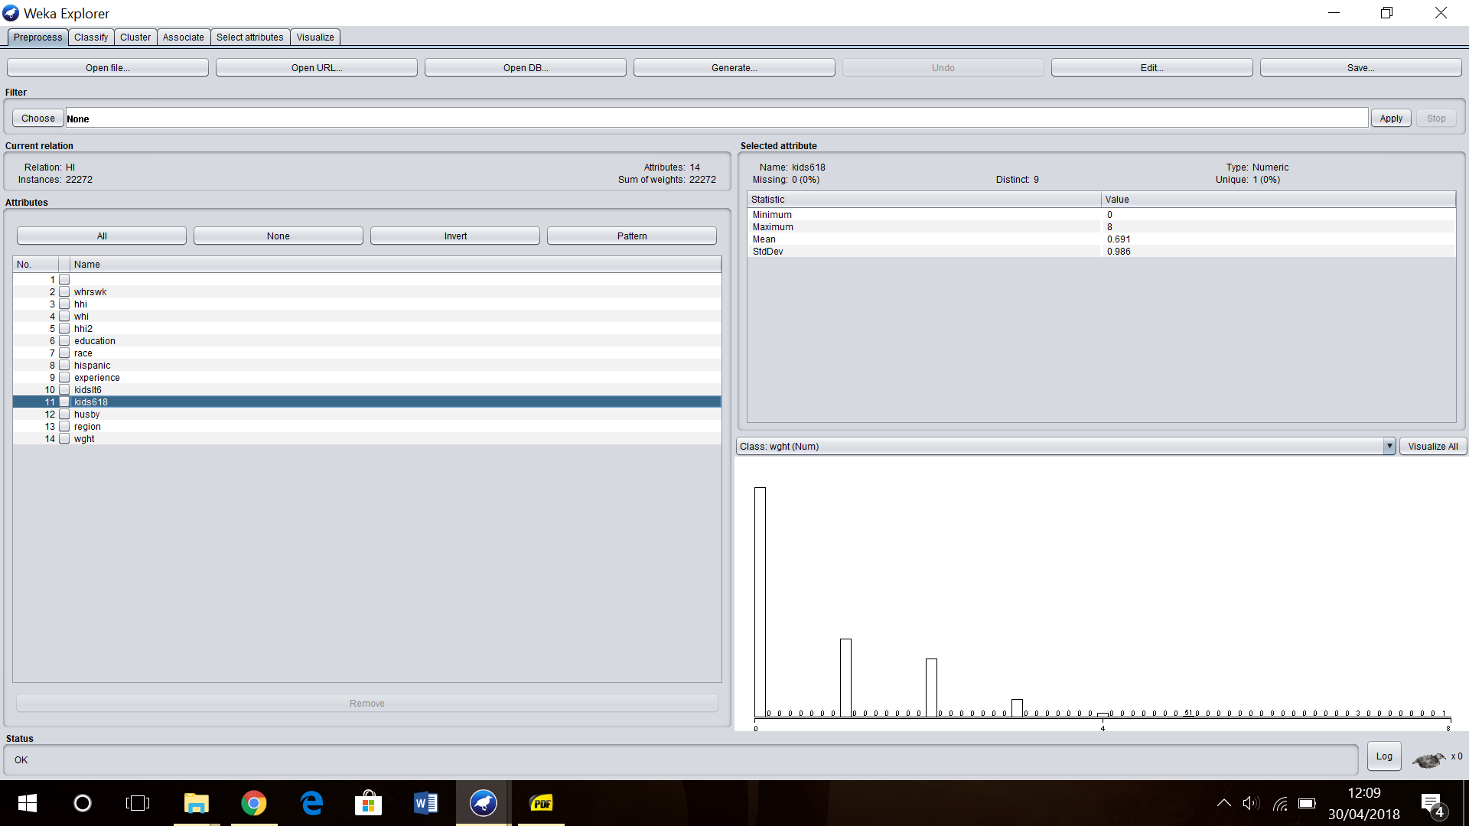

* husby: (Numeric Type) husband's income in thousands of dollars

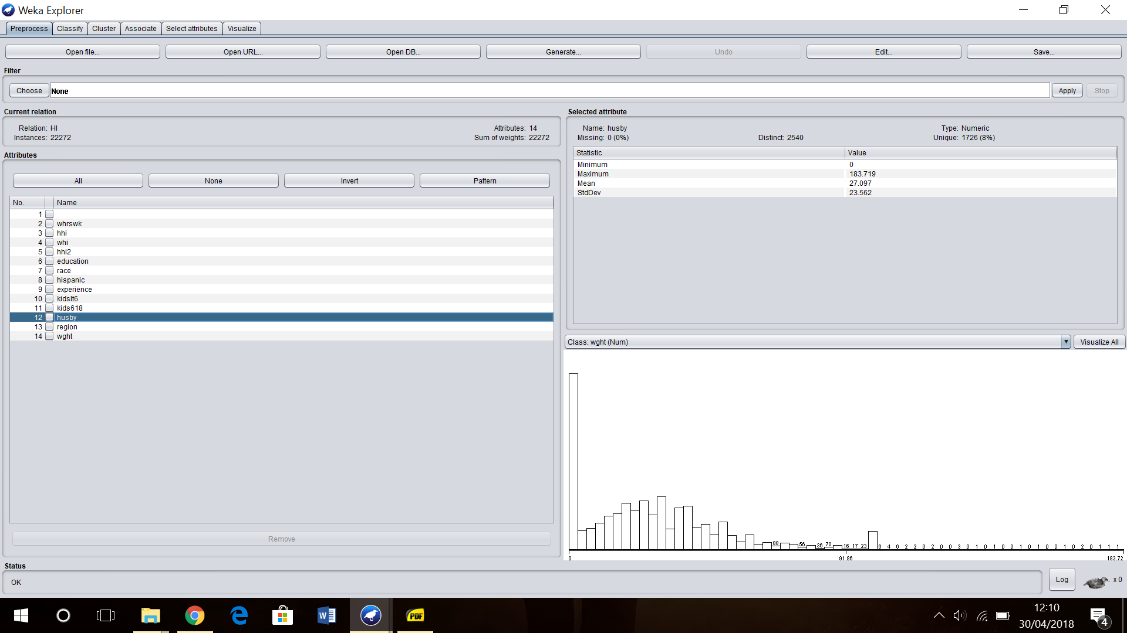

* region: (Nominal Type) one of other, northcentral, south, west

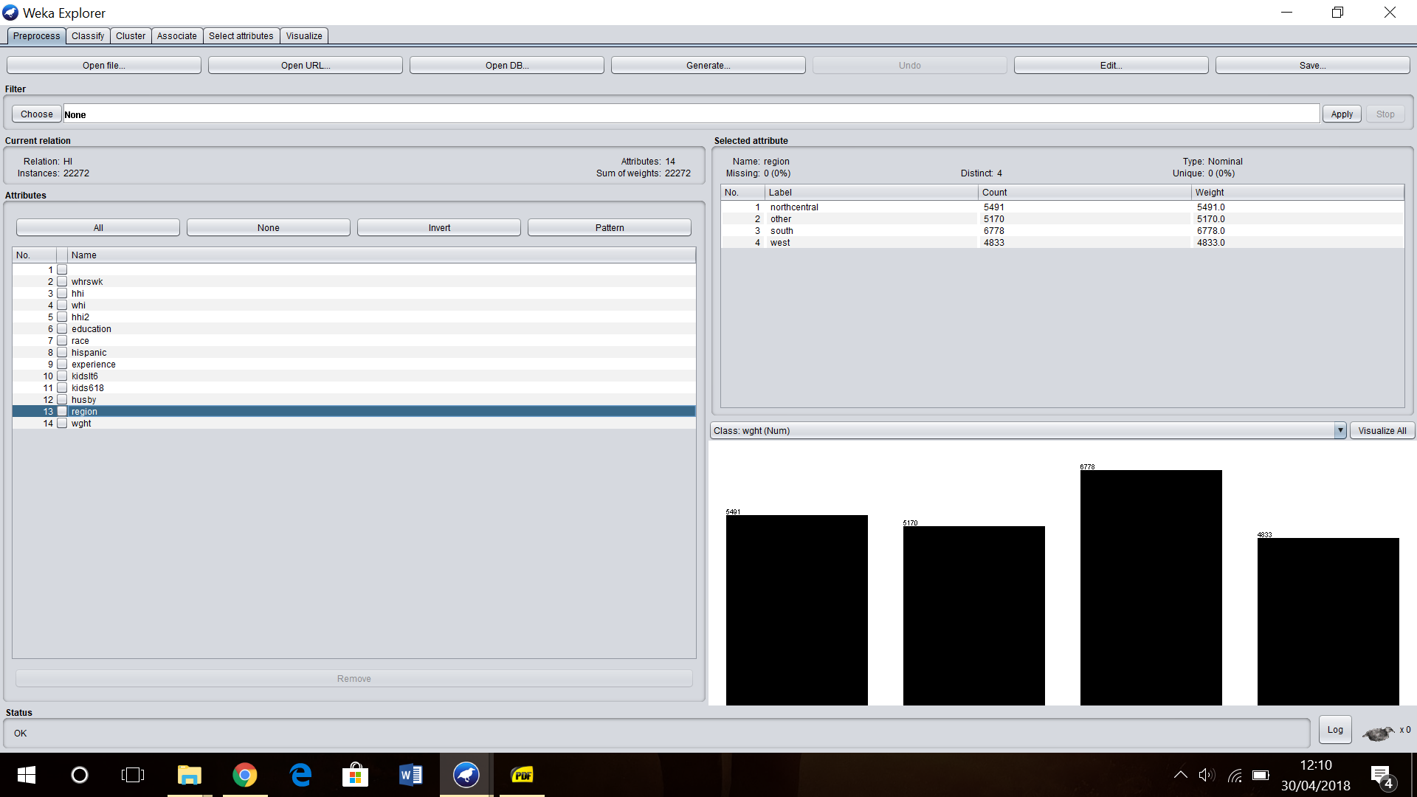

* wght: (Numeric Type) sampling weight of the data

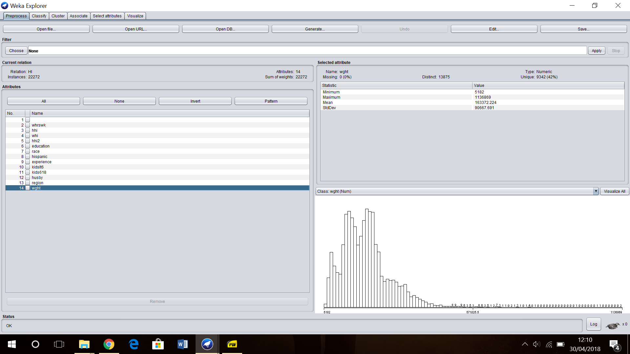

The visualisation matrix of all the attributes is given below:

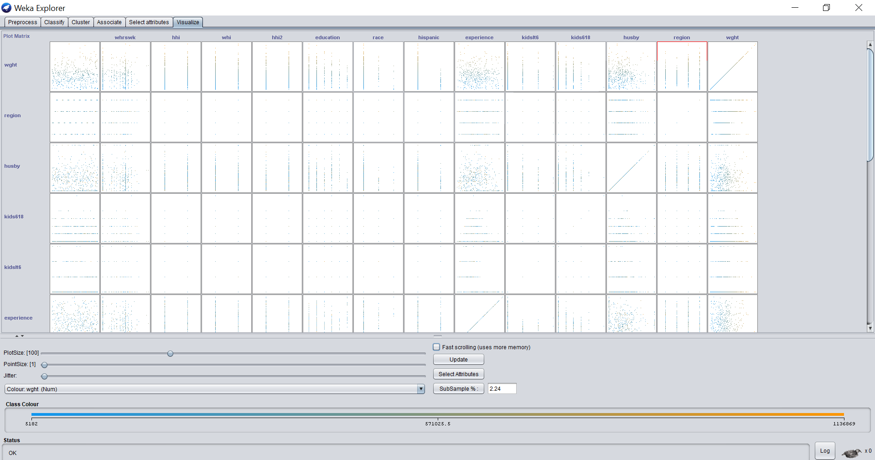

It gives us the information about how each attribute is related to each other.

(with one or two sentences of summary) of the dataset and also of the data summaries that are available through Weka.

· **Objective**: Our objective is to estimate the relationship between a husband's health insurance benefits and his wife's labour supply decisions.

· **Summary of Findings**: Following the objective of estimating the relationship between a husband's health insurance benefits and his wife's labour supply decisions, we found that in j48 algorithm, the women from south and northcentral were the only ones to work for 61 - max hours a week. In association rules, we found that. In Kmeans, women with 9-11 education years have less ‘0-2’ number of children in the age-groups of 6-18 years compared to the rest and also for women with education years greater than 16 years have no children at all in the age-groups of 6-18 years. In DBSCAN, the wives who were covered by the husband's health insurance had husband’s income in the range of 123_max(thousands of $). The wives who were not covered were more with husband’s income in the range of 0_61(thousands of $). Also in REPTree, we observe in the case 1 classifier visualization, when ‘whi’ is coupled with ‘race’ attribute we find that women with health insurance are mostly white or black, and less ‘other’ race women are found to have health insurance compared to the rest which is noteworthy.

## **2. Preprocessing – 10%**

We observe that our dataset can follow two of the preprocessing techniques, first is removal and second is discretization, since there are no missing values in our Health Insurance or HI dataset after careful analysis we don’t have to deal with missing values here. So, we have applied the following preprocessing techniques:-

1. Selecting/Filtering & Removing the Attributes:

In our data file, each record is commonly identified by id which is a nameless attribute just providing us with the numbers of records in our data and thus, bears no importance to our analysis. So, we remove ‘id’ attribute first.

There’s another attribute called ‘wght’ which gives us the sampling weight for each record and is again irrelevant to our analysis. So, we must remove ‘wght’. However we remove it at the end, after discretization of the numeric attributes between ‘id’ & ‘wght’.

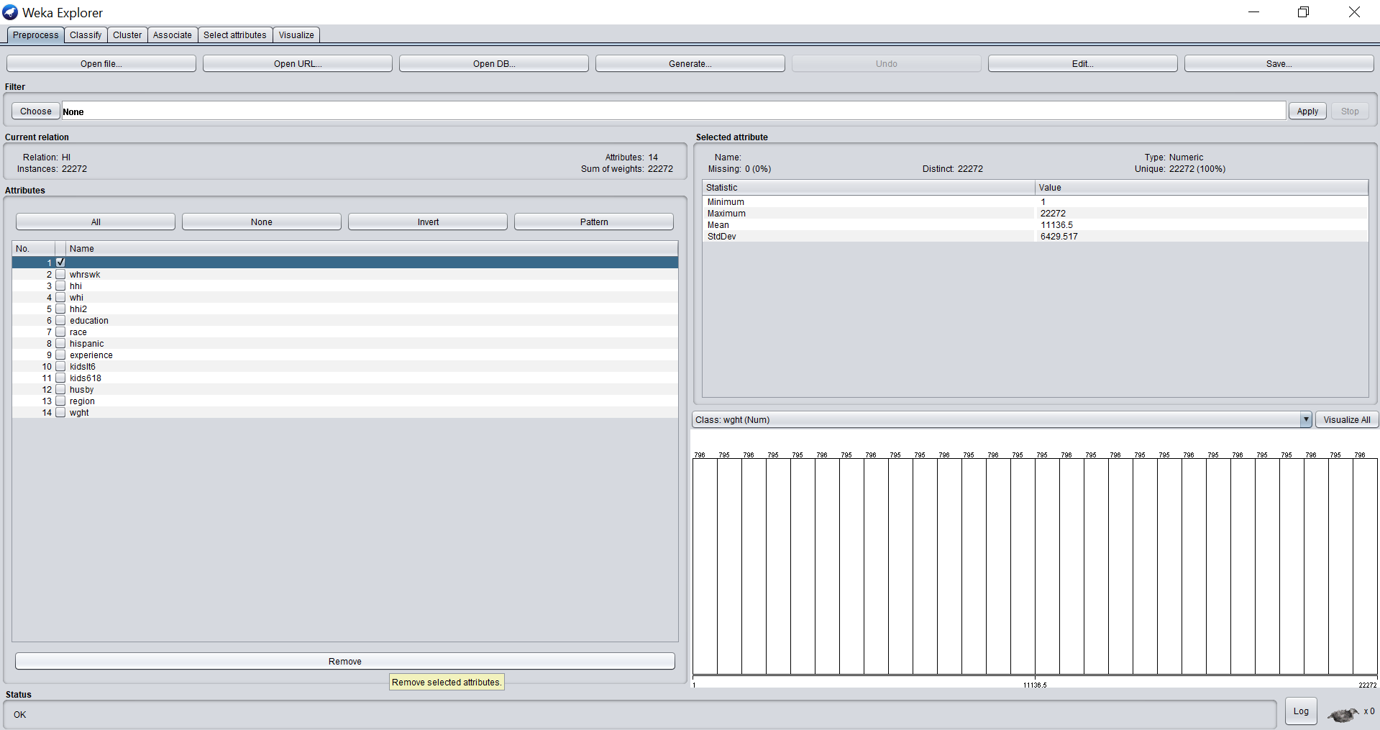

As seen in the image above, we select the nameless attribute ‘id’.

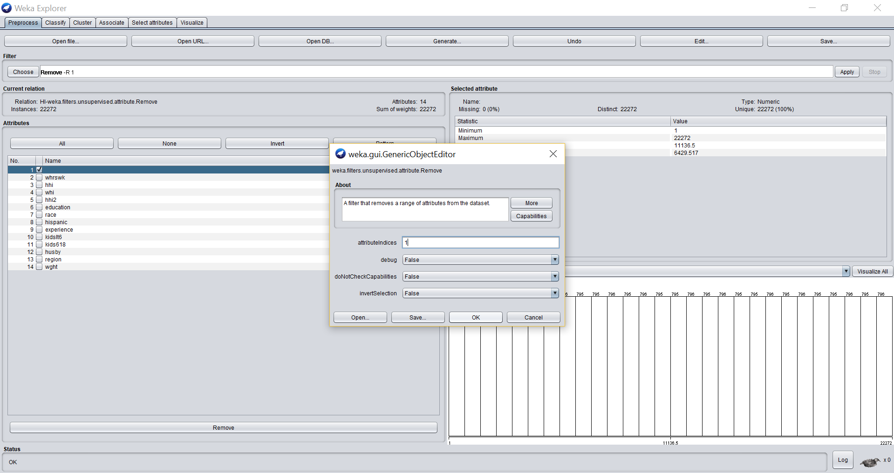

Now, we go to choose filter, and select under ‘weka.filters.unsupervised.attribute.Remove’, set the attribute indice to 1. We click OK.

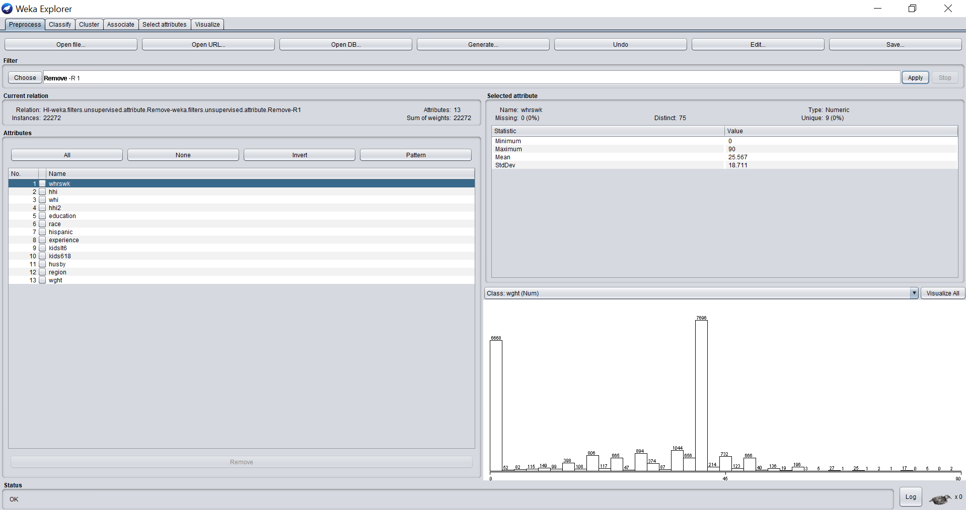

We click on Apply filter and thus, id attribute has been removed.

Identify the set of preprocessing techniques that can be applied to your data and clearly indicate which techniques are appropriate and which ones are not.

2. Discretization of Attributes:

In our dataset, we have about 6 attributes which are numeric including wght which will be removed later, the rest of our attributes are categorical so, there’s no need of discretizing them. So, in total we need to discretize 5 numeric attributes into categorical attributes, to perform techniques such as association rule mining which can be only performed on categorical data.

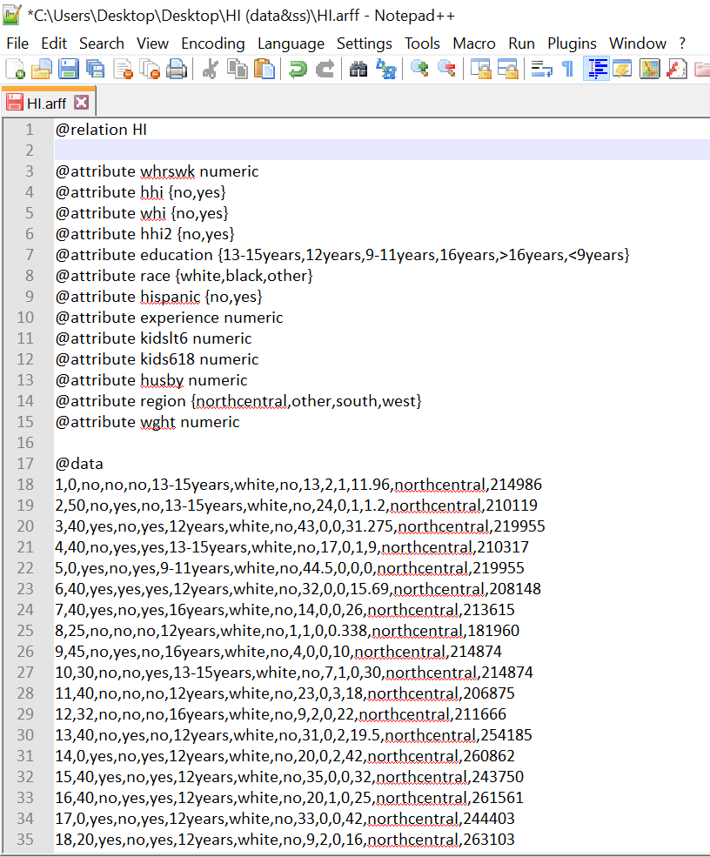

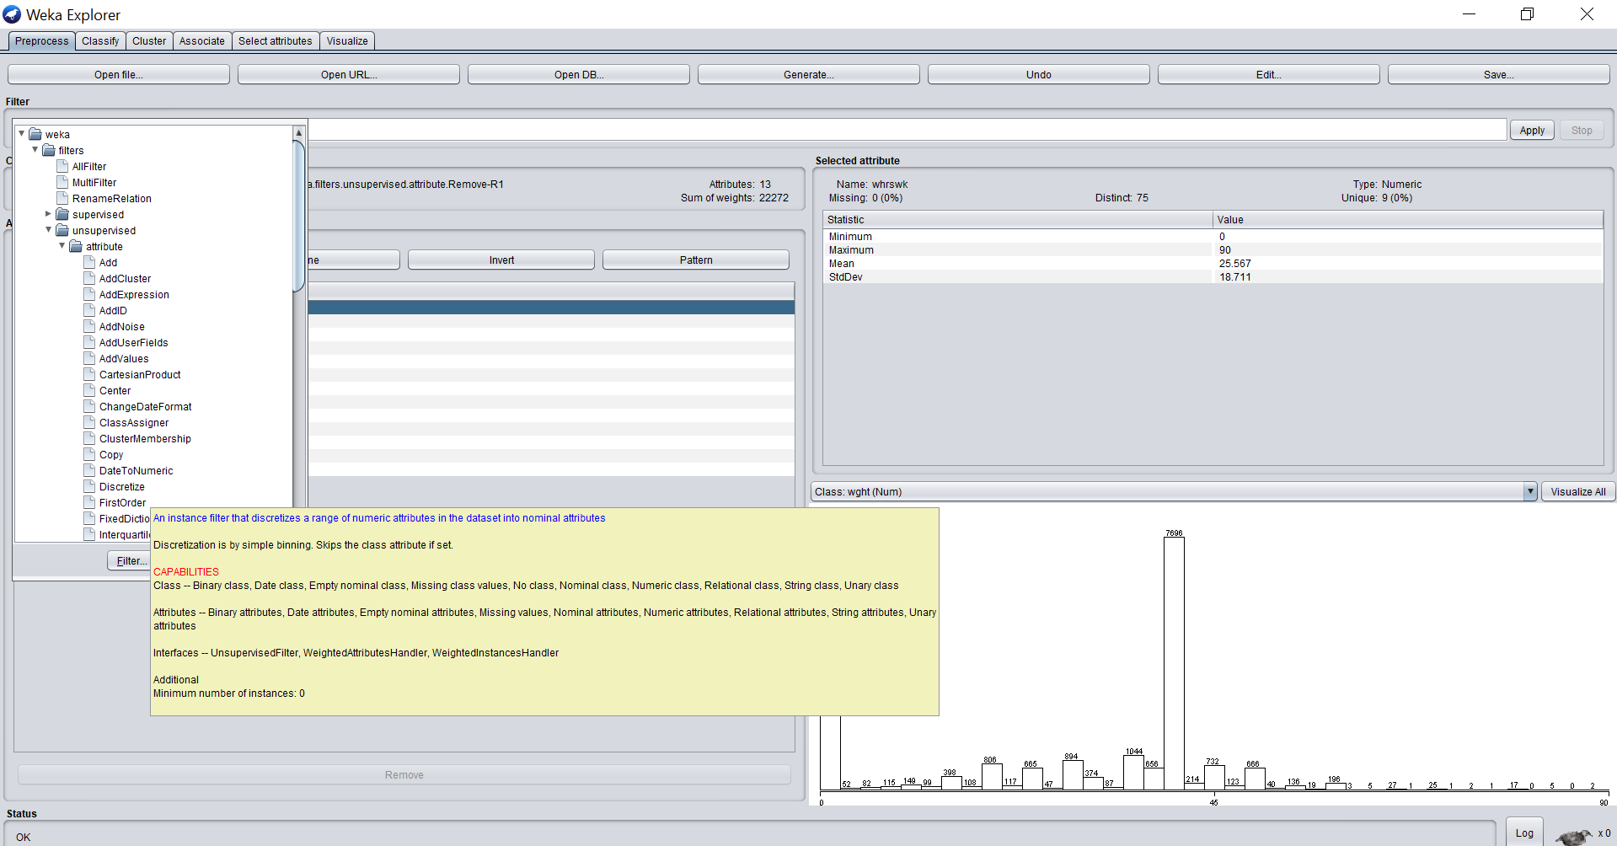

As seen in the above image we select the attribute we wish to perform discretization on and then choose filter select under ‘weka.filters.unsupervised.attribute.Discretize’. We shall keep the bin size as 3 for all the numeric attributes that we are converting to categorical.

(a). Whrsk: hours worked per week by wife

We select ‘whrsk’ & in the filter dialogue box, we set the attribute indice and keep bin size 3. After applying the filter we observe the changes in our attribute. We save these changes to dataset1.arff which is a file where our discretization changes our saved.

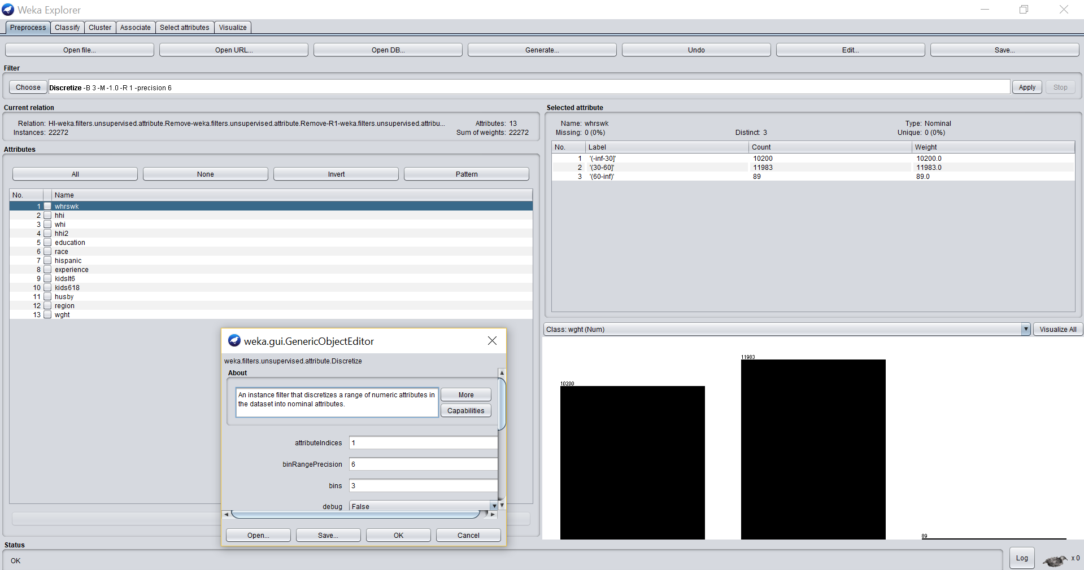

Now, we open dataset1.arff in wordpad, & change the bin labels to a interpretable label.

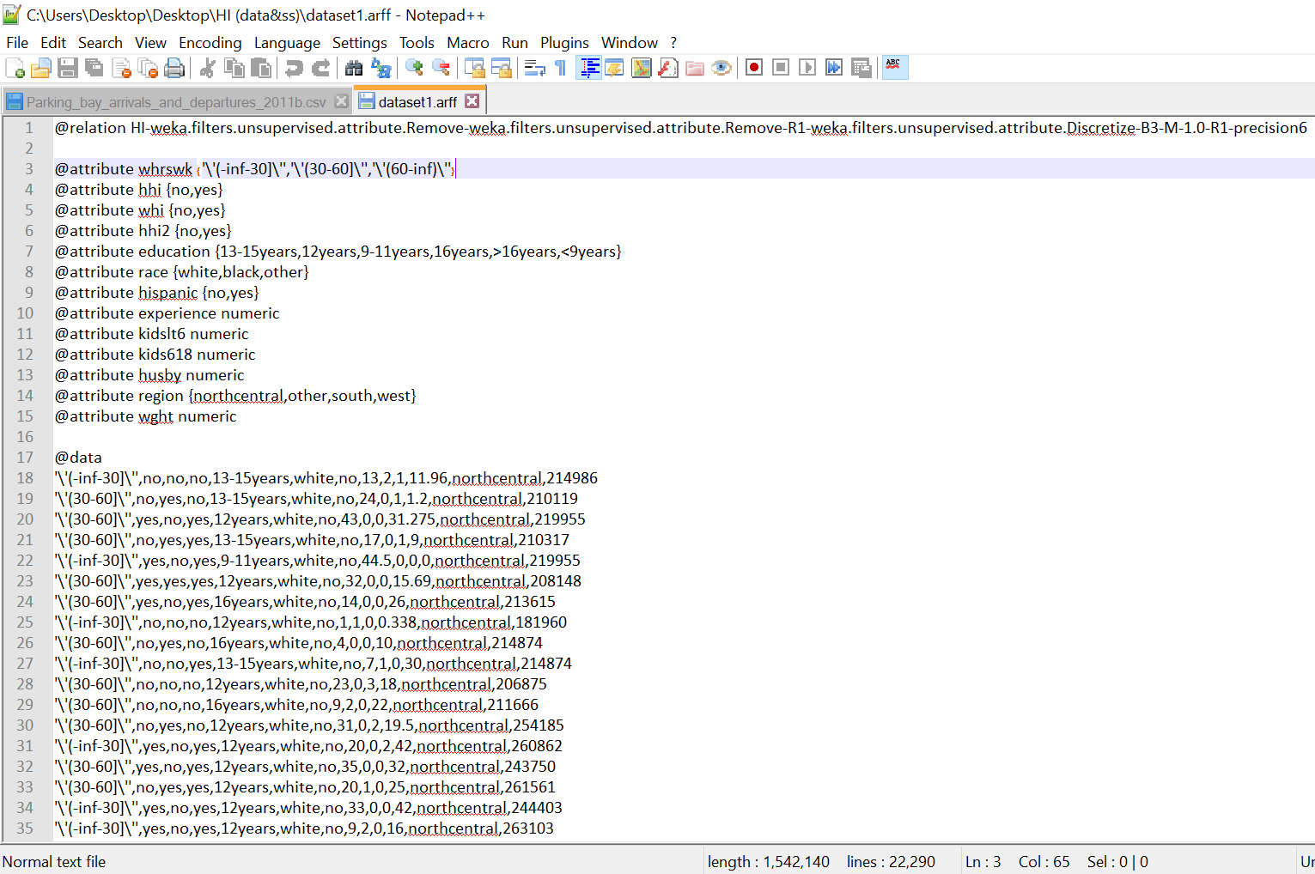

After saving the changes, we observe our new bin labels in Weka.

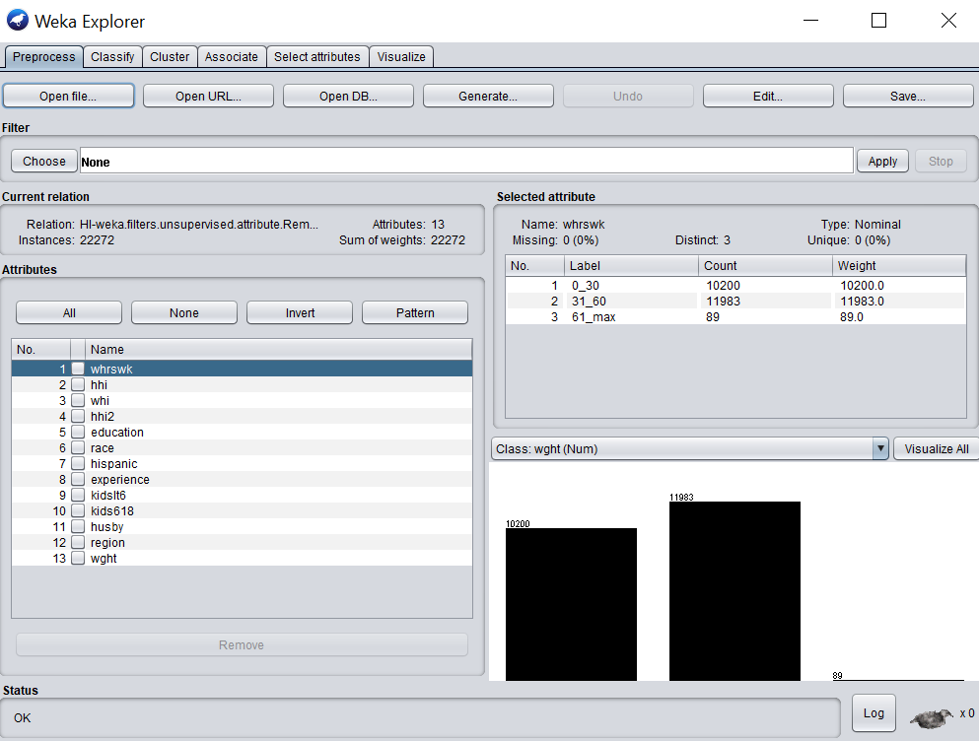

(b). Experience: years of potential work experience

We select ‘experience’ & in the filter dialogue box, we set the attribute indice and keep bin size 3. After applying the filter we observe the changes in our attribute. We save these changes to dataset1.arff which is a file where our discretization changes our saved.

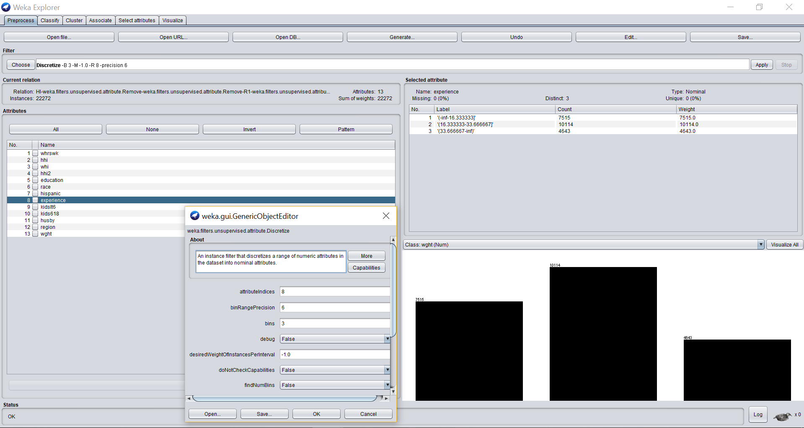

We save the changes to dataset1.arff and open it in wordpad to set understandable bin labels.

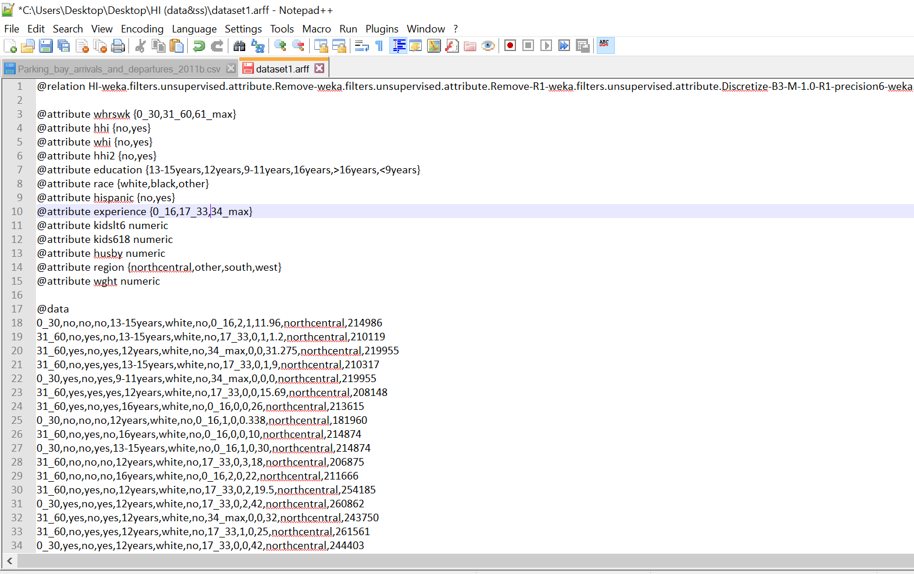

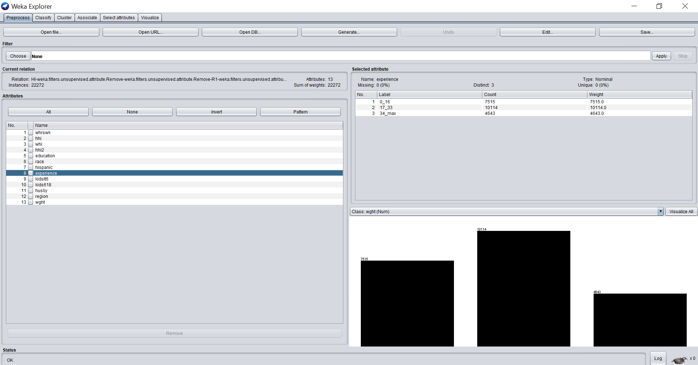

New bin labels are observed in Weka.

(c). Kidslt6: number of kids under age of 6

We select ‘kidslt6’’ & in the filter dialogue box, we set the attribute indice and keep bin size 3. After applying the filter we observe the changes in our attribute. We save these changes to dataset1.arff which is a file where our discretization changes our saved.

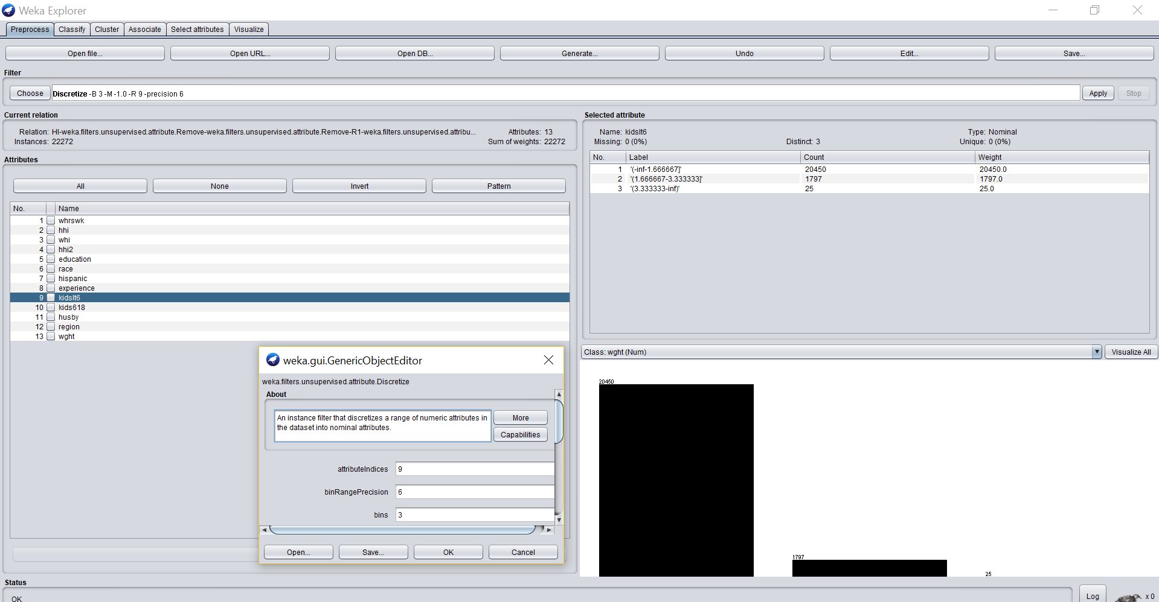

We select ‘kidslts6’ attribute & apply the ‘discretize’ filter. Changes are observed in Weka.

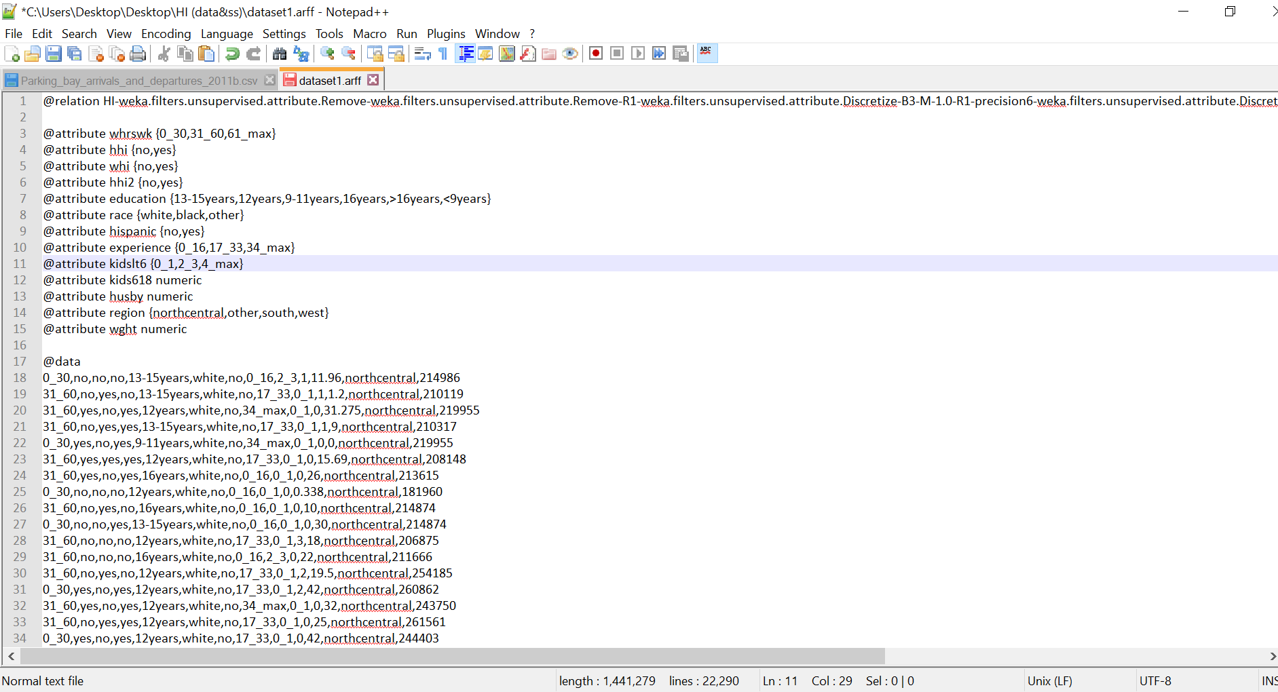

Now, we open dataset1.arff in wordpad, & change the bin labels to a interpretable label.

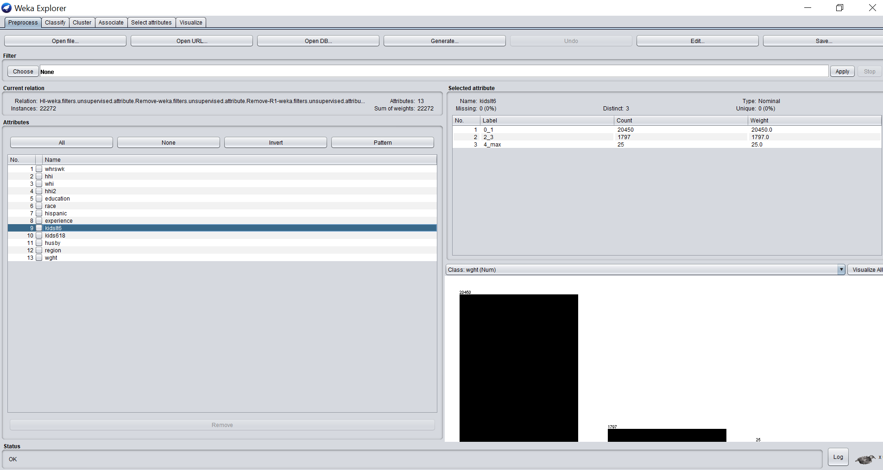

(d). Kids618: number of kids 6–18 years old

We select ‘kids618’’ & in the filter dialogue box, we set the attribute indice and keep bin size 3. After applying the filter we observe the changes in our attribute. We save these changes to dataset1.arff which is a file where our discretization changes our saved.

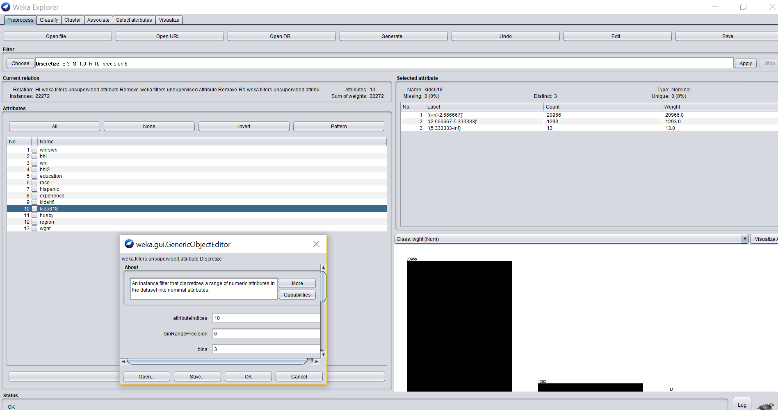

Now, we open dataset1.arff in wordpad, & change the bin labels to a interpretable label.

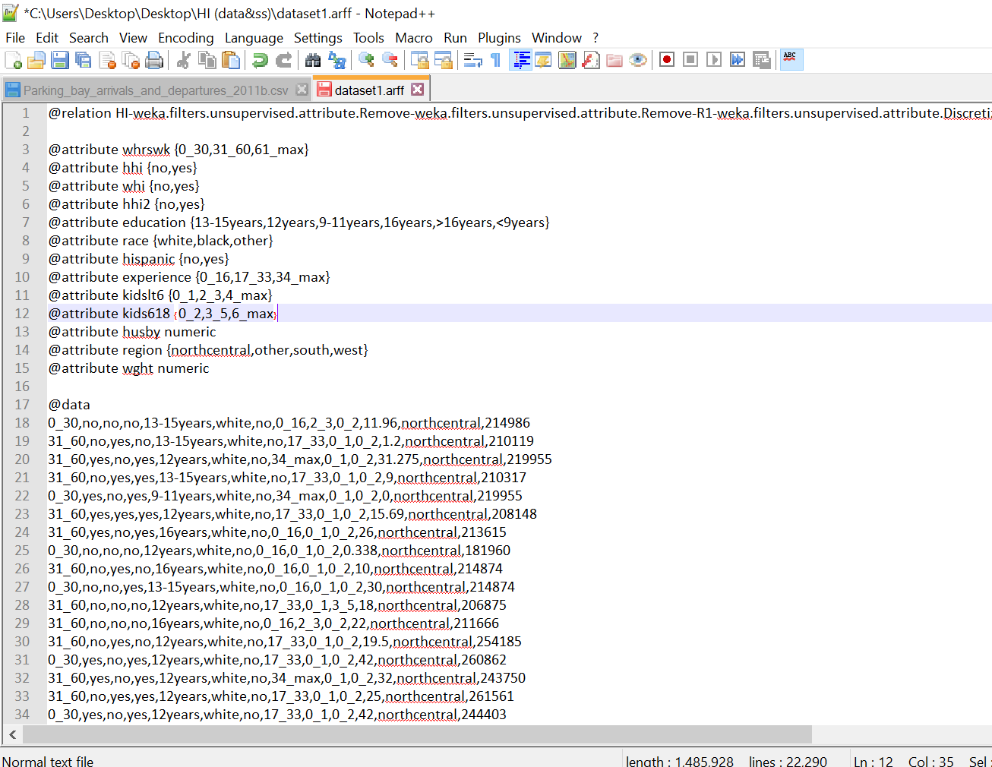

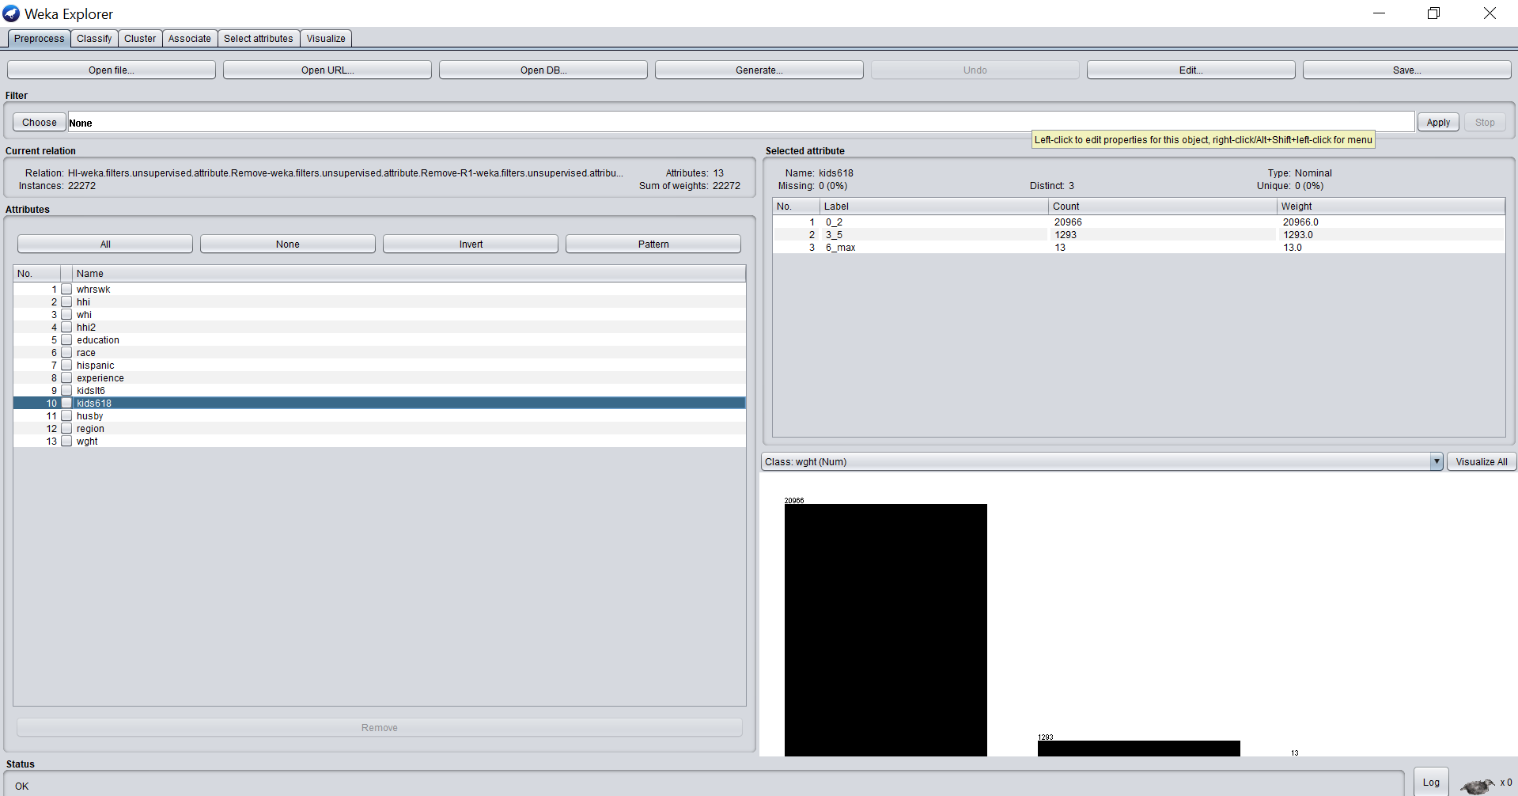

New bin labels are observed in Weka.

(e). Husby: husband's income in thousands of dollars

We select ‘husby’’ & in the filter dialogue box, we set the attribute indice and keep bin size 3. After applying the filter we observe the changes in our attribute. We save these changes to dataset1.arff which is a file where our discretization changes our saved.

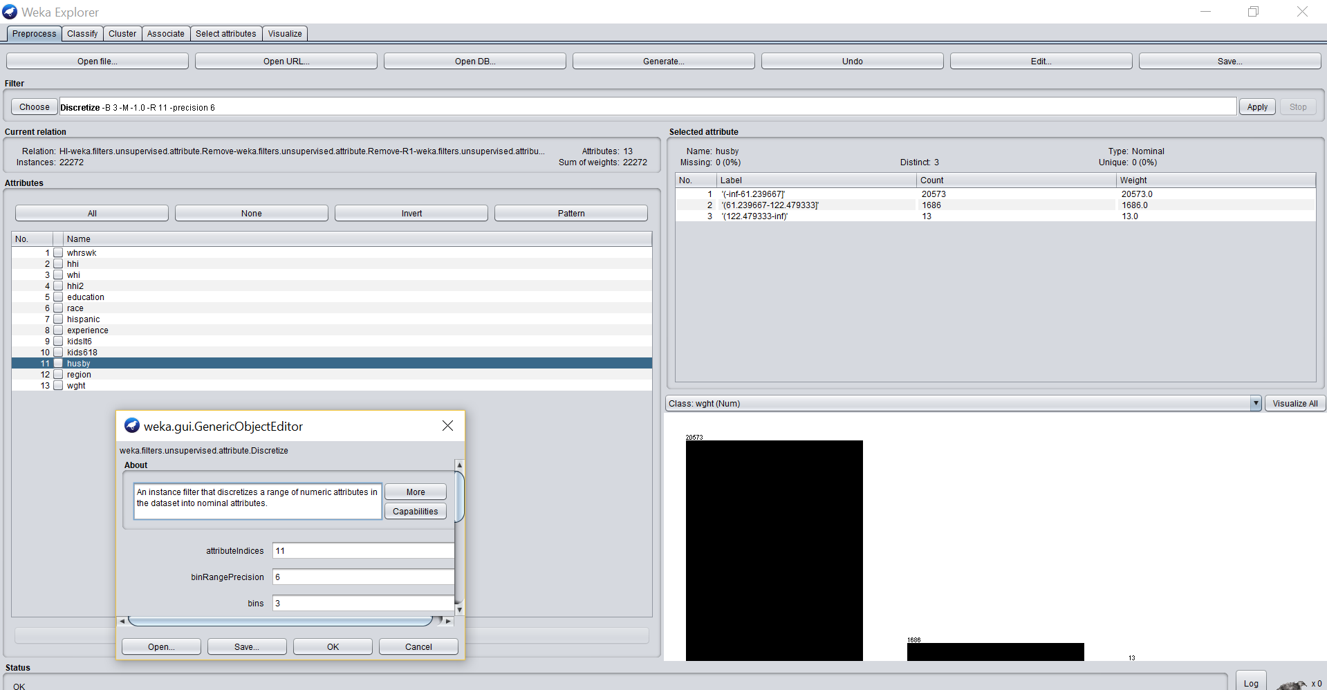

Now, we open dataset1.arff in wordpad, & change the bin labels to a interpretable label.

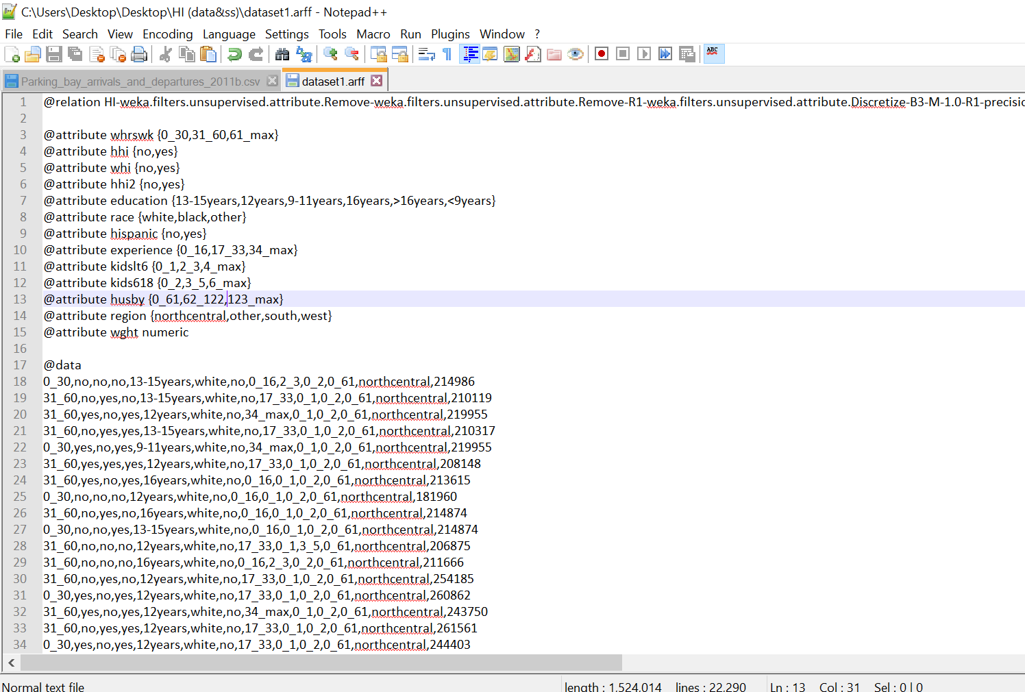

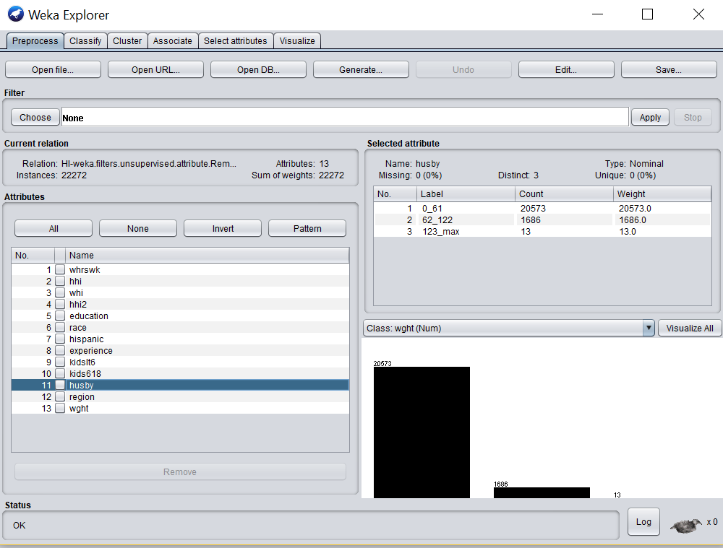

New bin labels are observed in Weka.

(f). Wght: sampling weight

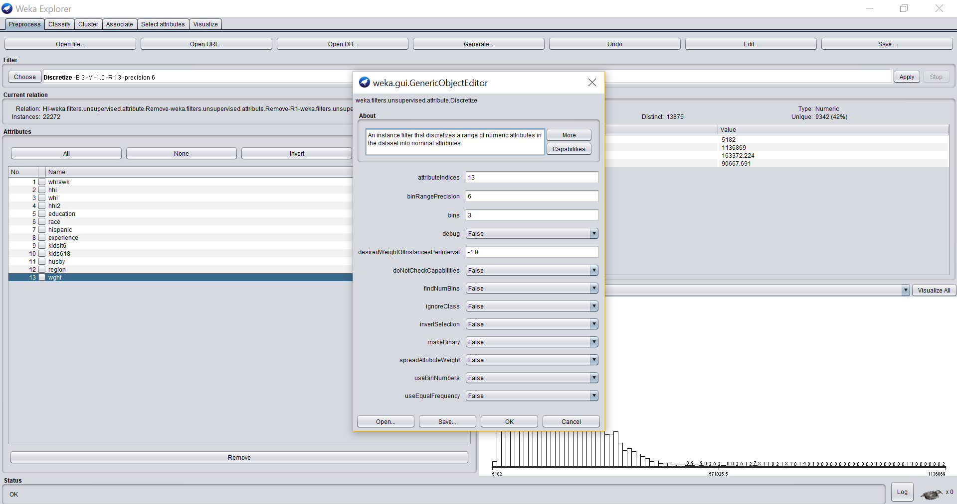

As mentioned earlier, since we decided to remove ‘wght’ attribute since it wasn’t required for our analysis of the health insurance aspects.

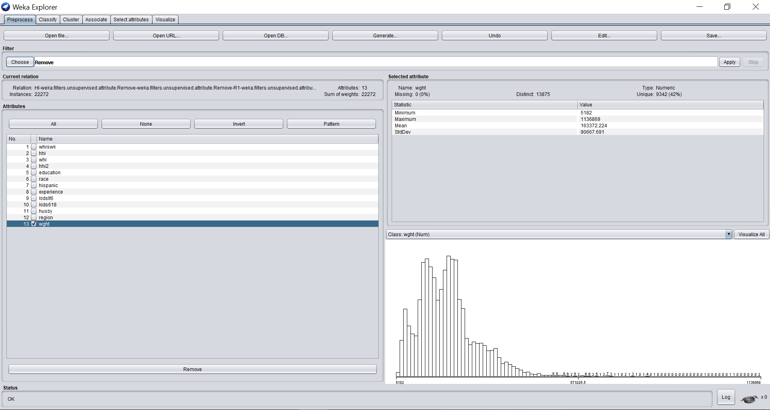

However, this decision was based after applying the discretize filter, since it wasn’t discretizing the values of ‘wght’ as they were too large and spread out.

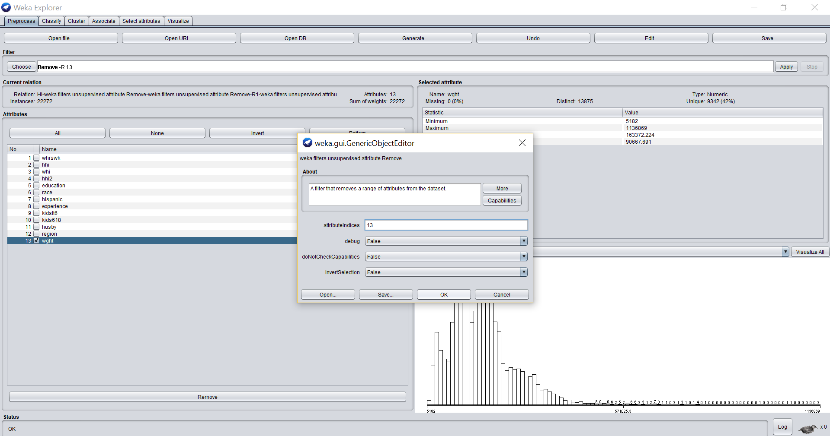

As seen in the above image, we apply the remove filter on ‘wght’.

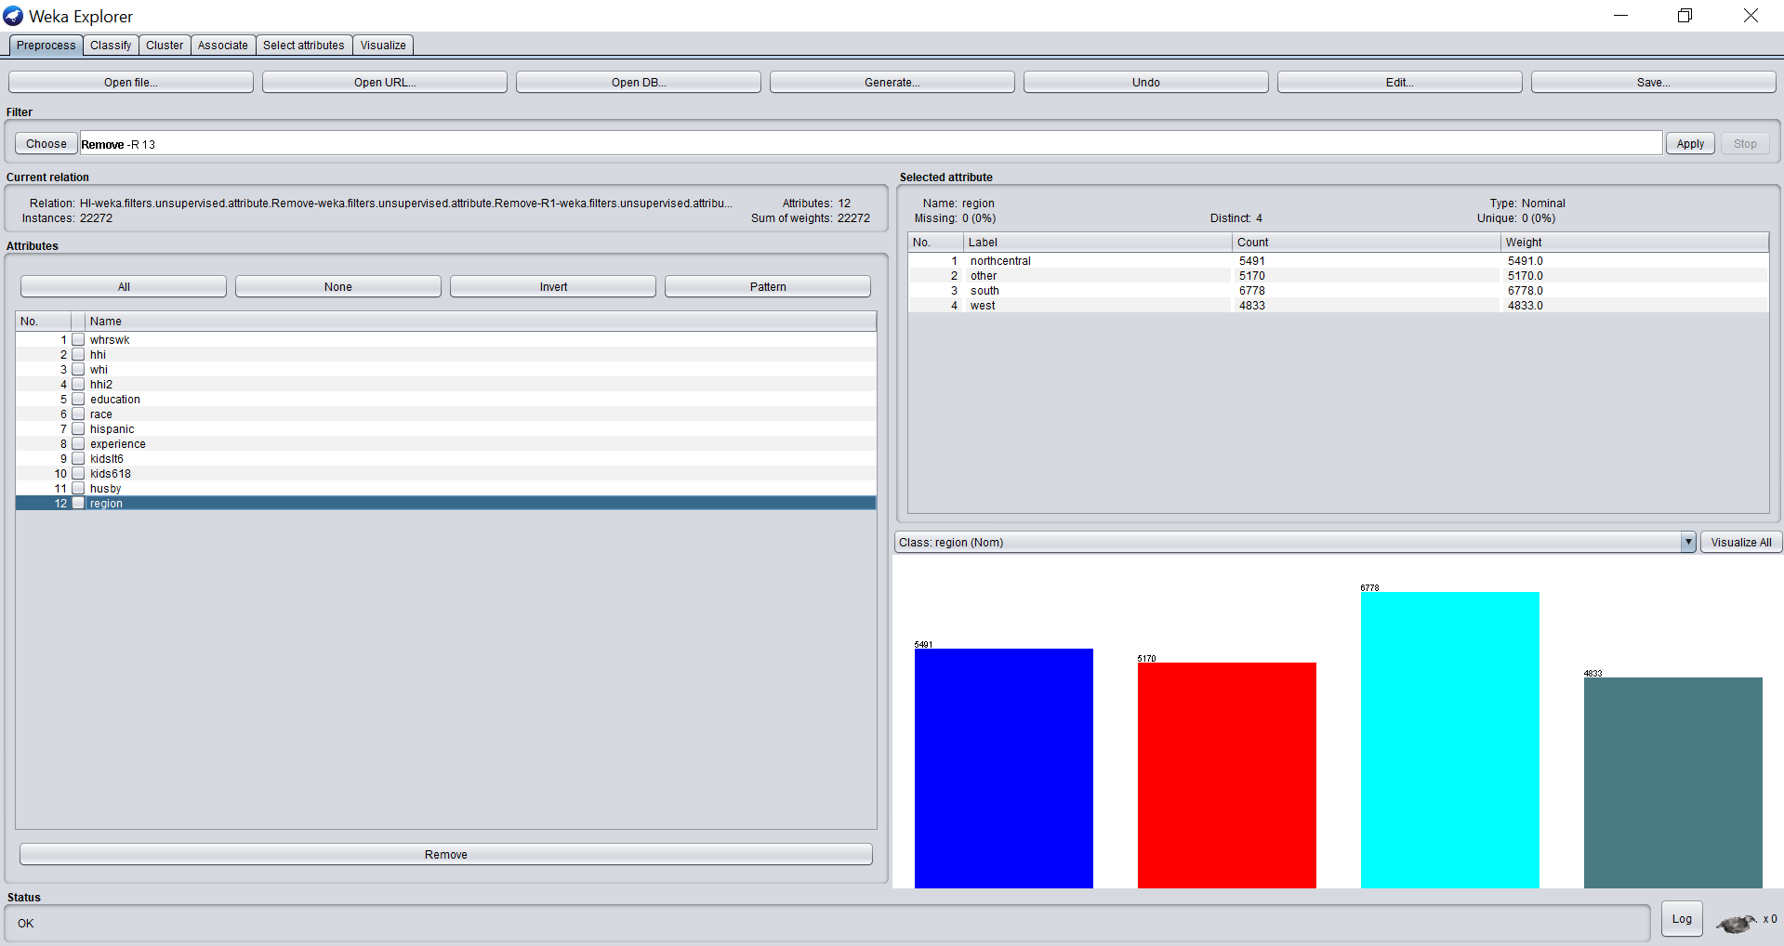

‘Wght’ attribute has been removed now and all the attributes are relating to the new last attribute ‘region’ as the class. From our 14 attributes in our original dataset after applying preprocessing techniques we are down to 12 attributes which are all categorical and shall be used for our further data mining techniques.

Now, we can observe the visualization of all the 12 attributes in relation to class ‘region’. This class can be changed for different visualizations.

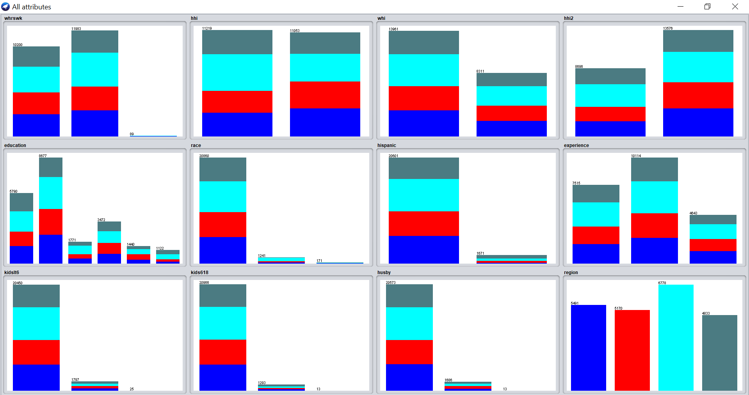

We save this final file as dataset.arff.

## **3. Divide your dataset into training and test set – 0%**

Now, in order to perform techniques such as J48, multilayer perceptron layer (MLP), REPTree, we need to split our dataset.arff into trainingSet.arff and testingSet.arff. For this, we split our dataset in the ratio of 9:1. For this we use RemovePercentage filter under ‘weka.unsupervised.instance.RemovePercentage’.

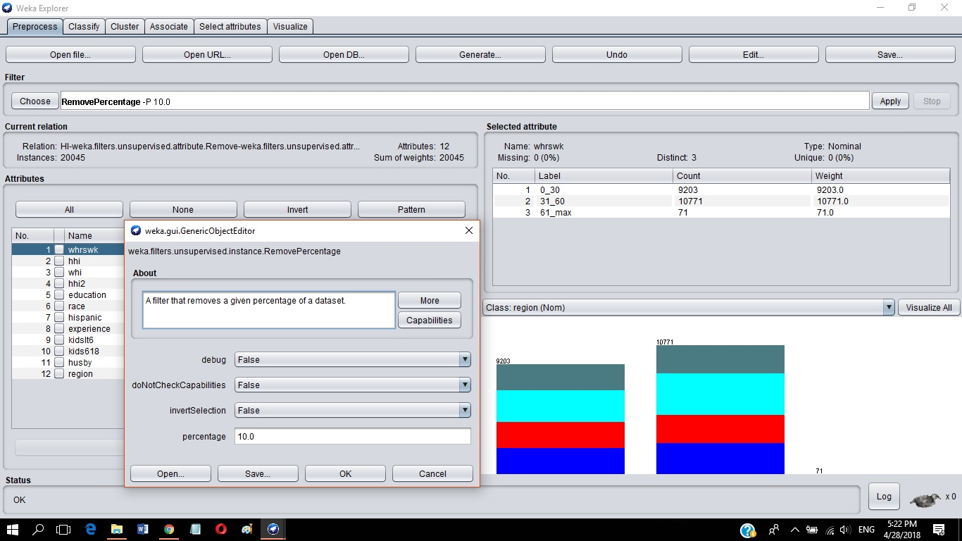

As seen above, to obtain our trainingSet we set invertSelection to False & percentage of removal to 10%. This gives us a set of 20045 records. Save this as trainingSet.arff

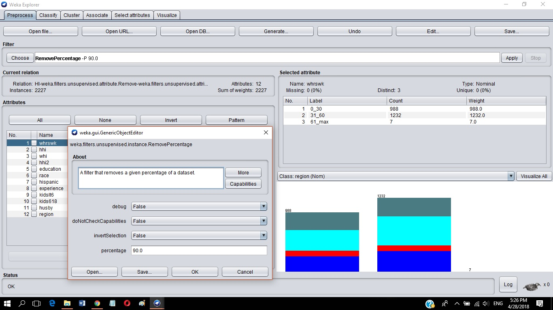

In the above image, to obtain our testingSet we again set invertSelection to False & percentage of removal to 90%. We get a set of 2227 records & is saved as testingSet.arff

#### **Data Mining Techniques**

# **Classification**

## **4.1 Classification: J48 Tree – 10%**

For each of the following classification techniques

1. Training model using trainingSet.arff

|  |  |  |  |  |
| --- | --- | --- | --- | --- |
| **batchSize** | **reducedErrorPruning** | **confidence level** | **numFolds** | **seed** |
| 1) 100 | True | 0.25 | 3 | 1 |
| 2) 100 | True | 0.50 | 6 | 2 |
| 3) 100 | True | 0.90 | 9 | 3 |

Now, we proceed to the classify tab to apply our first classification method - the J48 tree,

for this we choose j48 algorithm under trees in the classifier and in the options dialogue box.

Following the parameters in the table above with class attribute = ‘region’., we set them for each case.

**(a).** Case 1:

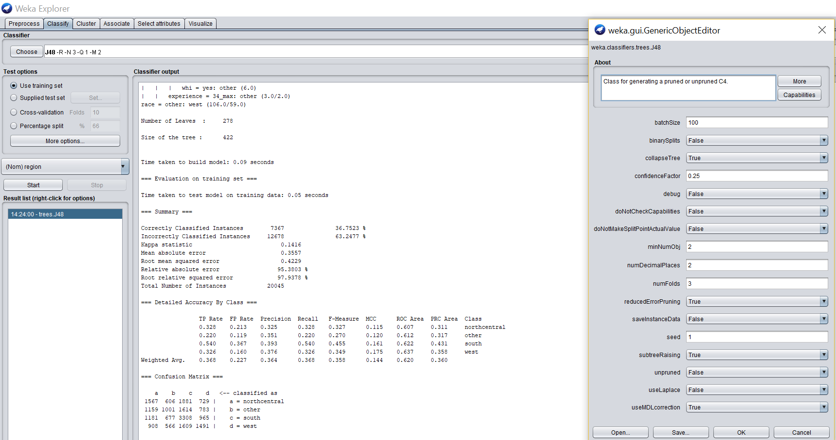

We click on OK and in test options we select ‘Use training set’ and finally ‘Start’. We get the following in the result window below.

A. The model or a visualization of the model

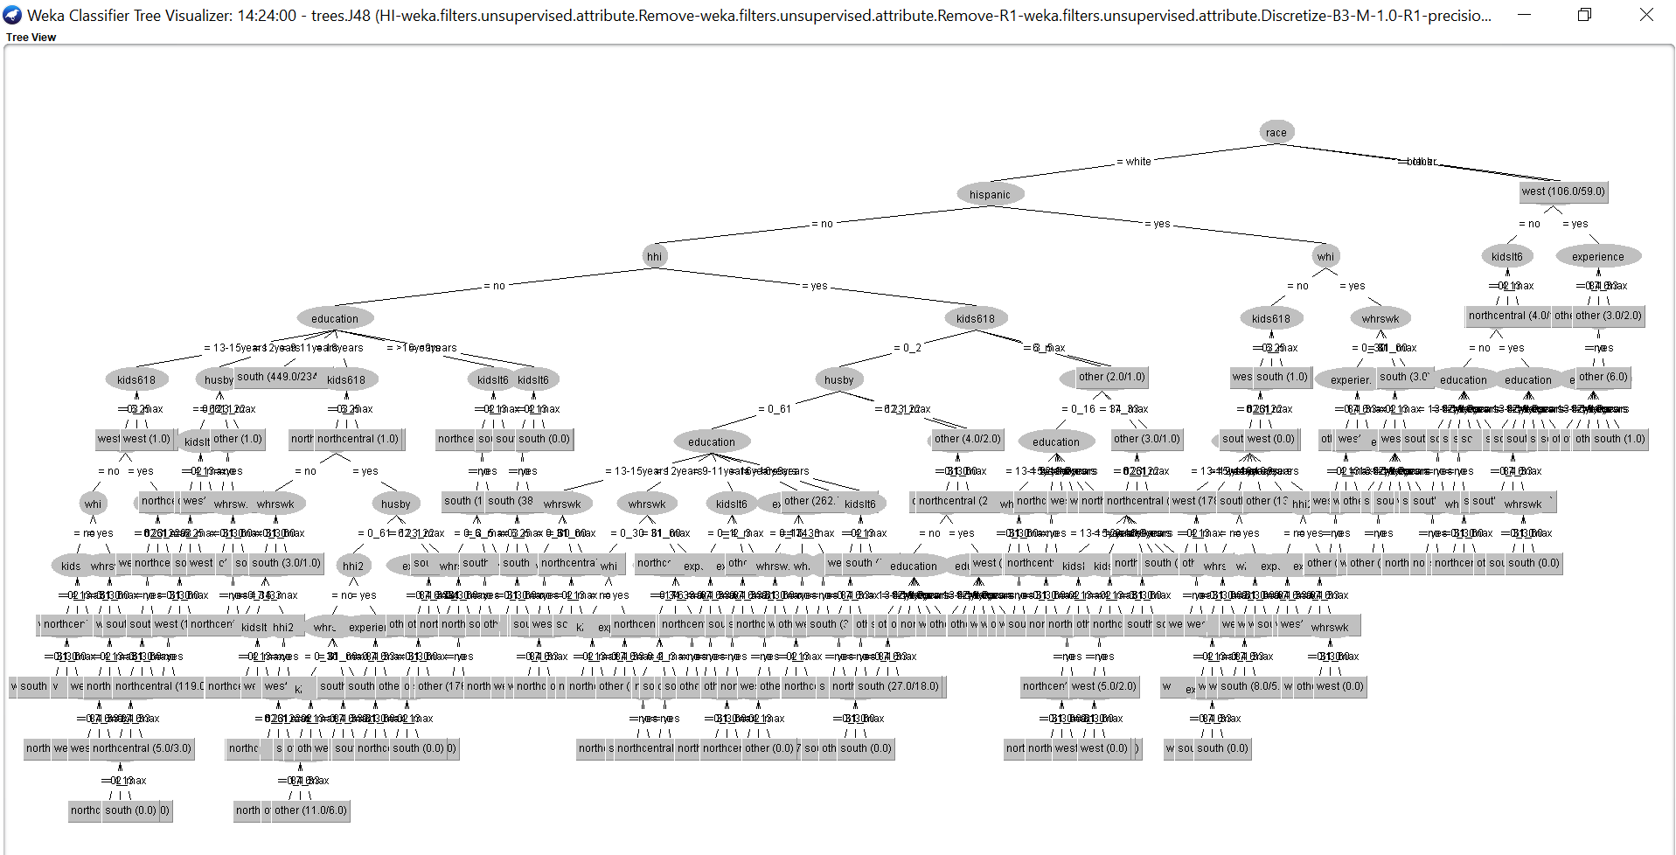

B. The results of the model

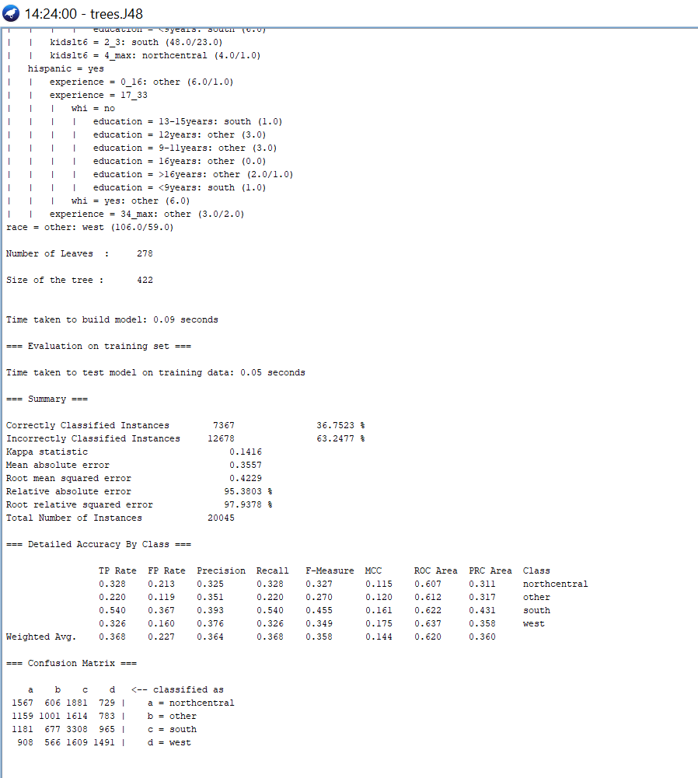

C. Additional output of the model

i. Confusion Matrices

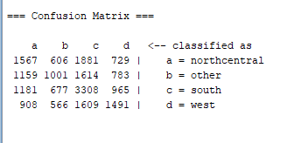

ii. Classifier Error Visualization  
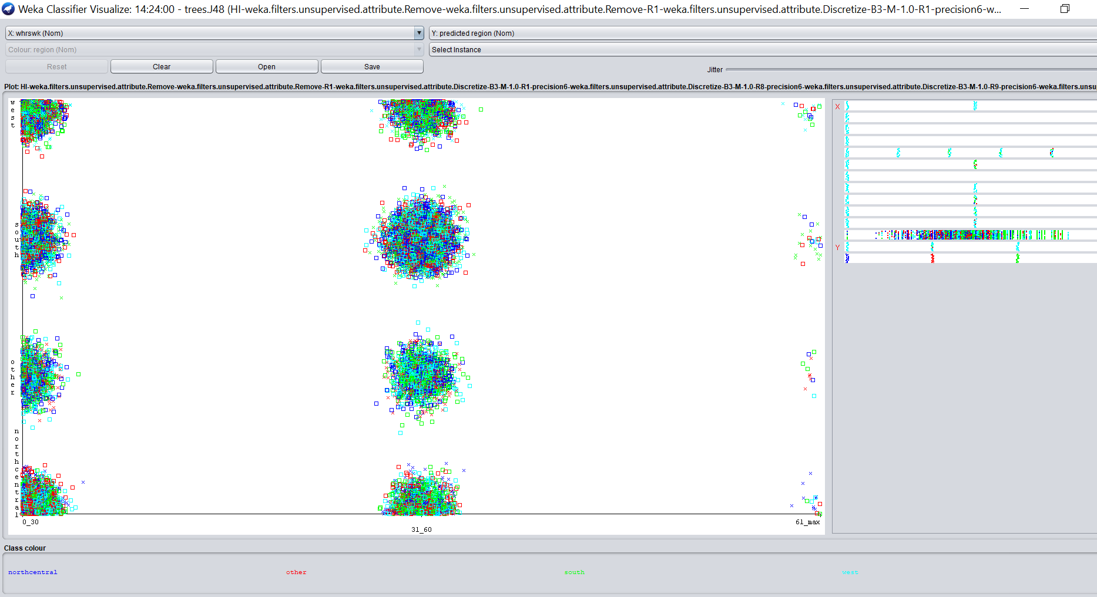

**(b).** Case 2:

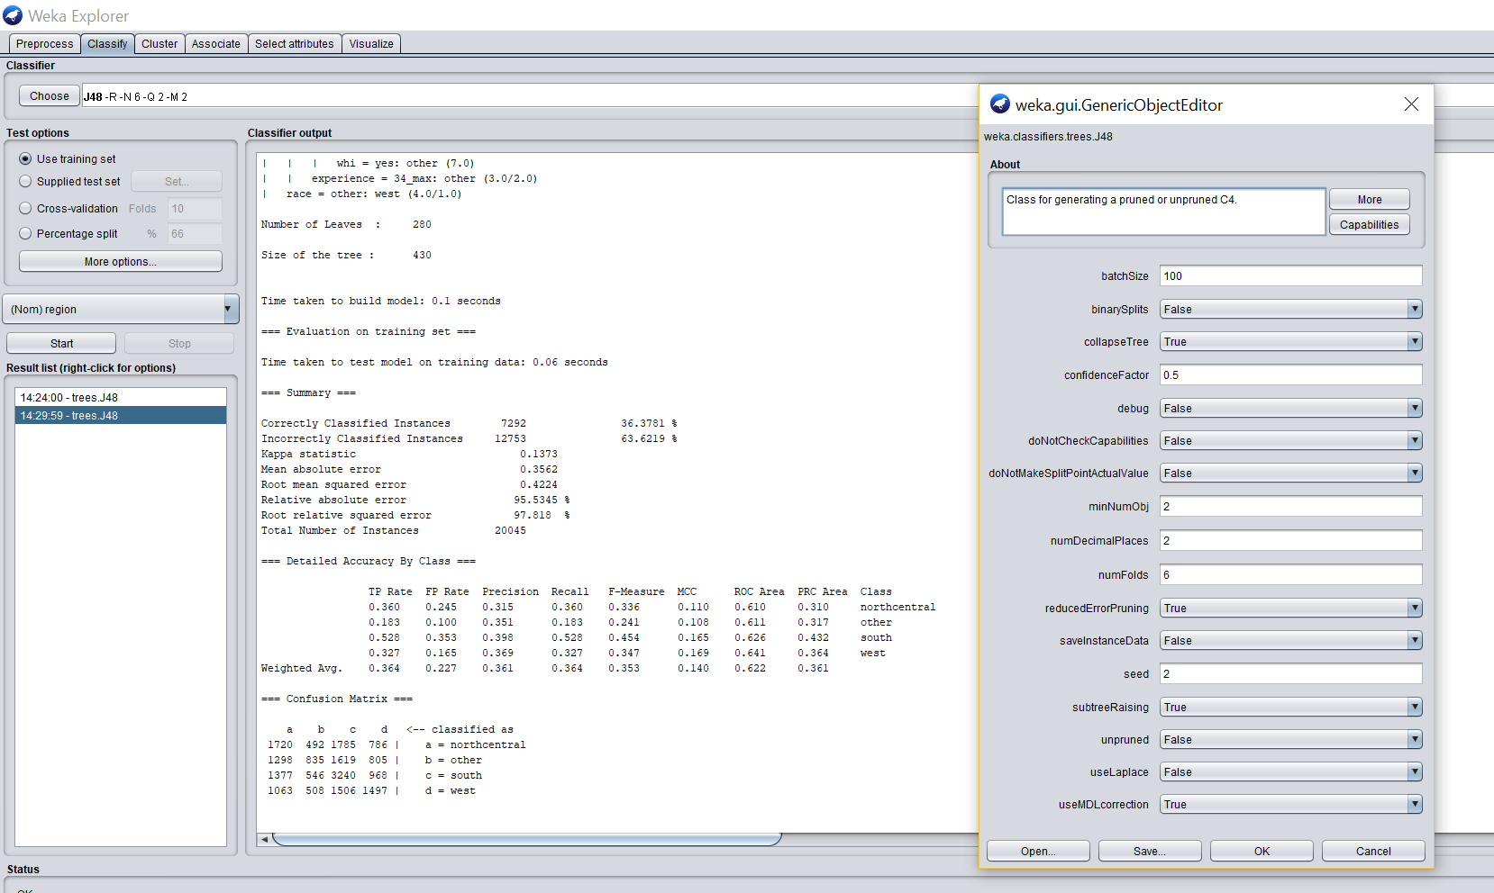

We click on OK and then ‘Start’. We get the following in the results window below.

A. The model or a visualization of the model

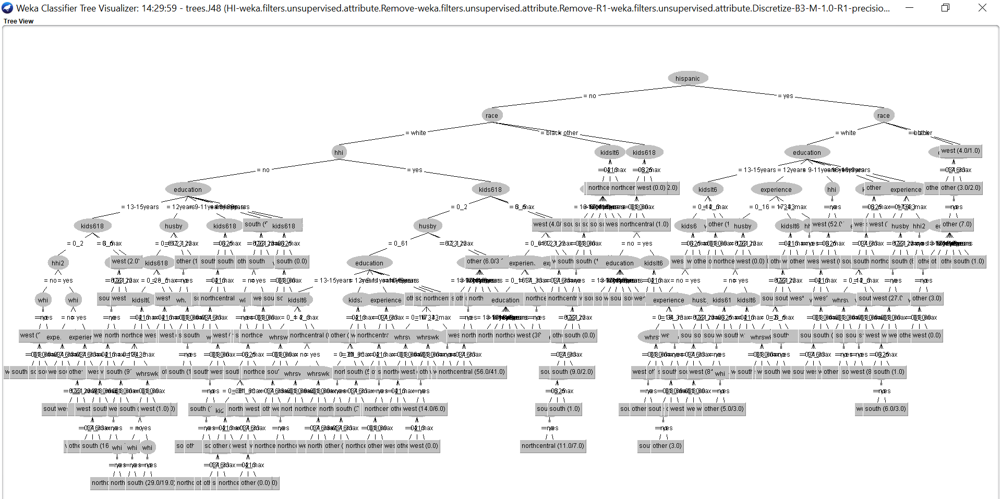

B. The results of the model

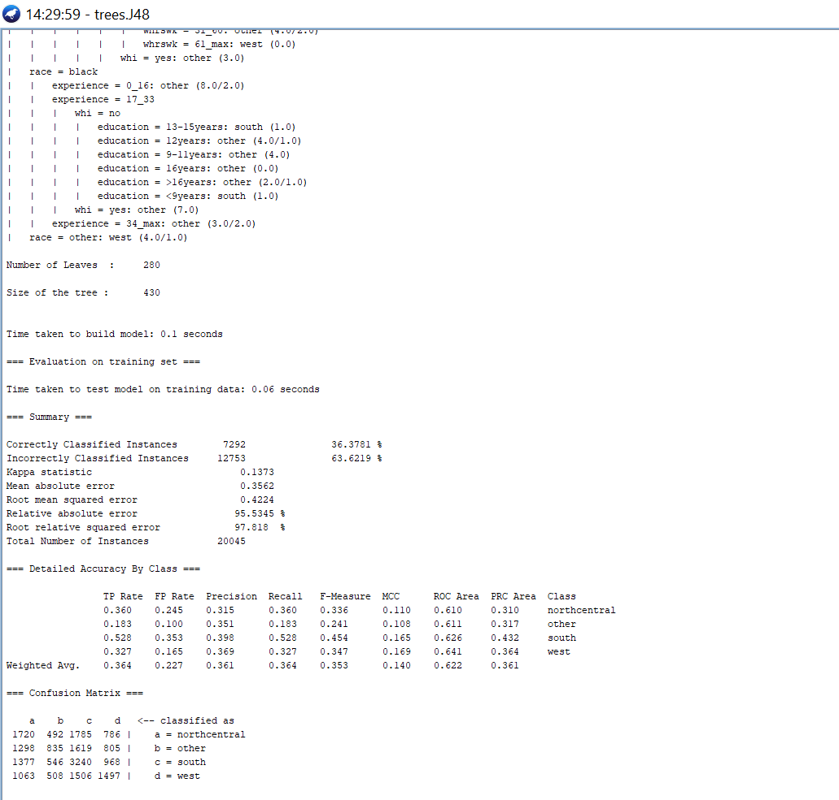

C. Additional output of the model

i. Confusion Matrices

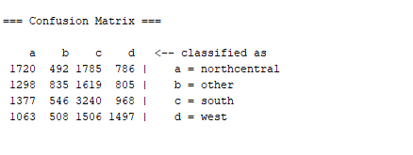

ii. Classifier Error Visualization

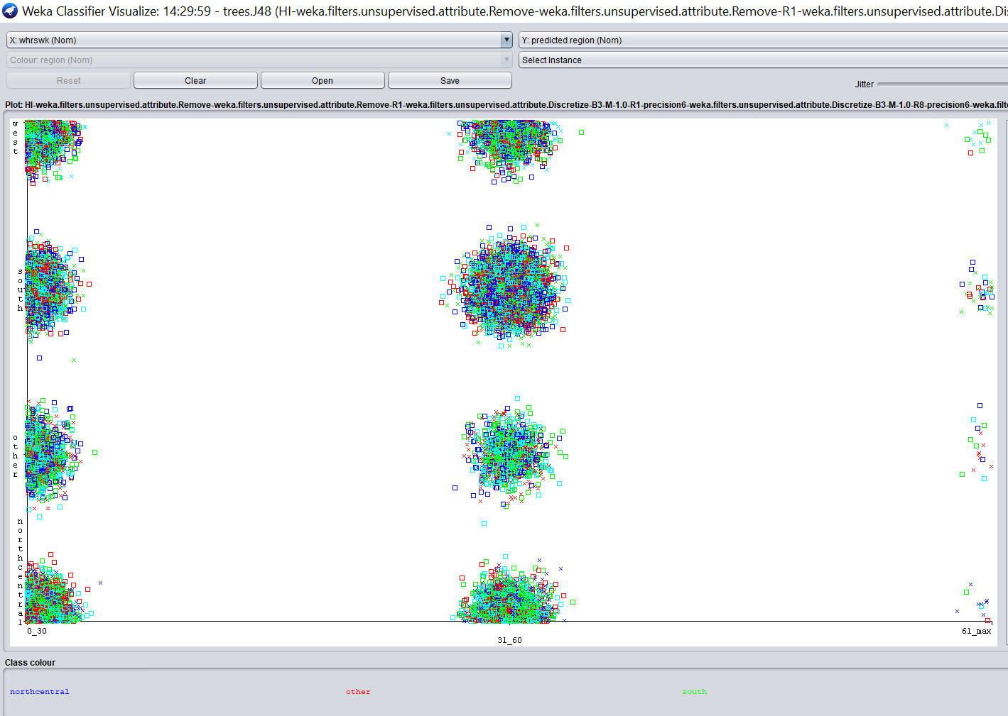

**(c).** Case 3:

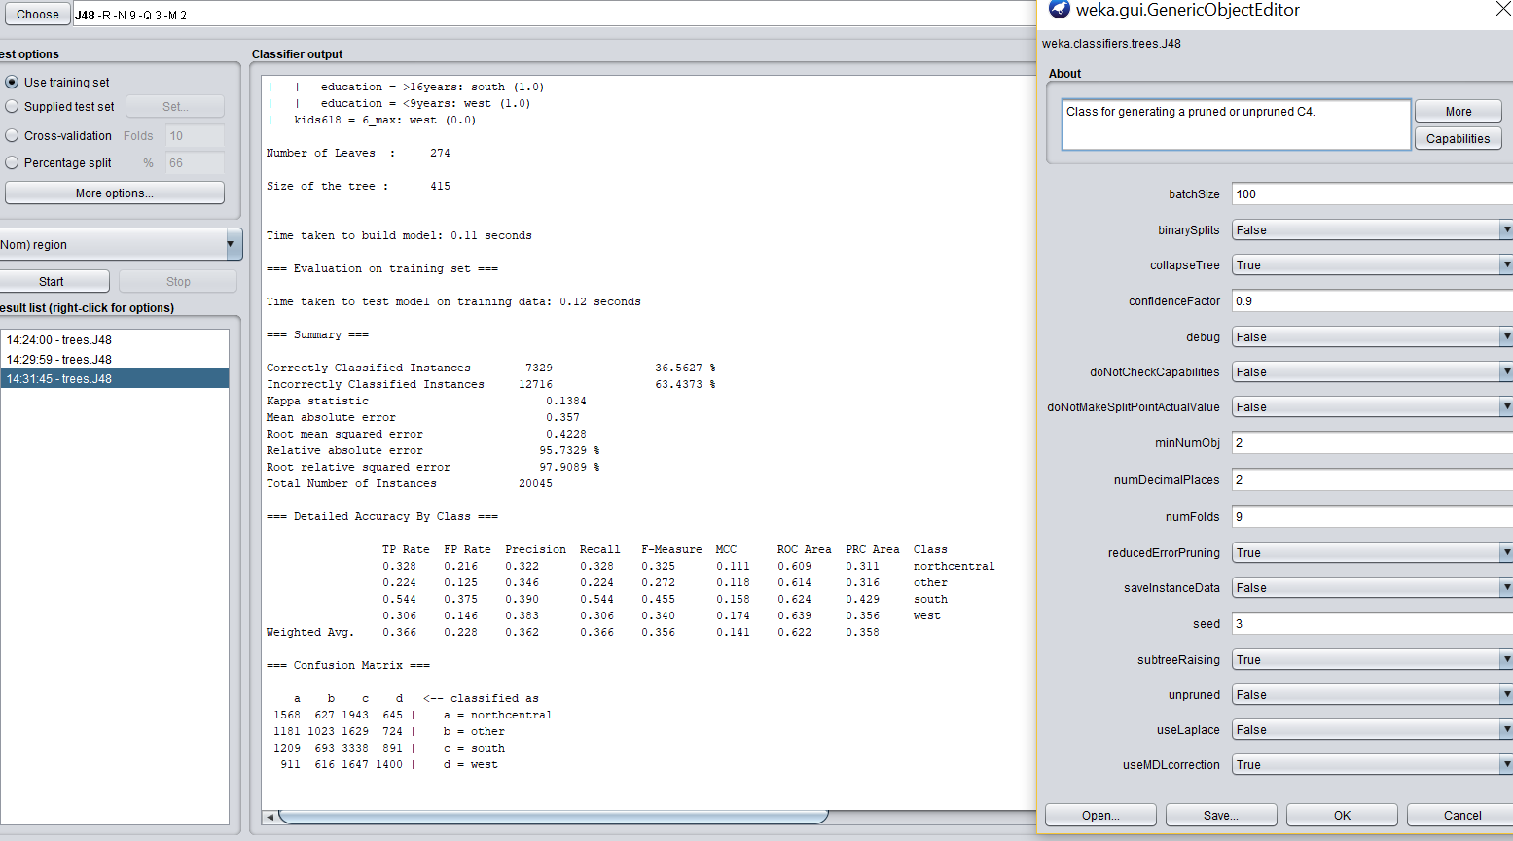

We click on OK and then ‘Start’. We get the following in the results window below.

A. The model or a visualization of the model

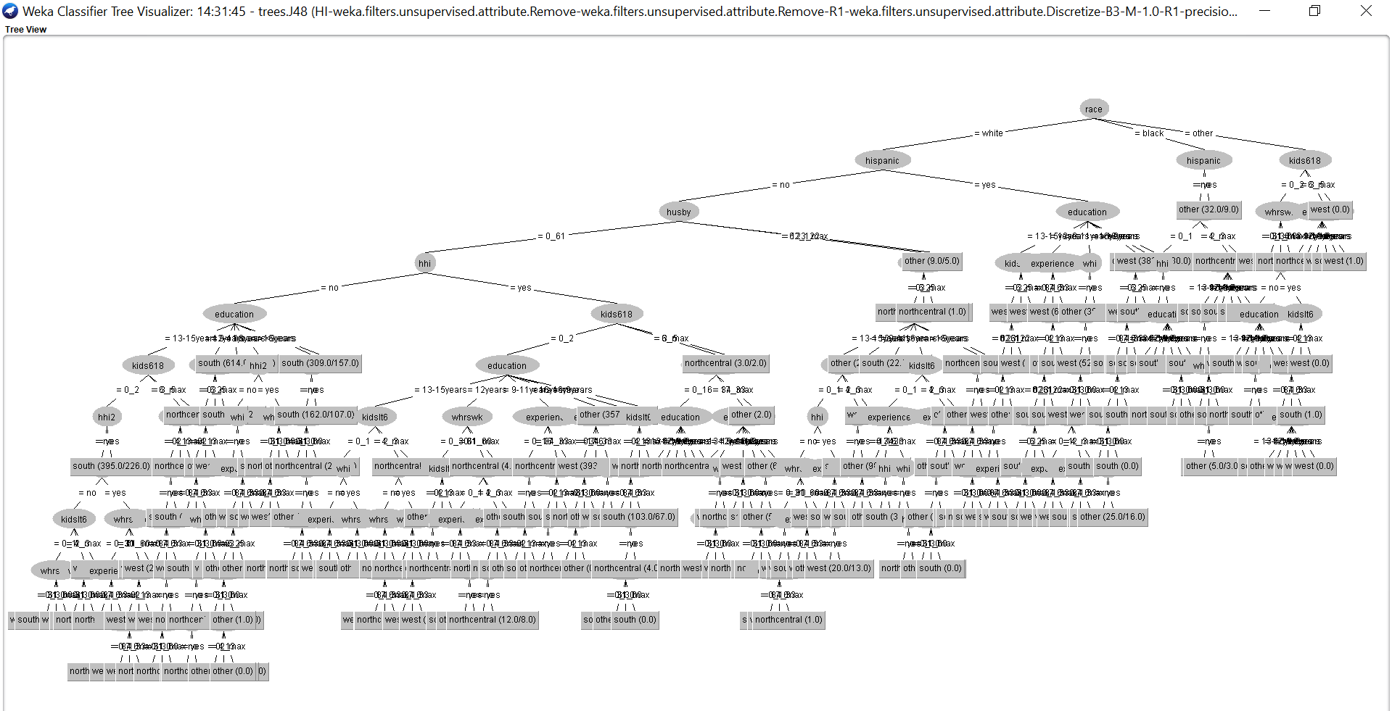

B. The results of the model

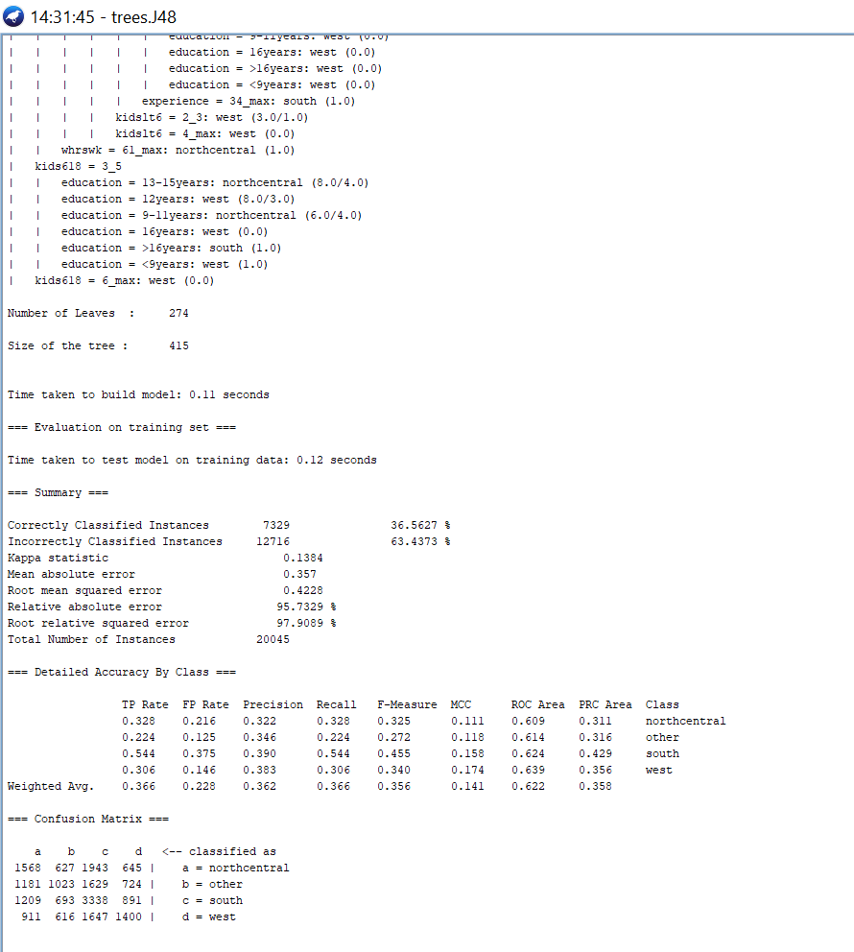

C. Additional output of the model

i. Confusion Matrices

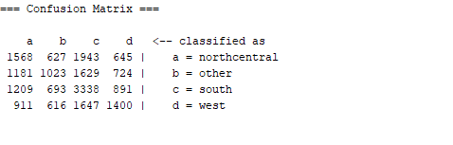

ii. Classifier Error Visualization

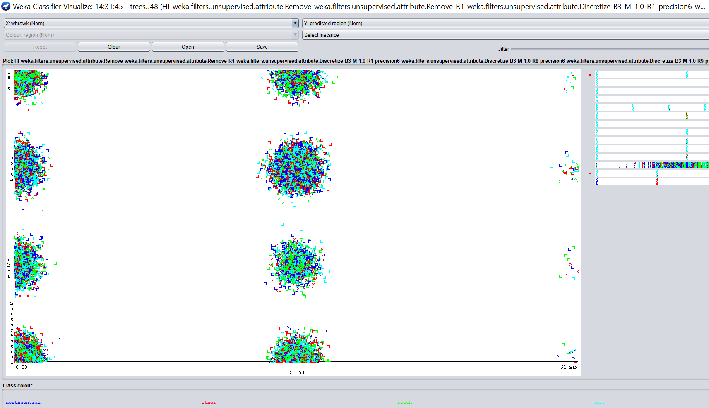

2. Testing model using testingSet.arff

|  |  |  |  |
| --- | --- | --- | --- |
| **batchSize** | **confidence level** | **numFolds** | **seed** |
| 1) 100 | 0.30 | 3 | 1 |
| 2) 100 | 0.55 | 6 | 2 |
| 3) 100 | 0.95 | 9 | 3 |

Now, we proceed to testing our dataset model using testingSet.arff. So, in the classifier tab, we use ‘Supplied Test Set’ and in the dialogue box we select our testingSet.arff file. Class attribute is ‘region’.

a) Case 1:

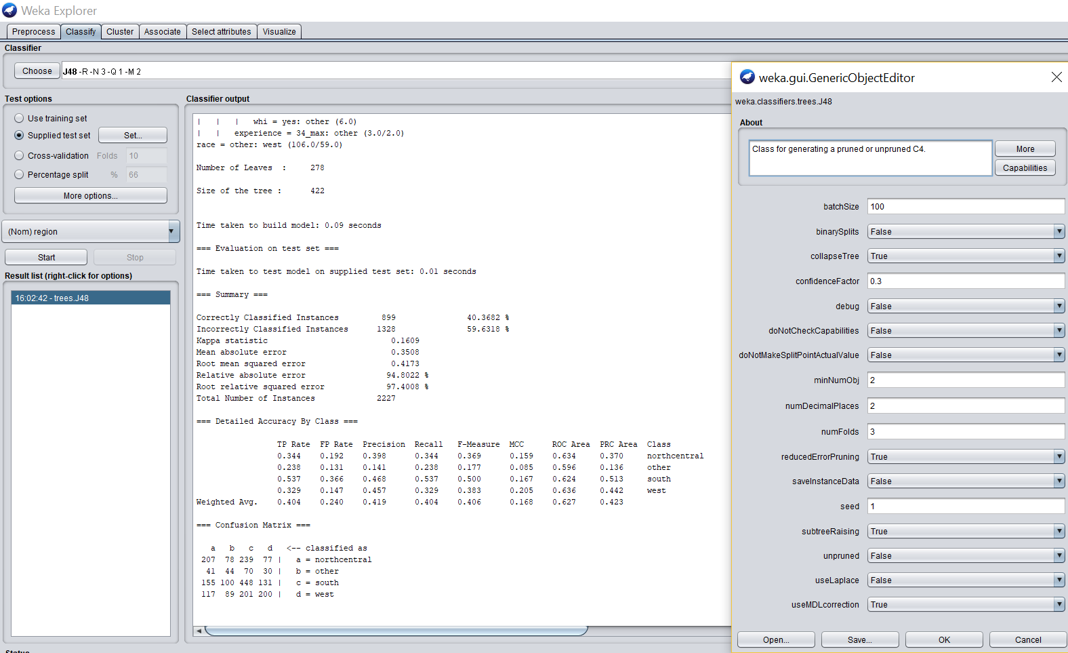

We click on OK and then ‘Start’. We get the following in the results window below.

A. The model or a visualization of the model

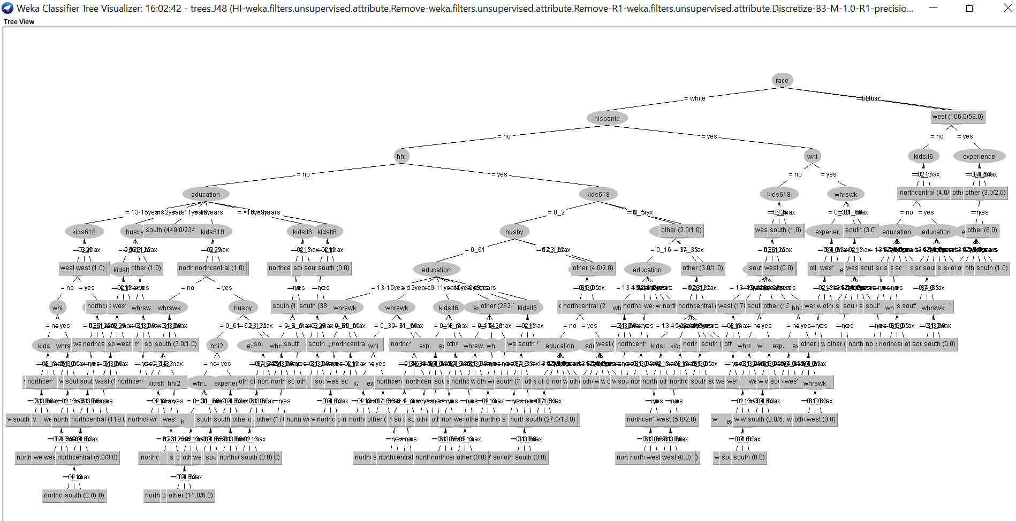

B. The results of the model

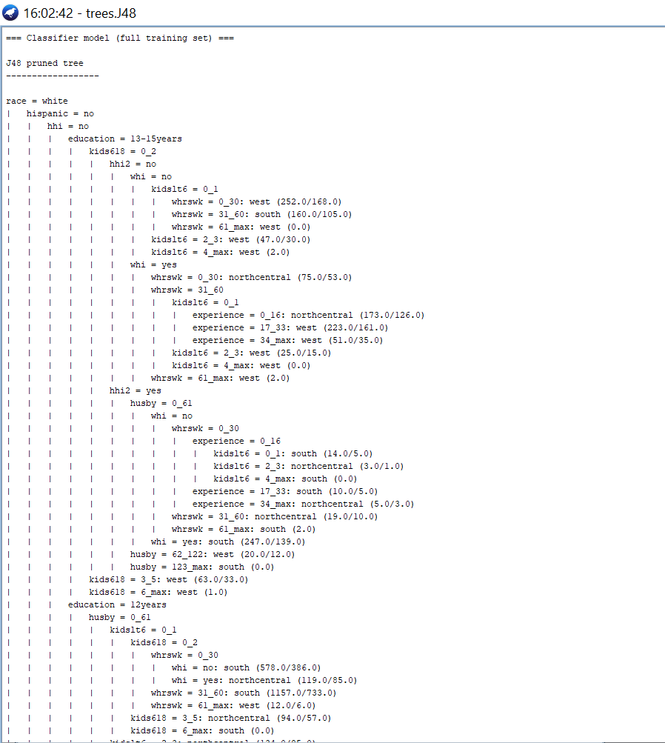

C. Additional output of the model

i. Confusion Matrices

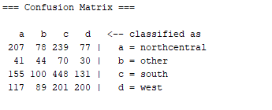

ii. Classifier Error Visualization

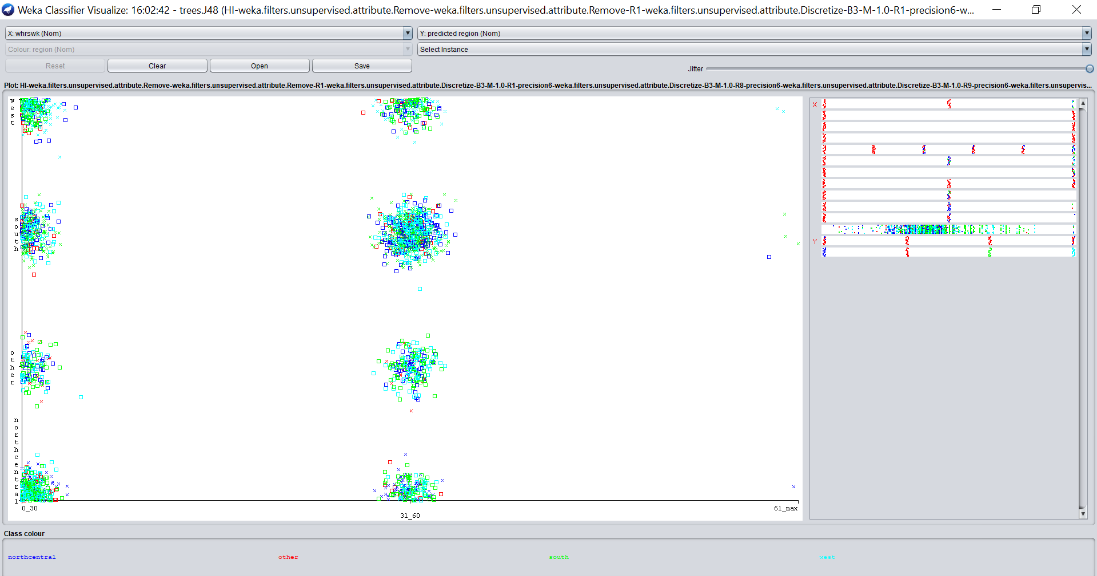

b) Case 2:

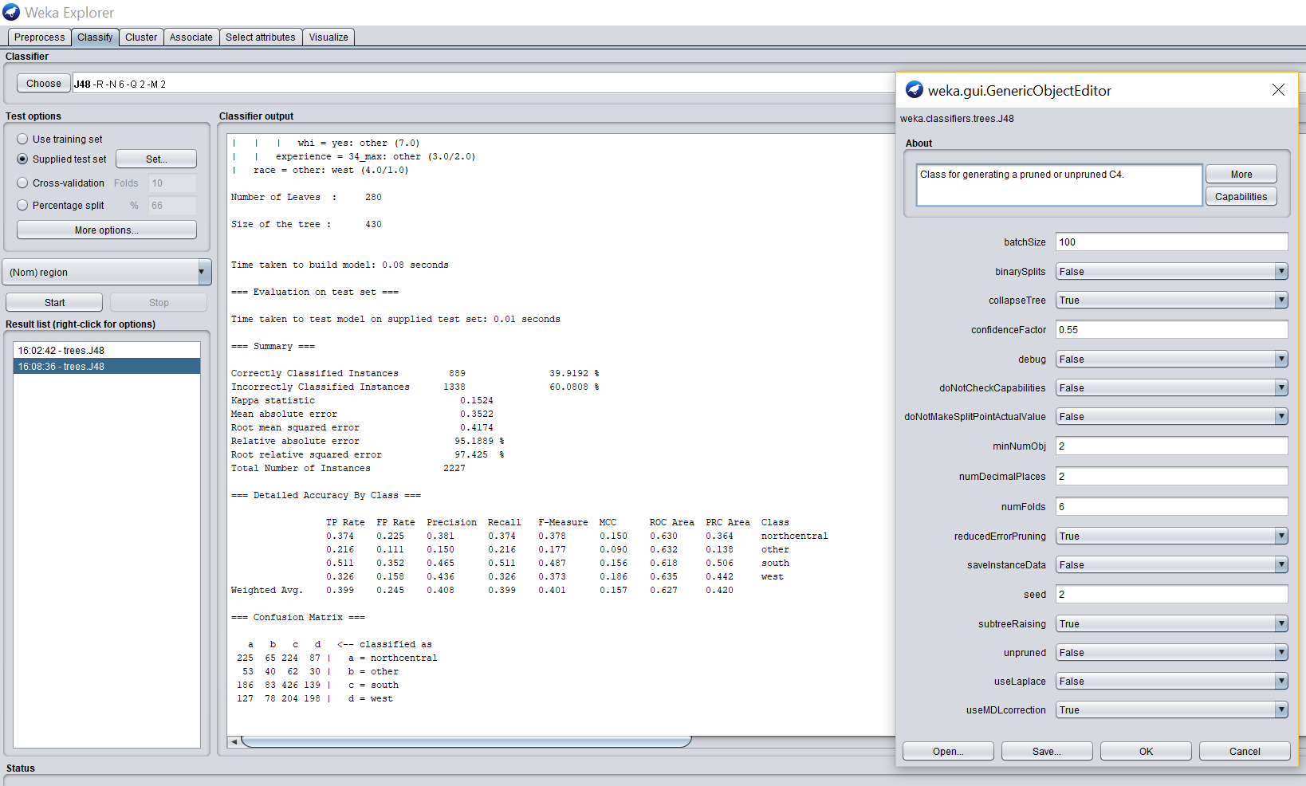

We click on OK and then ‘Start’. We get the following in the results window below.

A. The model or a visualization of the model

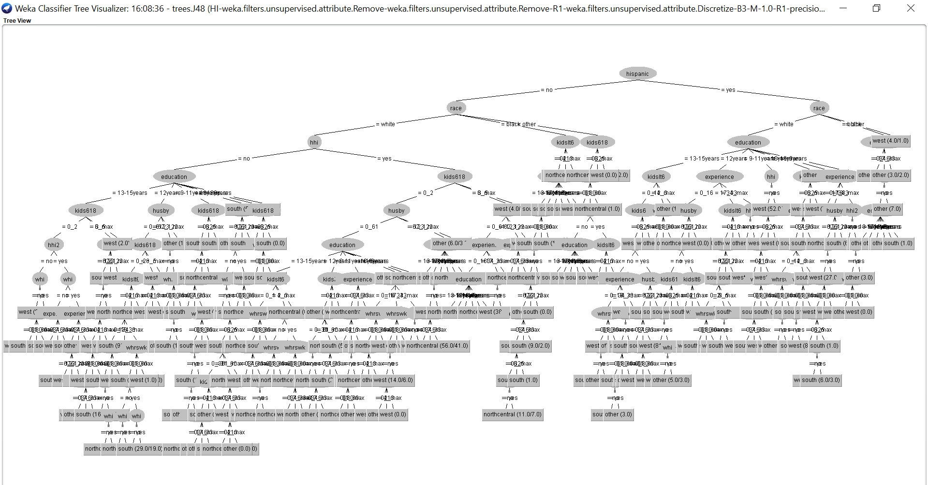

B. The results of the model

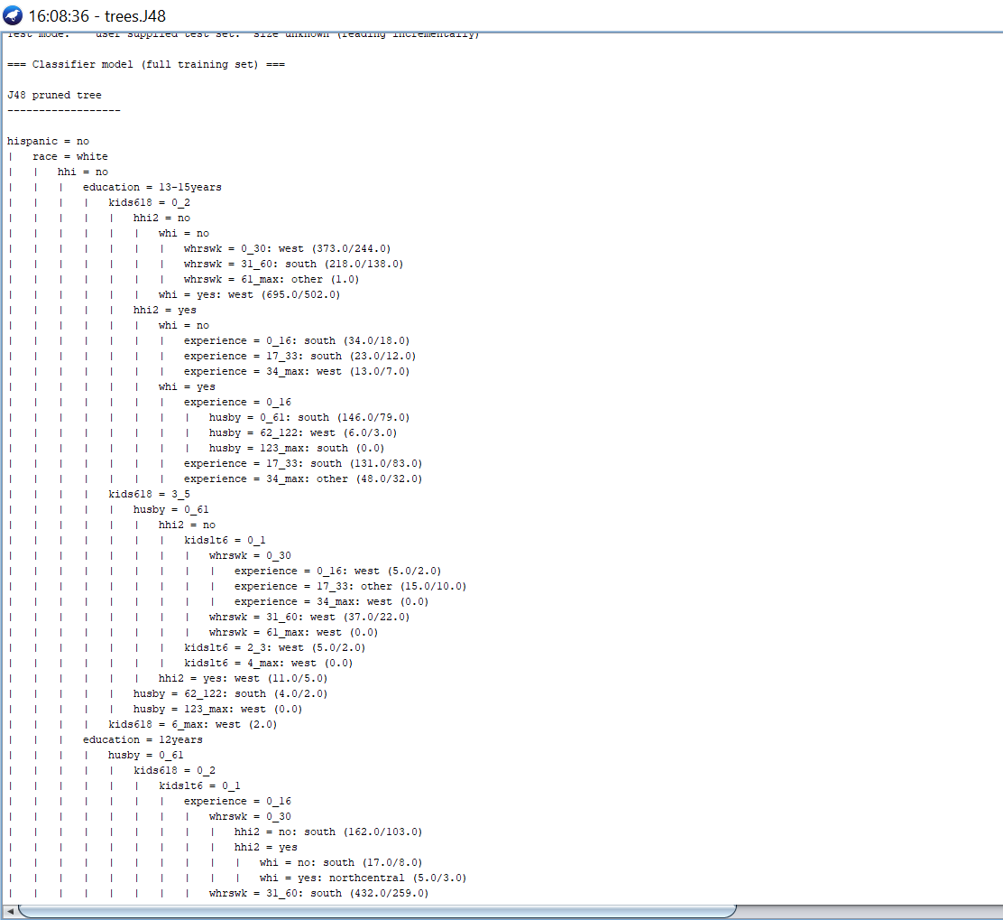

C. Additional output of the model

i. Confusion Matrices

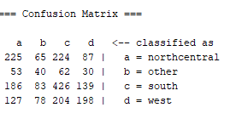

ii. Classifier Error Visualization

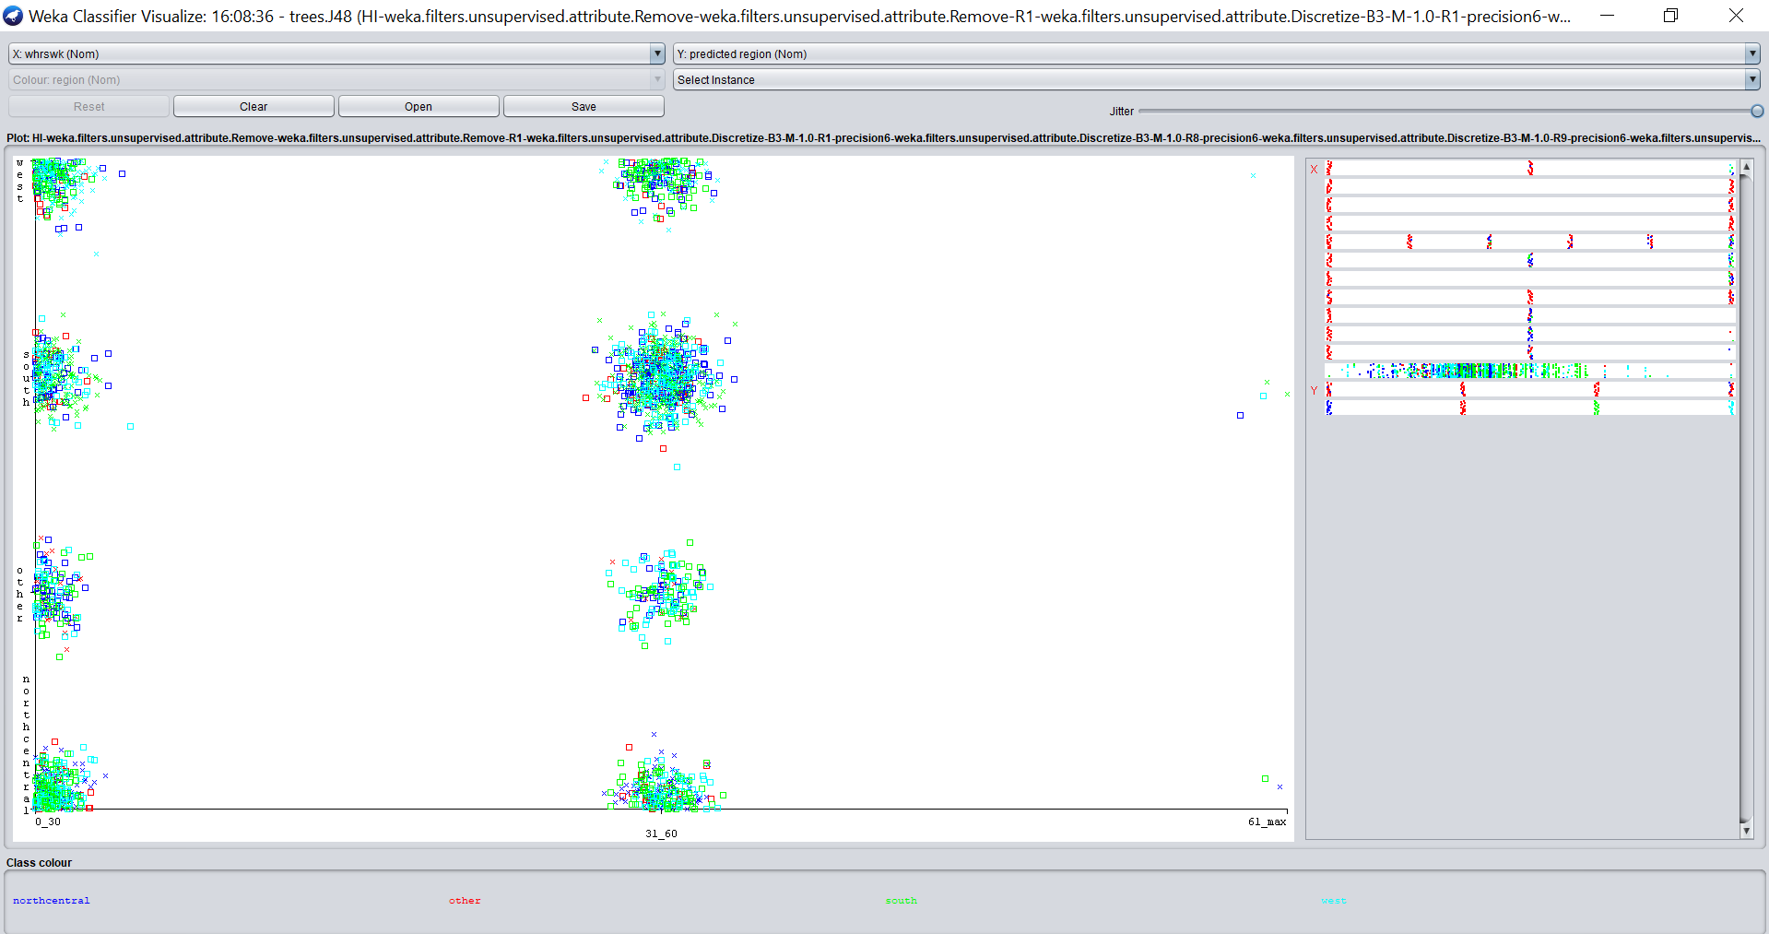

c) Case 3:

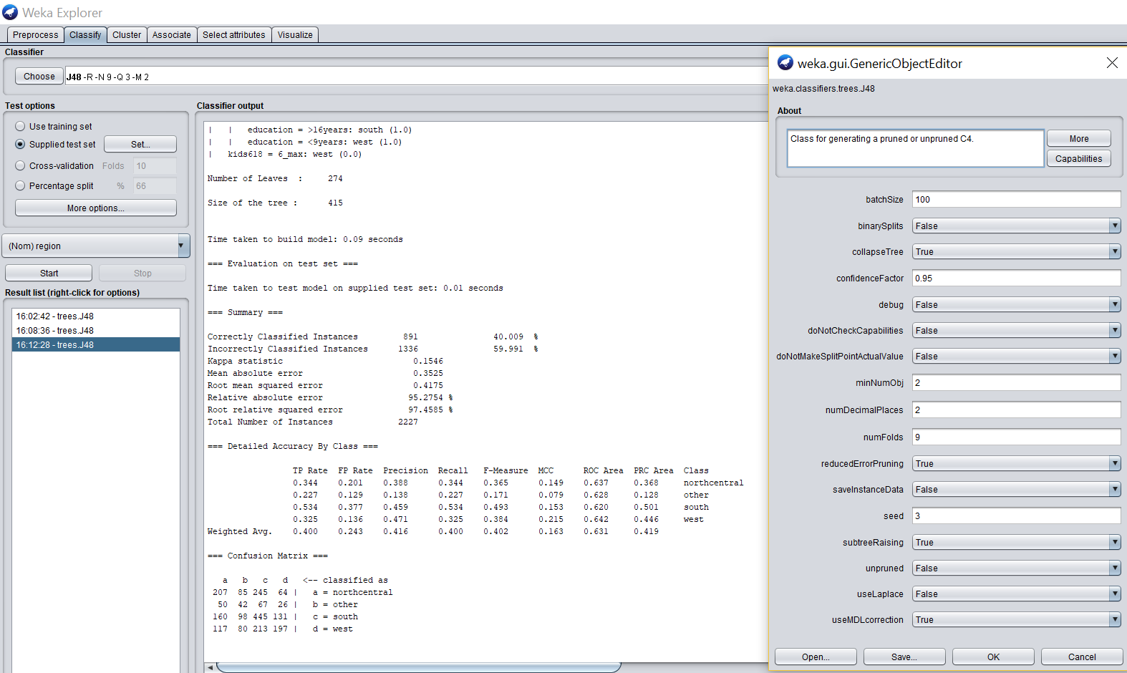

We click on OK and then ‘Start’. We get the following in the results window below.

A. The model or a visualization of the model

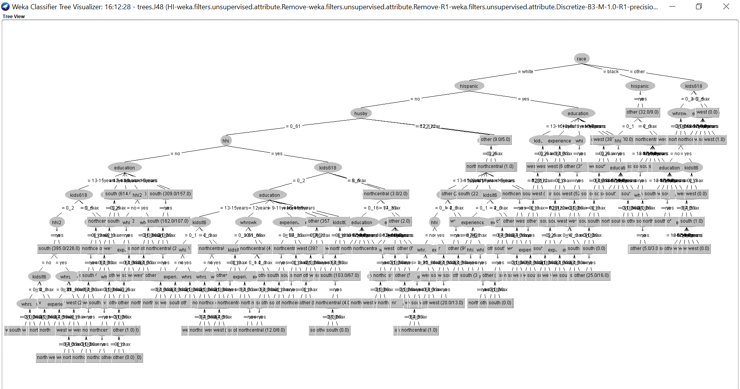

B. The results of the model

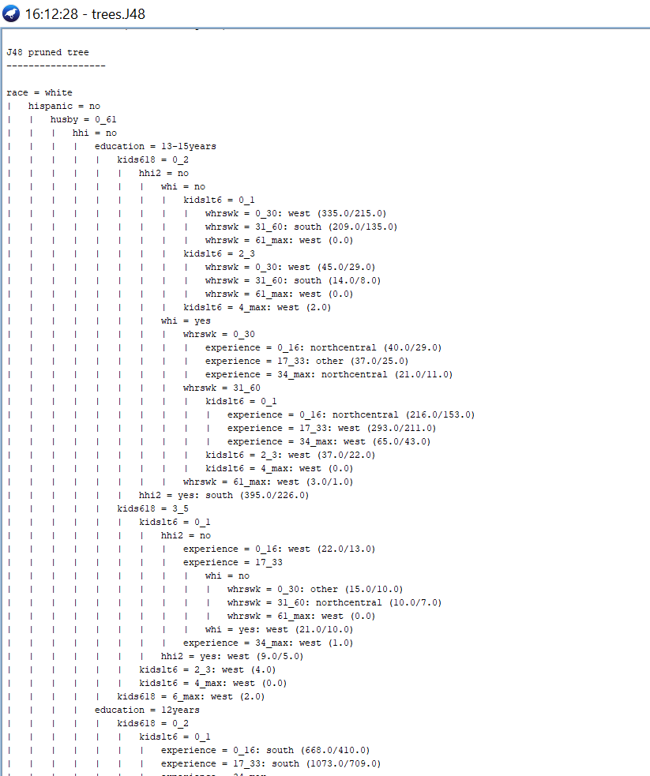

C. Additional output of the model

i. Confusion Matrices

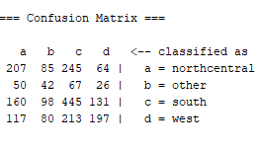

ii. Classifier Error Visualization

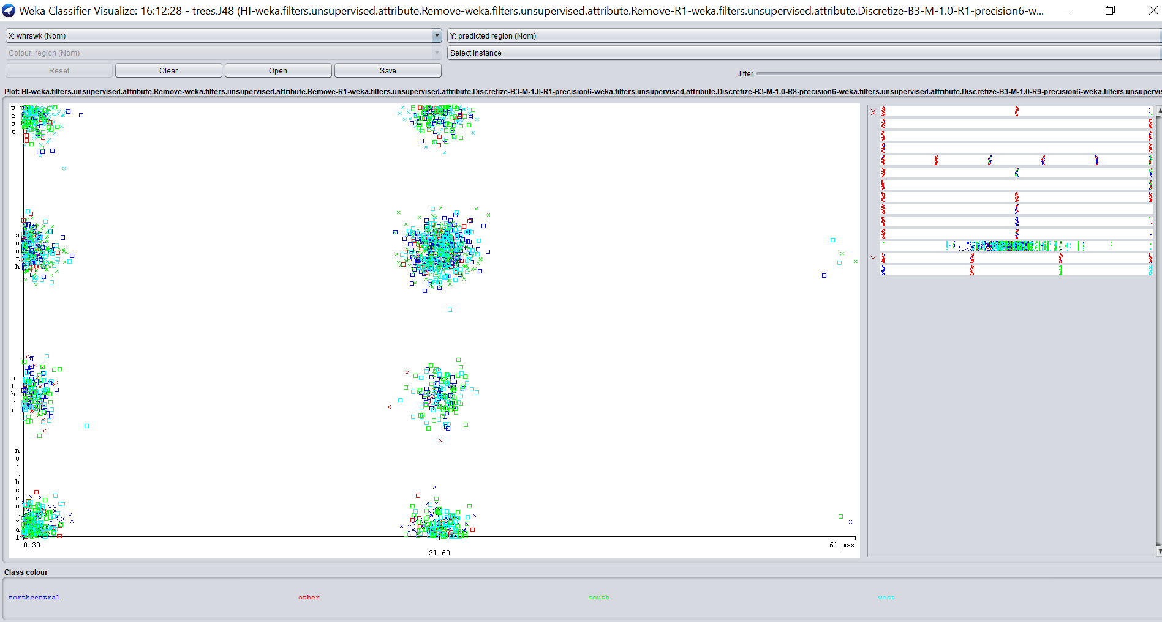

Conclusions/Findings:

|  |  |  |  |  |
| --- | --- | --- | --- | --- |
| Using | Correctly Classified Instances | Incorrectly Classified Instances | Number of Leaves | Size of the Tree |
| Training Set | 1) 36.7523 % | 63.2477 % | 278 | 422 |
| Training Set | 2) 36.3781 % | 63.6219 % | 280 | 430 |
| Training Set | 3) 36.5627 % | 63.4373 % | 274 | 415 |
| Testing Set | 1) 40.3642% | 59.6318 % | 278 | 422 |
| Testing Set | 2) 39.9192 % | 60.0808 % | 280 | 430 |
| Testing Set | 3) 40.009 % | 59.991 % | 274 | 415 |

As it’s observed above we get better results in the case (1) using testing set as the correctly classified instances were found to be more here compared to other cases, although size of the tree was bigger than case 3 & smaller than case 2. Also we got better results in case (1) using training set. Thus from both our selections we got much better results from case (1) using testing set which is our preferable result.

It is also observed in our classifier visualization that the women from south and northcentral were the only ones to work for 61 - max hours a week.

**Links/References:**

Data Mining with Weka: online course from the University of Waikato   
Class 2 - Lesson 2: Training and testing: http://weka.waikato.ac.nz/   
Slides (PDF): <http://goo.gl/D3ZVf8>

<https://twitter.com/WekaMOOC>

<http://wekamooc.blogspot.co.nz/>

Department of Computer Science, University of Waikato, New Zealand: <http://cs.waikato.ac.nz/>

## **4.2 Classification: Association Rules – 10%**

Now, to perform Association Rule Mining we use Apriori algorithm as default, and for that our dataset should satisfy the condition of having only categorical attributes which is true.   
So, we perform AR mining on our dataset.arff file. Loading it in WEKA and now click on the Associate tab where apriori algorithm is selected as default and in ‘Apriori’ dialogue box type the following parameters for each case.

|  |  |  |  |  |
| --- | --- | --- | --- | --- |
| **lowerBoundMinSupport** | **metricType** | **minMetric** | **numRules** | **outputItemSets** |
| 1) 0.2 | Confidence | 0.7 | 10 | True |
| 2) 0.3 | Confidence | 0.8 | 10 | True |
| 3) 0.4 | Confidence | 0.9 | 20 | True |

1. Case 1:

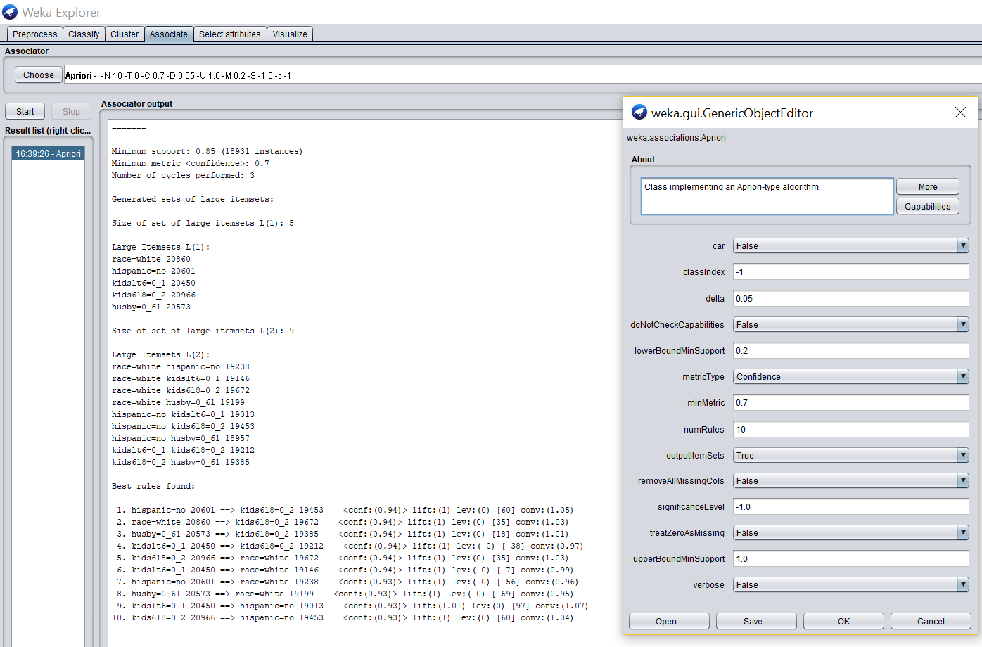

a. The model or a visualization of the model  
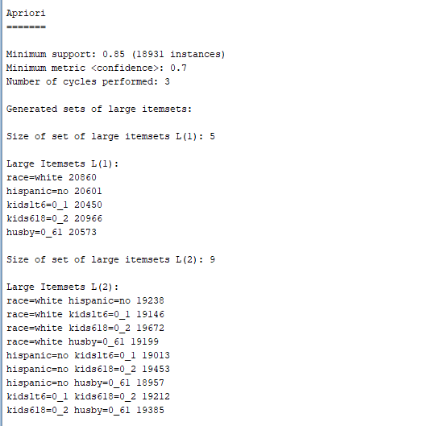

b. The results of the model

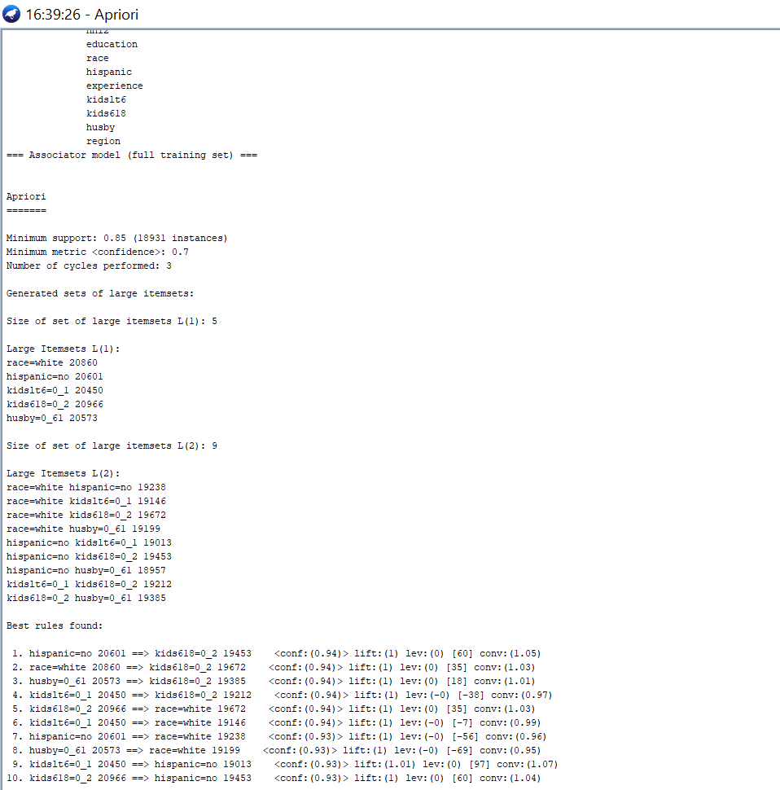

2. Case 2:

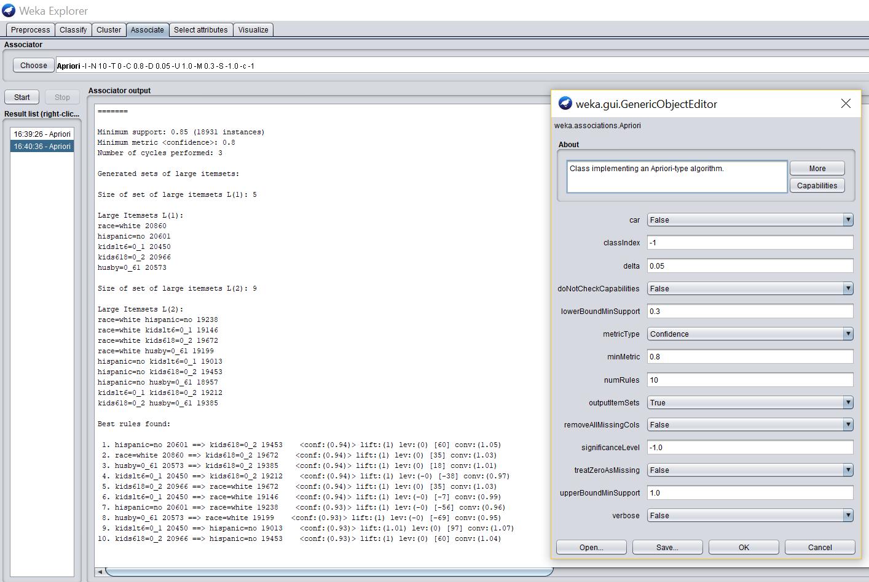

a. The model or a visualization of the model  
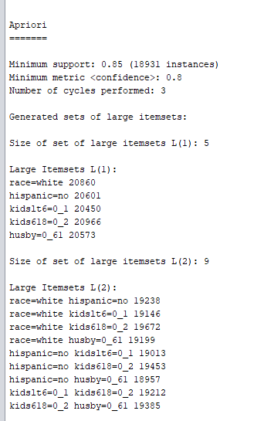

b. The results of the model

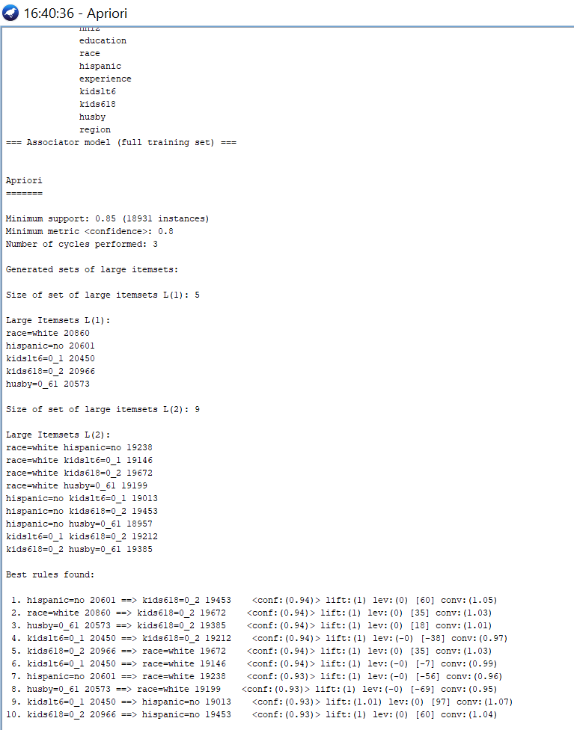

3. Case 3:  
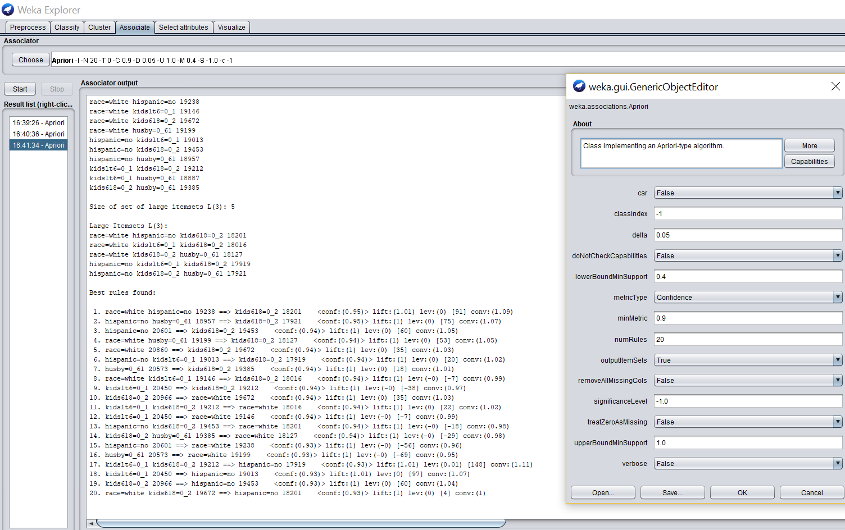  
a. The model or a visualization of the model  
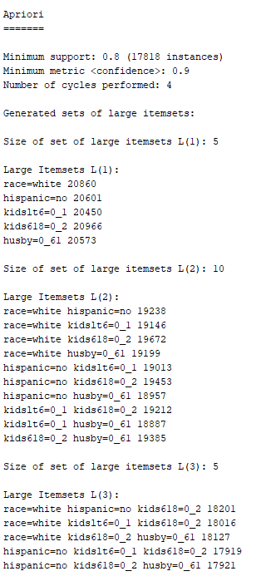  
  
b. The results of the model

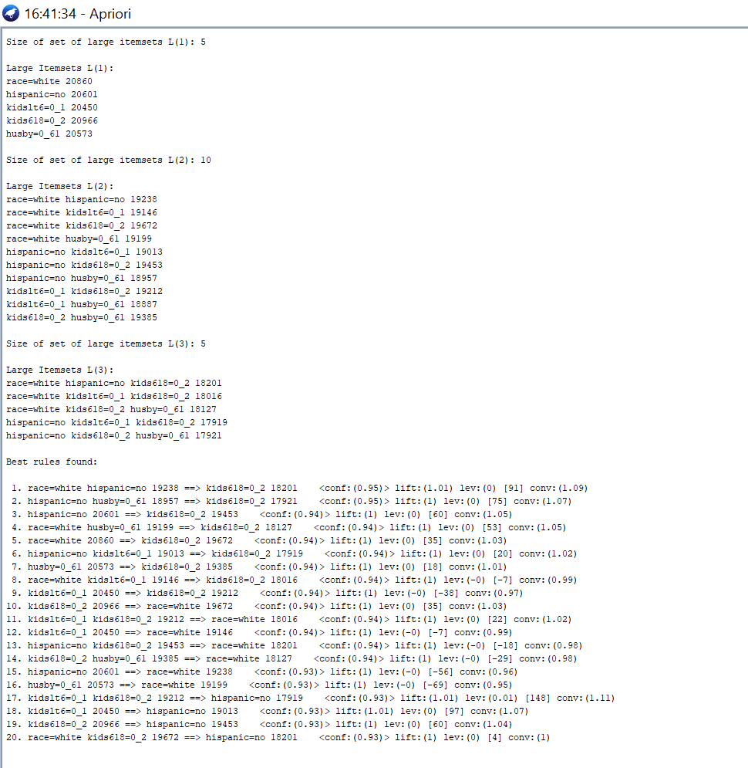

**Conclusions/Findings:**

In case 1 with confidence level 0.7 and case 2 with confidence level 0.8, it is observed that the association rules were found to be the same probably because of the low confidence levels and minimum supports. However, in case 3 increasing confidence level to 0.9 and minimum support to 0.4 gave us different results than the first two, first was the association rules were different and second was that case 1 & 2 only provided two levels of itemsets but case 3 provided a three level of itemset which is noteworthy.

**Links/References:**

<https://en.wikipedia.org/wiki/Association_rule_learning>

<http://facweb.cs.depaul.edu/mobasher/classes/ect584/WEKA/association_rule_mining_in_weka.html>

## **5.1 Classification: MLP – 10%**

For performing Multilayer Perceptron or MLP algorithm, we’ve chosen to work on dataset.arff and in classify tab, select ‘use training set’, then set the parameters as follows.

|  |  |  |  |  |  |
| --- | --- | --- | --- | --- | --- |
| **LearningRate** | **momentum** | **GUI** | **epoch value** | **Hidden Layer** | **Class Attribute** |
| 0.3 | 0.2 | True | 102 (approx.) | 1 | Whi (Nominal) |

After getting the GUI interface we started the MLP algorithm so that the neurons could start learning. We ‘accept’ the learning process at the above given epoch values and get the following results.

Correctly Classified Instances 17713 79.5304 %

Incorrectly Classified Instances 4559 20.4696 %

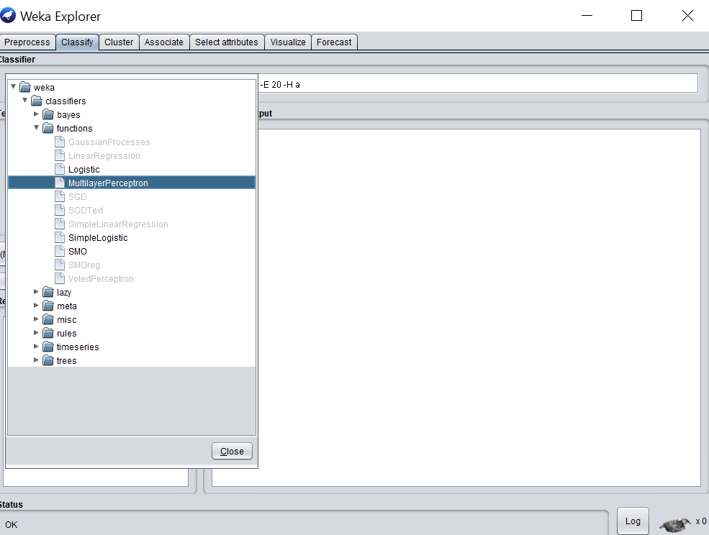

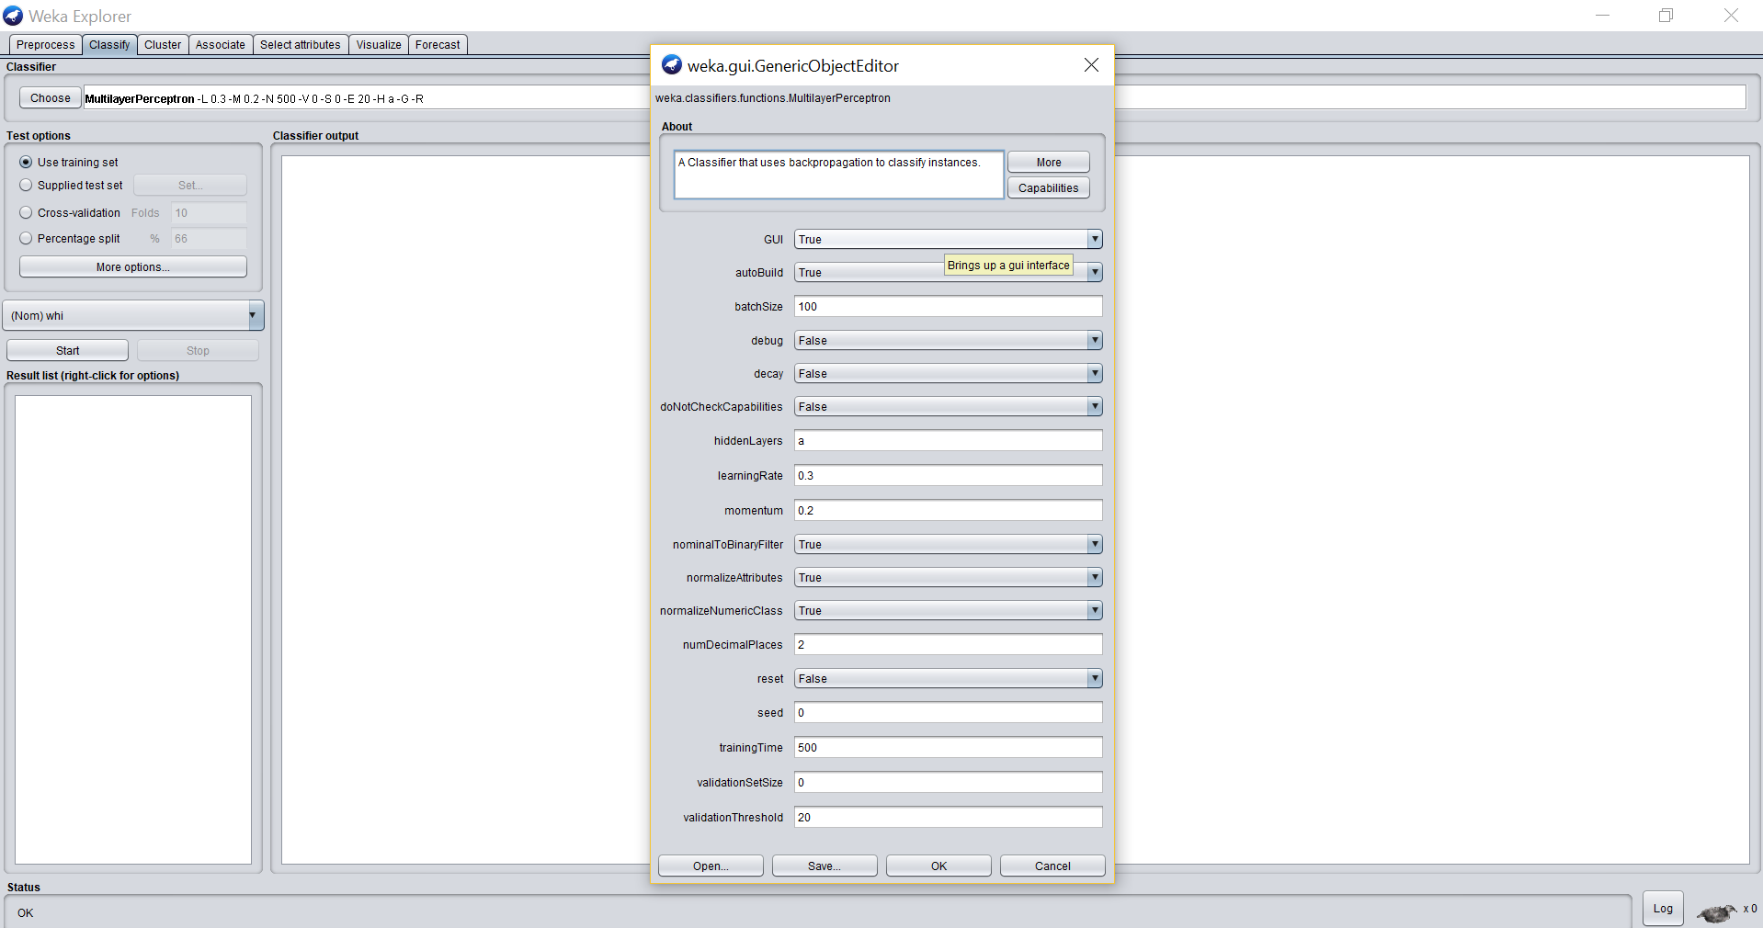

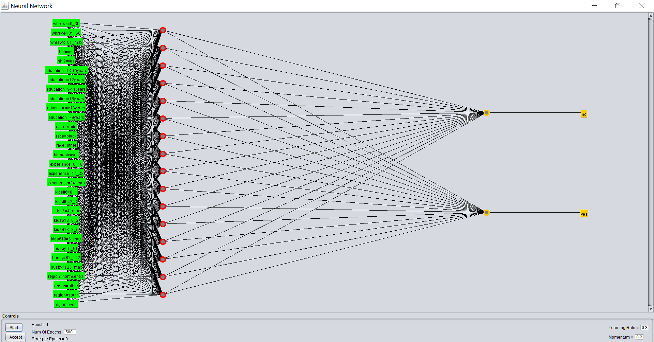

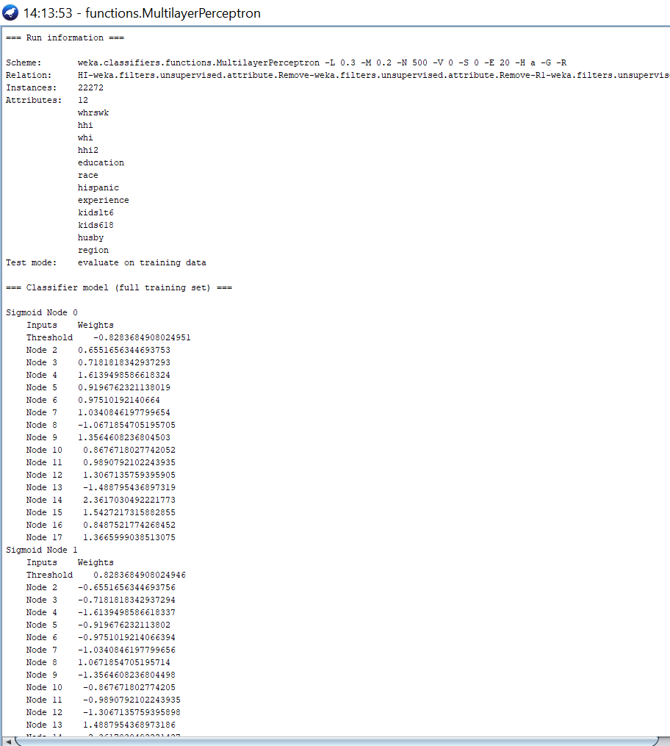

**Conclusions/Findings:**

In Multilayer Layer Perceptron taking parameters mostly default and with one hidden layer, we see that Weka has produced us with really good results of Correctly Classified Instances - 17713 that is 79.5304 % and Incorrectly Classified Instances - 4559 that is 20.4696 % after stopping at a epoch value of 102.

**Links/References:**

https://www.youtube.com/watch?v=mo2dqHbLpQo

## **5.2 Classification: REPTree 10%**

From the Research Paper that we are referring, we have chosen to implement the REPTree algorithm along with the J48 algorithm that we used previously to get some better results if available. REPTree is a fast decision tree learner. It builds a decision/regression tree using information gain/variance and prunes it using reduced-error pruning with backfitting.

|  |  |  |  |  |  |
| --- | --- | --- | --- | --- | --- |
| **batchSize** | **maxDepth** | **minNum** | **numFolds** | **seed** | **noPruning** |
| 1) 100 | -1 | 2.0 | 3 | 1 | False |
| 2) 100 | -1 | 2.0 | 3 | 1 | True |

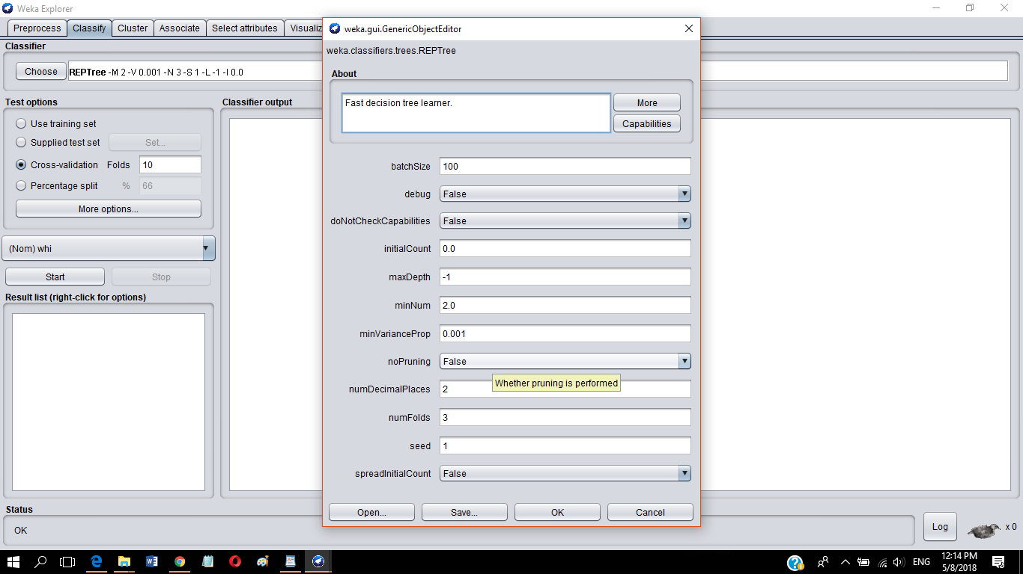

As seen above, we have chosen to keep the parameters as default in the first case as default parameter values usually give us better results. We have chosen test options as Cross-validation of 10 folds with class attribute as ‘whi (Nom)’.

**Case 1:** With pruning turned on as default, we get the following results in the REPTree.

*Results of the Model:

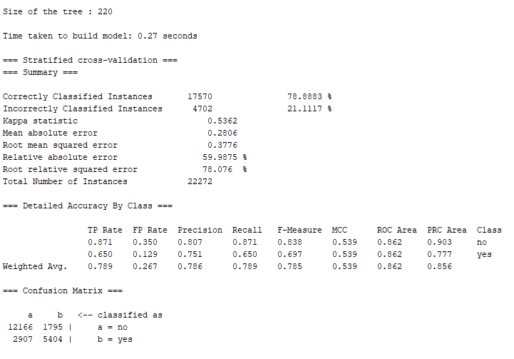

**Case 2**: Pruning is turned off now i.e. noPruning = True, & the results are as follows.

*Results of the Model:

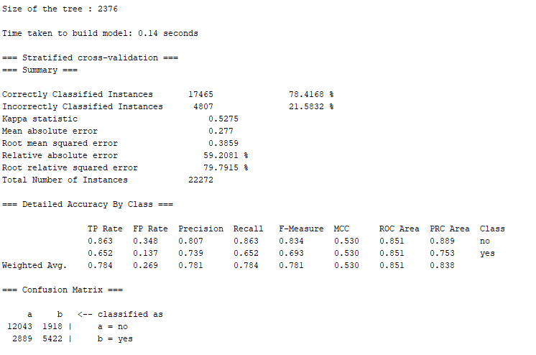

|  |  |
| --- | --- |
| **Correctly Classified Instances** | **Size of the Tree** |
| 1) 78.8883 % | 220 |
| 2) 78.4168 % | 2376 |

Classifier visualization for Case 1:

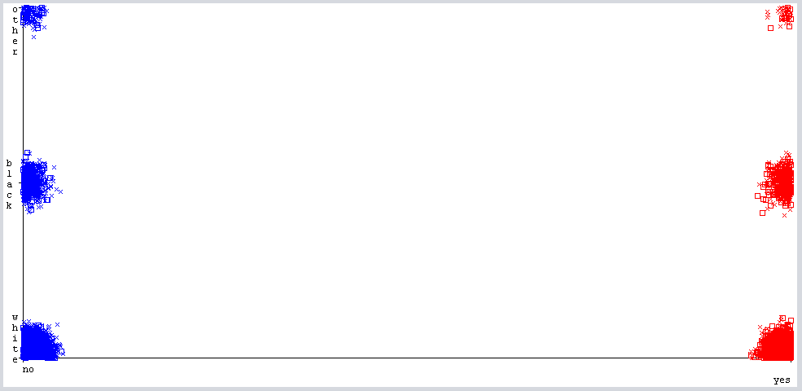

Model of Tree for Case 1:

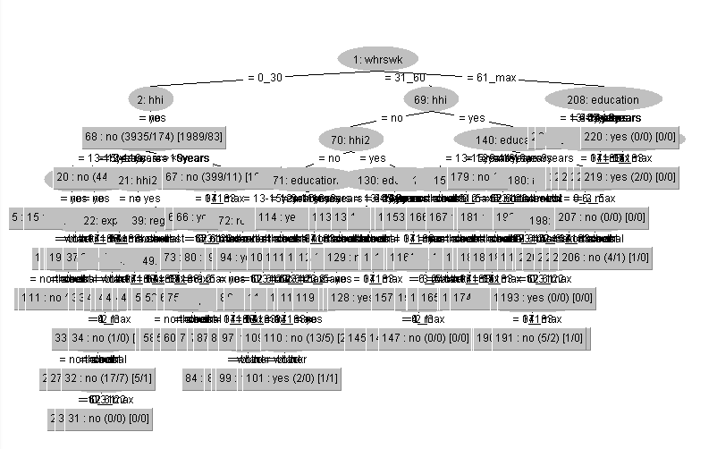

Conclusions/Findings

It is observed that when the pruning was turned off we got a slightly less better REPTree result in terms of correctly classified instances. Also, the unpruned tree of case 2 is found to be larger in size compared to the case 1 pruned tree. Thus, we shall go ahead with the pruned REPTree result.

Also, we observe in the case 1 classifier visualization, when ‘whi’ is coupled with ‘race’ attribute we find that women with health insurance are mostly white or black, and less ‘other’ race women are found to have health insurance compared to the rest which is noteworthy.

Links/References:

1) https://www.youtube.com/watch?v=ncR_6UsuggY&t=232s

# **Clustering**

For one of the following 2 clustering techniques

1. Use dataset.aff as input. If adaptations are necessary clearly indicate them.

2. Write one or two paragraph analyzing the results of the clustering. Be sure to vary parameters at least 3 times in each case. Support this analysis with screenshots of the following

a. The clusters and/or a visualization of the clusters

b. The results of the clusters

c. Any additional output of the clustering process

d. Simple references to the notes or URL links to online resources complete with a sentence or two of explanation.

e. Evaluate the clusters using the “classes to clusters evaluation”. A worked example may be found here<http://www.cs.ccsu.edu/~markov/ccsu_courses/datamining-ex3.html>

## **6.1 Clustering: K-Means – 10%**

We shall use the implementation of k-means algorithm to form clusters defining characteristics and forming relationships between two attributes.

first we shall load the dataset.arff file into WEKA and then we shall click on Cluster tab. There we shall select SimpleKMeans in the clusterer tab.

|  |  |
| --- | --- |
| **numClusters** | **Seed** |
| 1) 3 | 10 |
| 2) 4 | 10 |
| 3) 6 | 10 |

1. Setting parameters of numClusters = 3, leaving value of seed as it is.

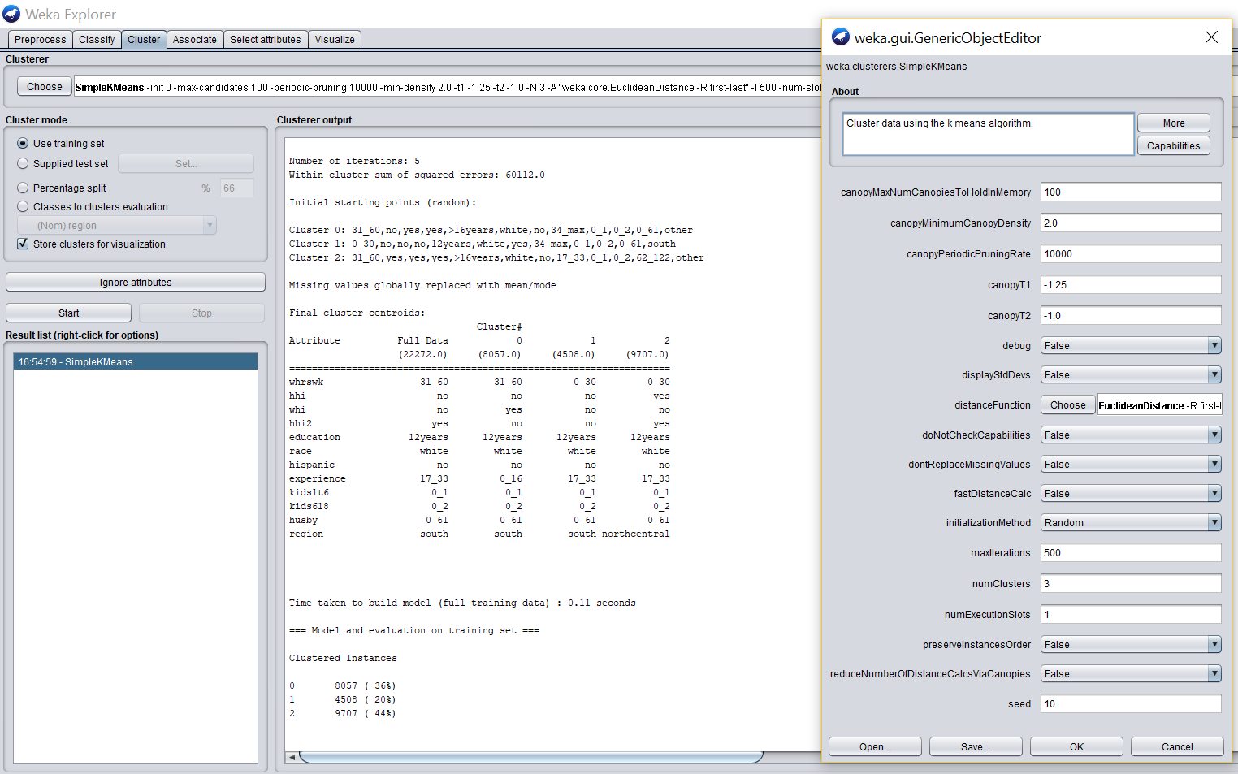  
a. The visualization of the clusters

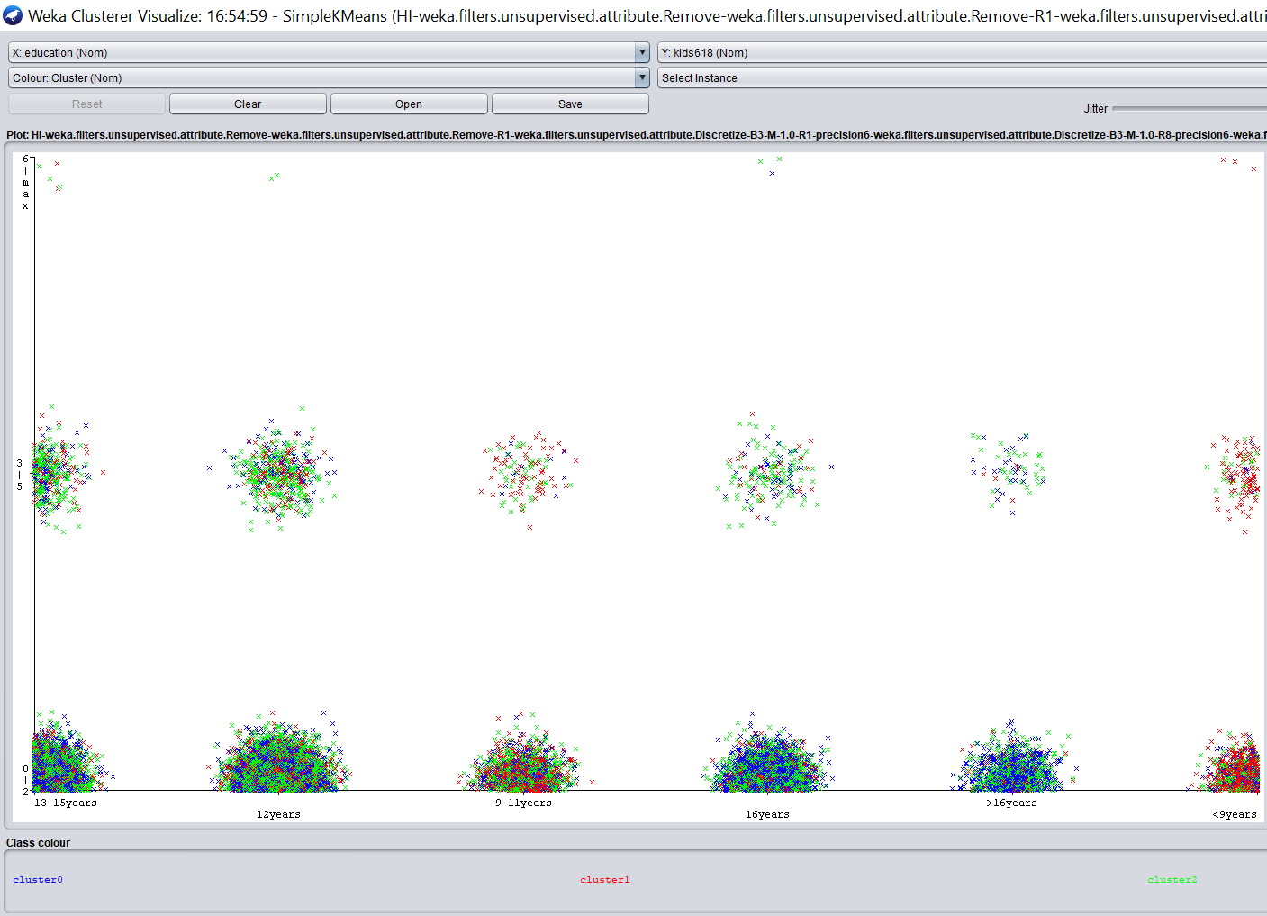  
b. The results of the clusters

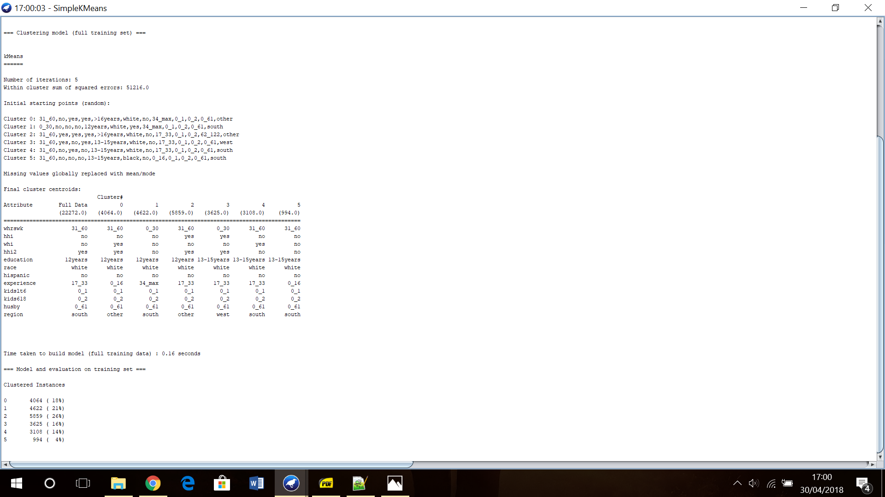

c. Model of the cluster

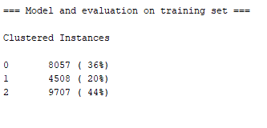

2. Setting parameters of numClusters = 4, seed value is constant.

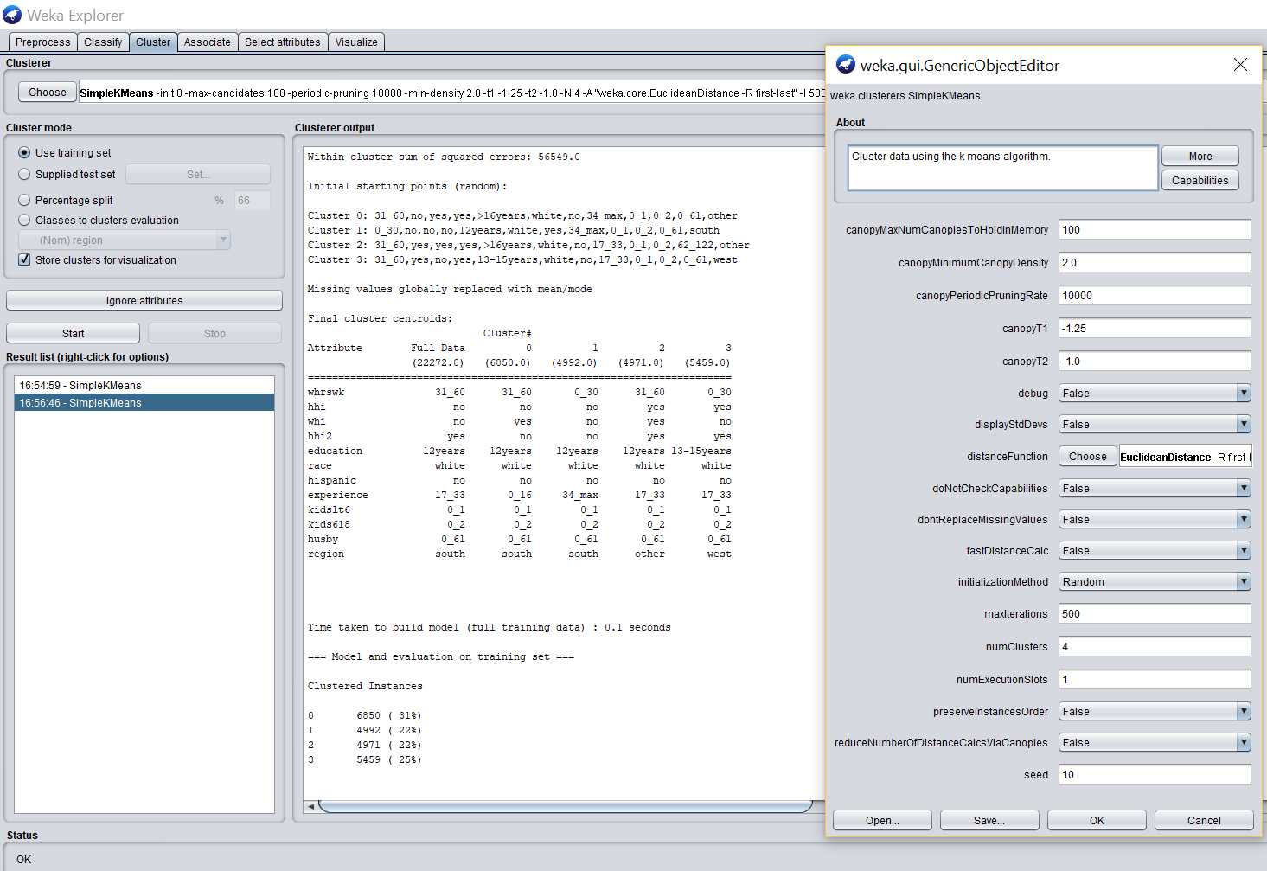  
a. The visualization of the clusters

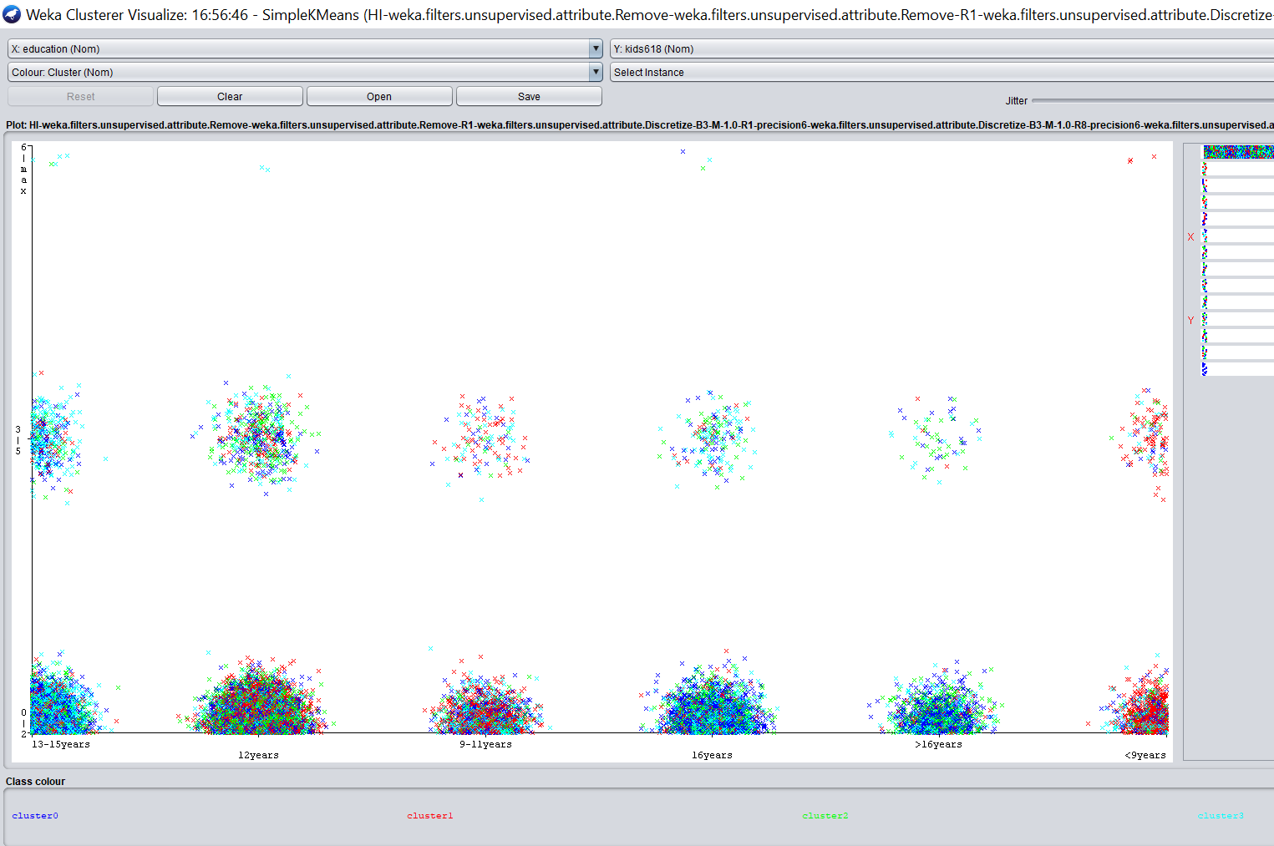  
b. The results of the clusters

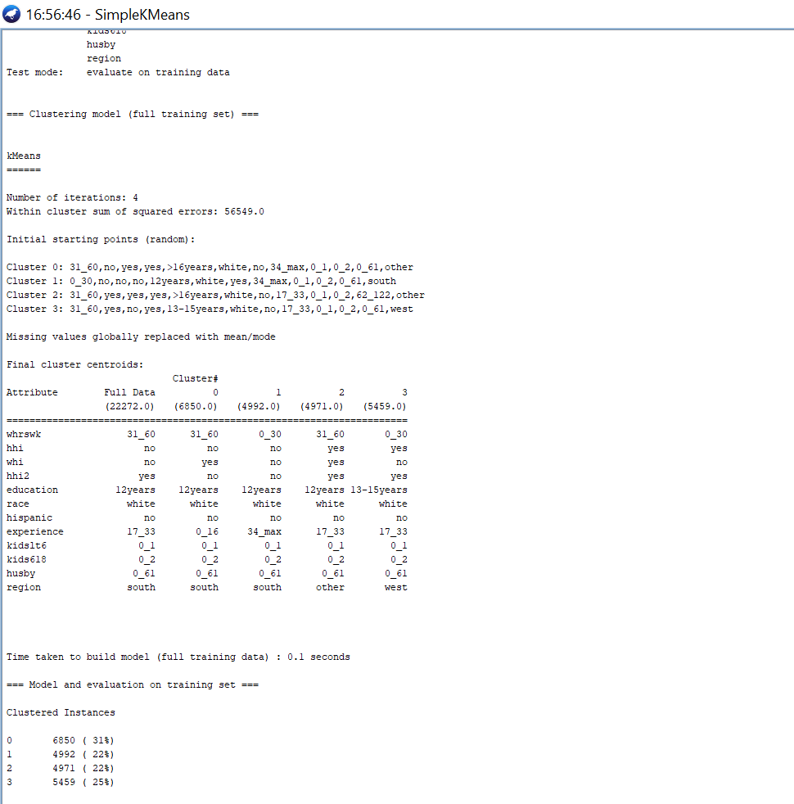

c. Model of the cluster

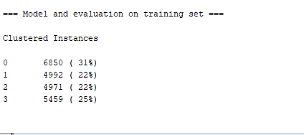

3. Setting parameters of numClusters = 6, seed value is constant.

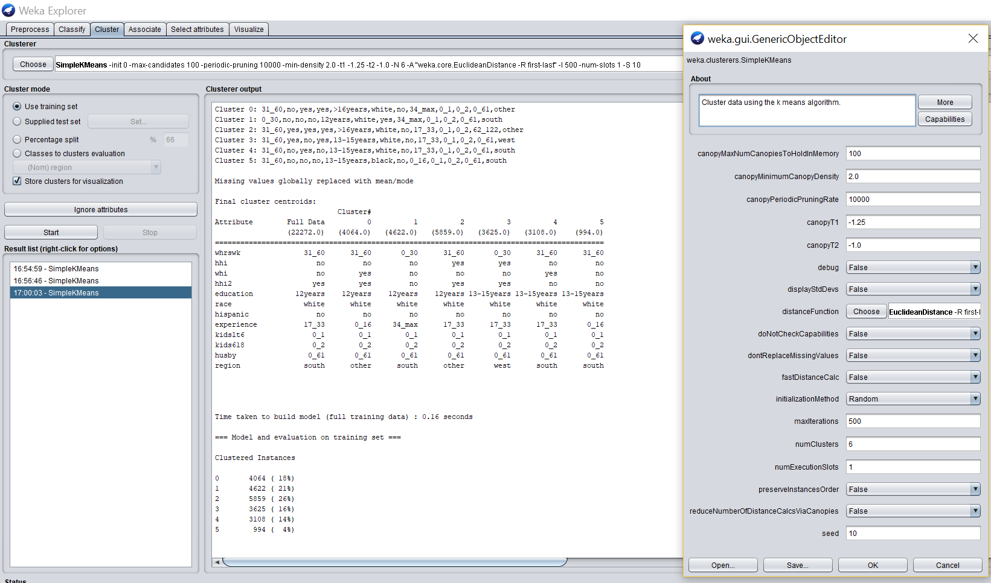  
a. The visualization of the clusters

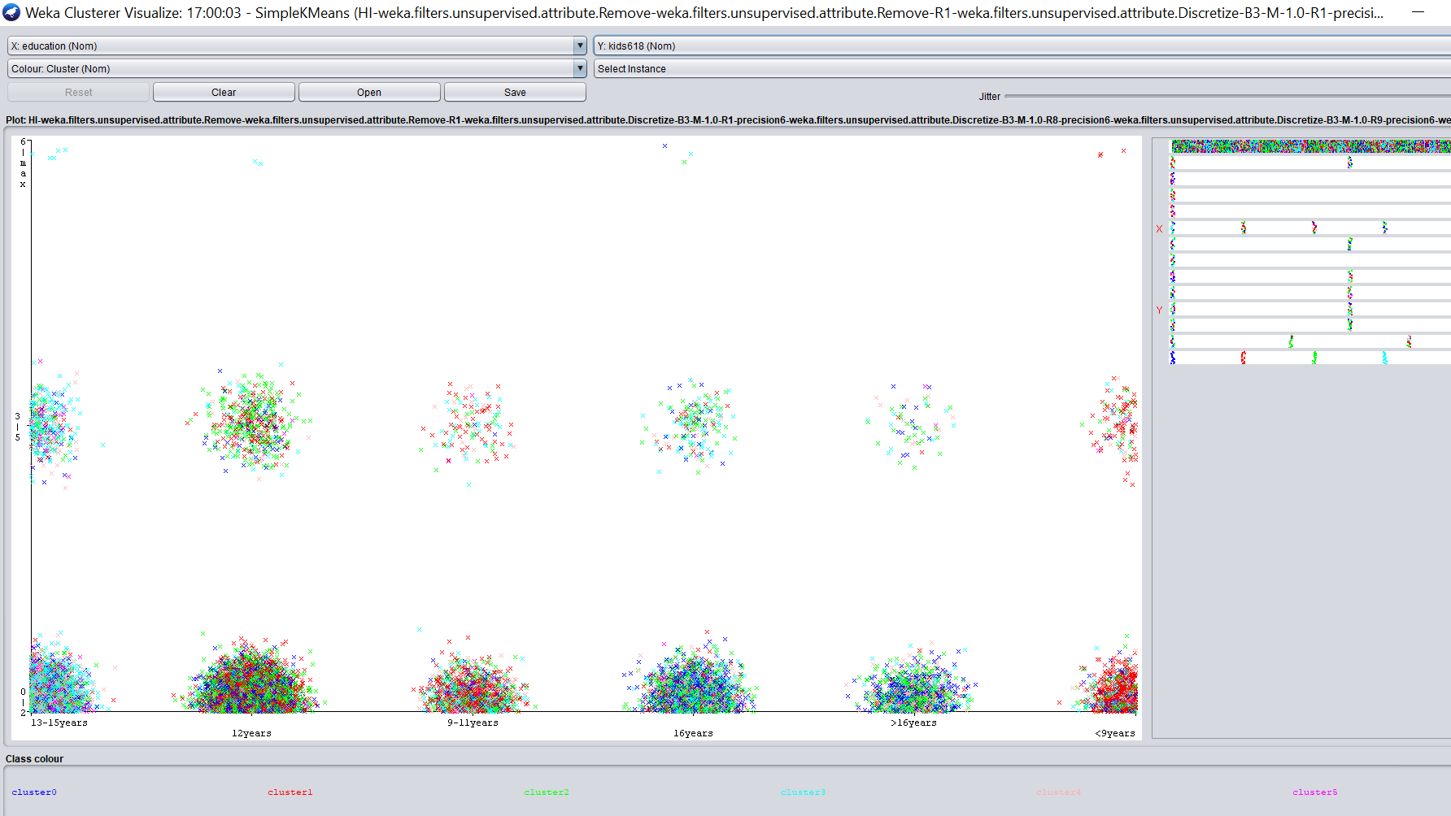

b. The results of the clusters

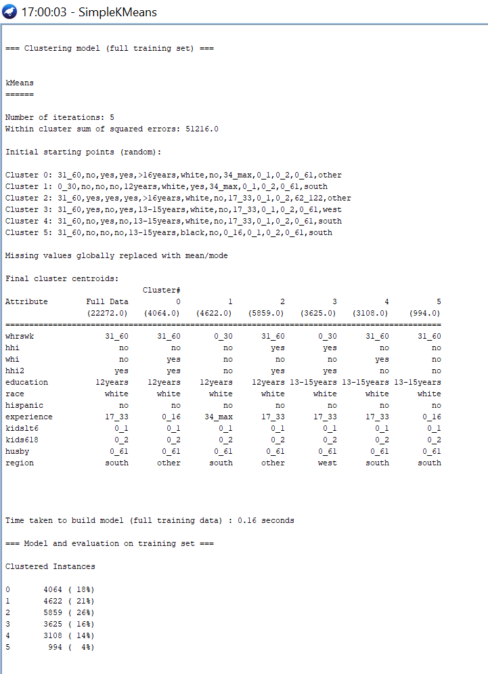

c. Model of the cluster

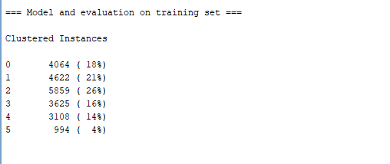

**Results/Findings:**

We observe that in all the 3 cluster with unequal distributions of clustered instances, the first case gave us less clusters compared to the rest cases. But we are not looking for less clusters, we are looking for more characteristics and features that are relating to the clusters. So the preferable result is the third case. This way we can see our visualization in more depth.

In the third case of the cluster visualization, we observe that women with 9-11 education years have less ‘0-2’ number of children in the age-groups of 6-18 years compared to the rest and also for women with education years greater than 16 years have no children at all in the age-groups of 6-18 years.

**Links/References:**  
<http://www.cs.ccsu.edu/~markov/ccsu_courses/datamining-ex3.html>

## **6.2 Clustering: DBSCAN – 10%**

|  |  |  |  |
| --- | --- | --- | --- |
| Epsilon | minPoints | Clusters Generated | Unclusters |
| 1) 0.9 | 6 | 713 | 4278 |
| 2) 0.4 | 3 | 1253 | 2237 |
| 3) 0.3 | 2 | 1710 | 1323 |

1. Epsilon: 0.9, minPoints: 6

Number of clusters generated: 713

Number of unclustered items: 4278

Screenshot of cluster visualisation:

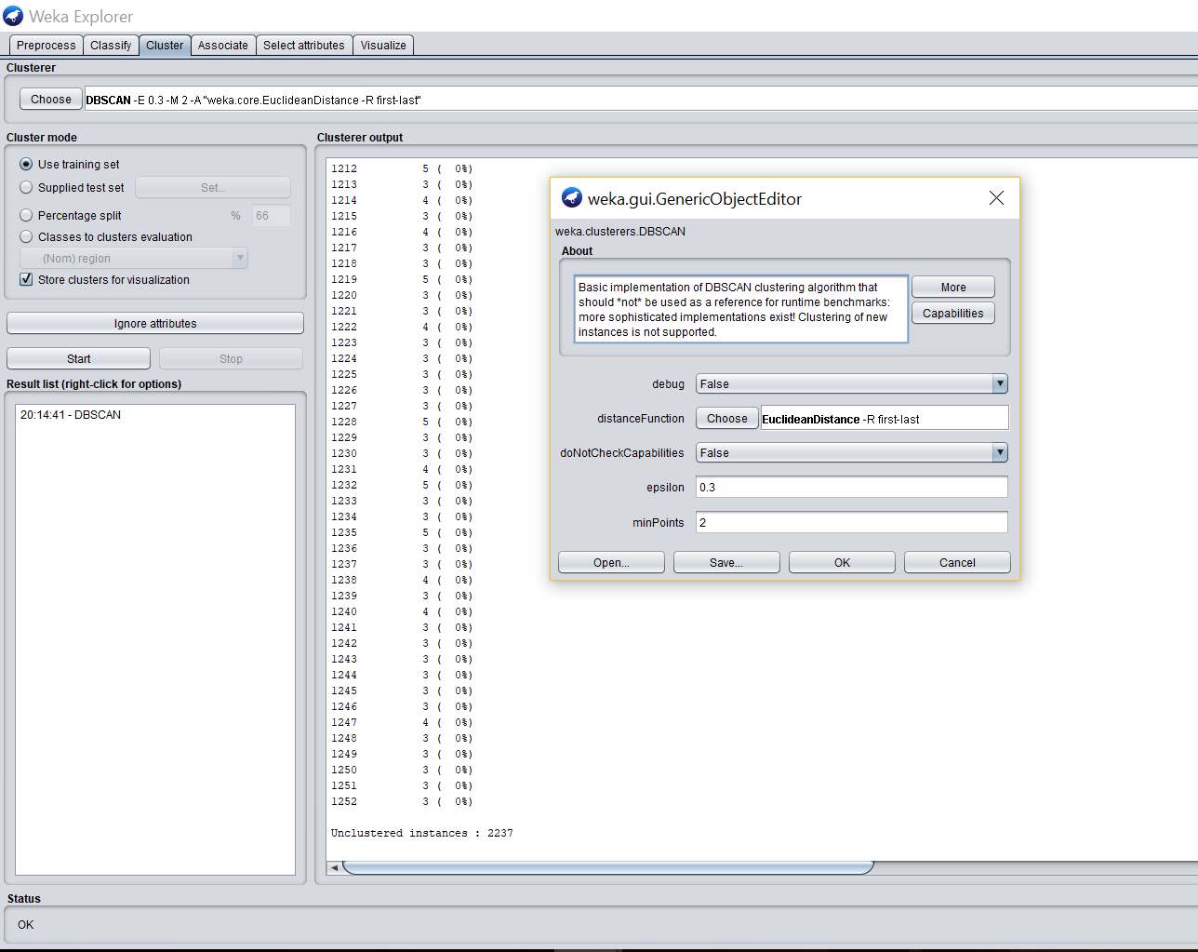

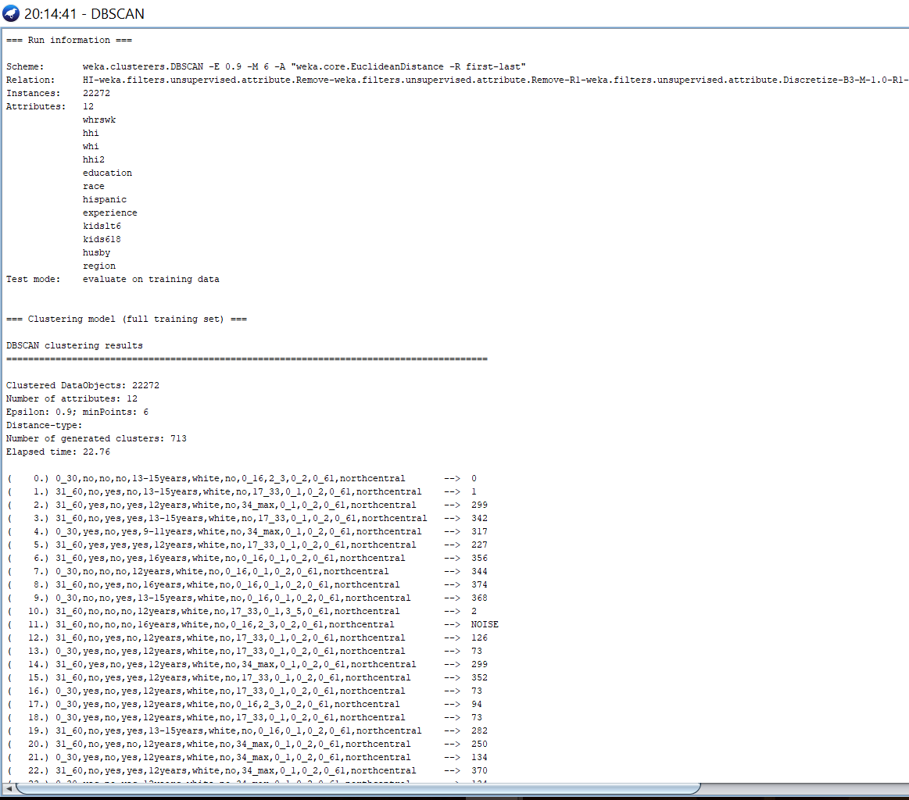

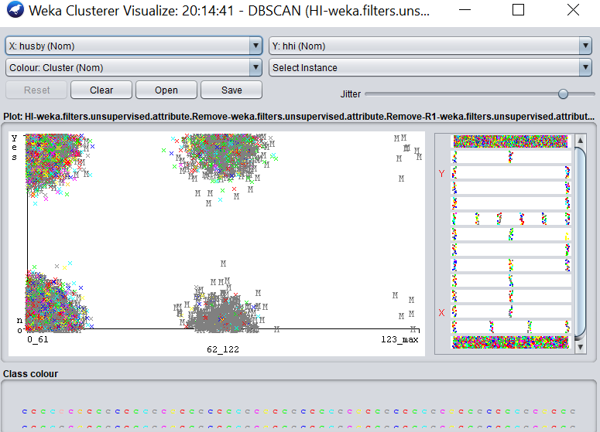

2. Epsilon: 0.4, minPoints: 3

Number of clusters generated: 1253

Number of unclustered items: 2237

**Screenshots:**

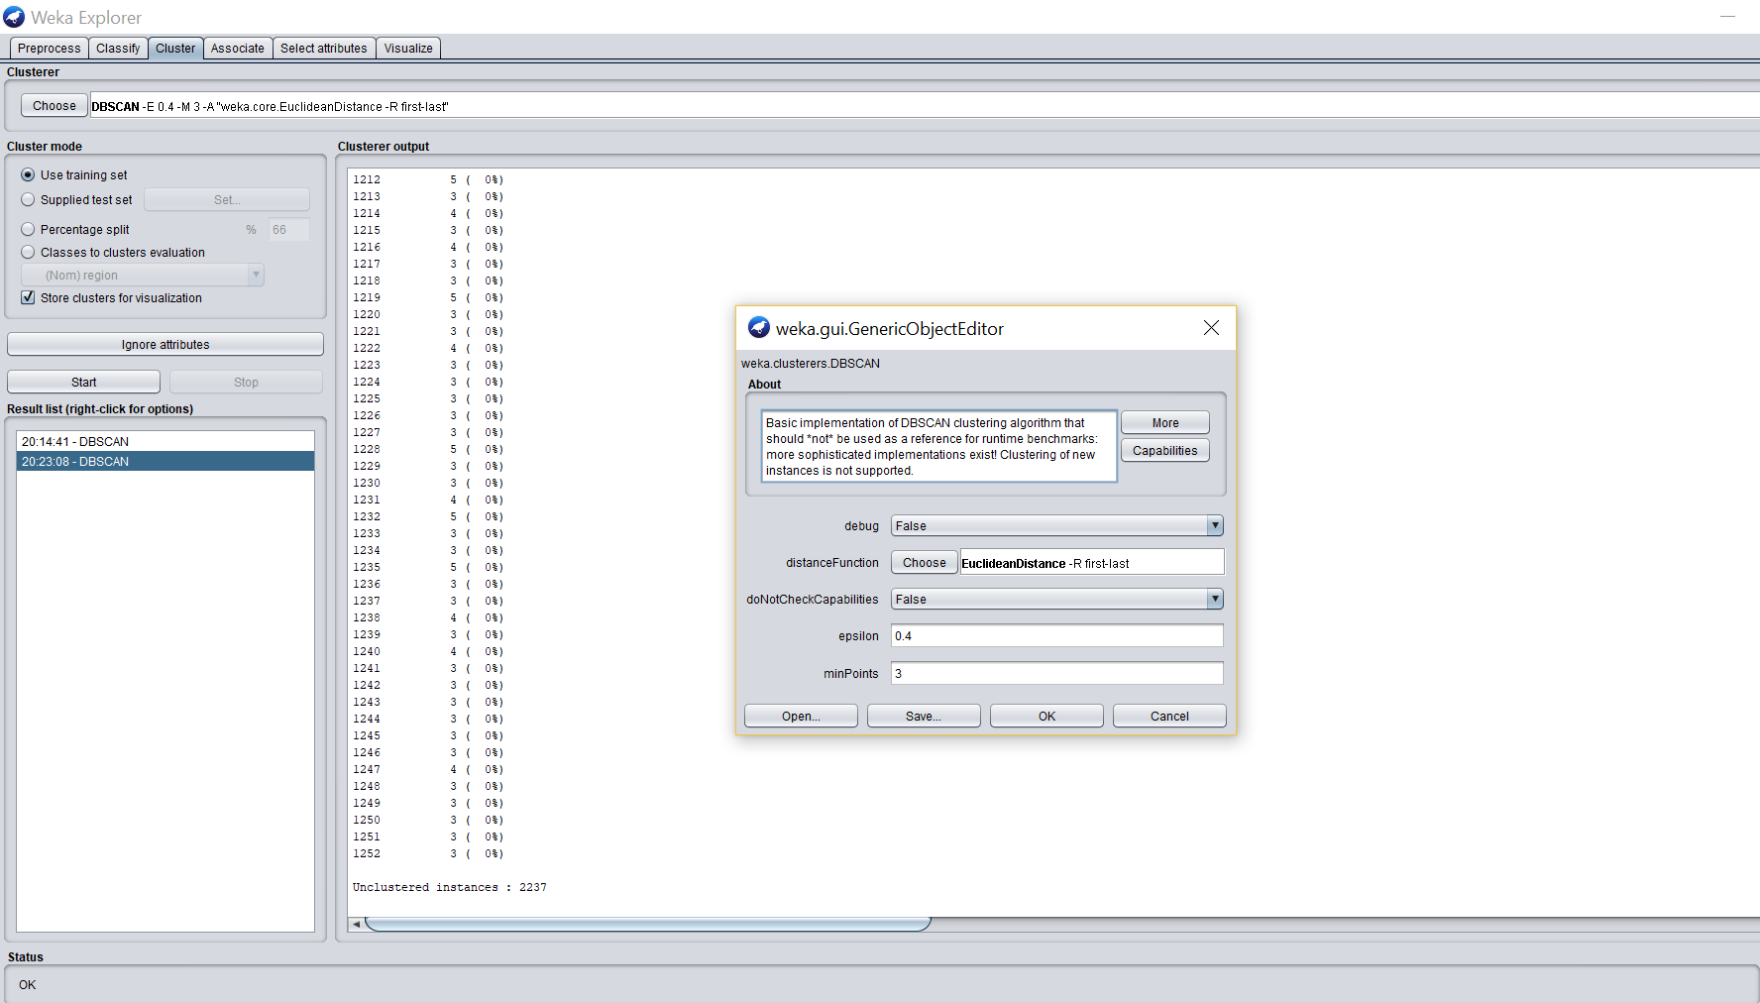

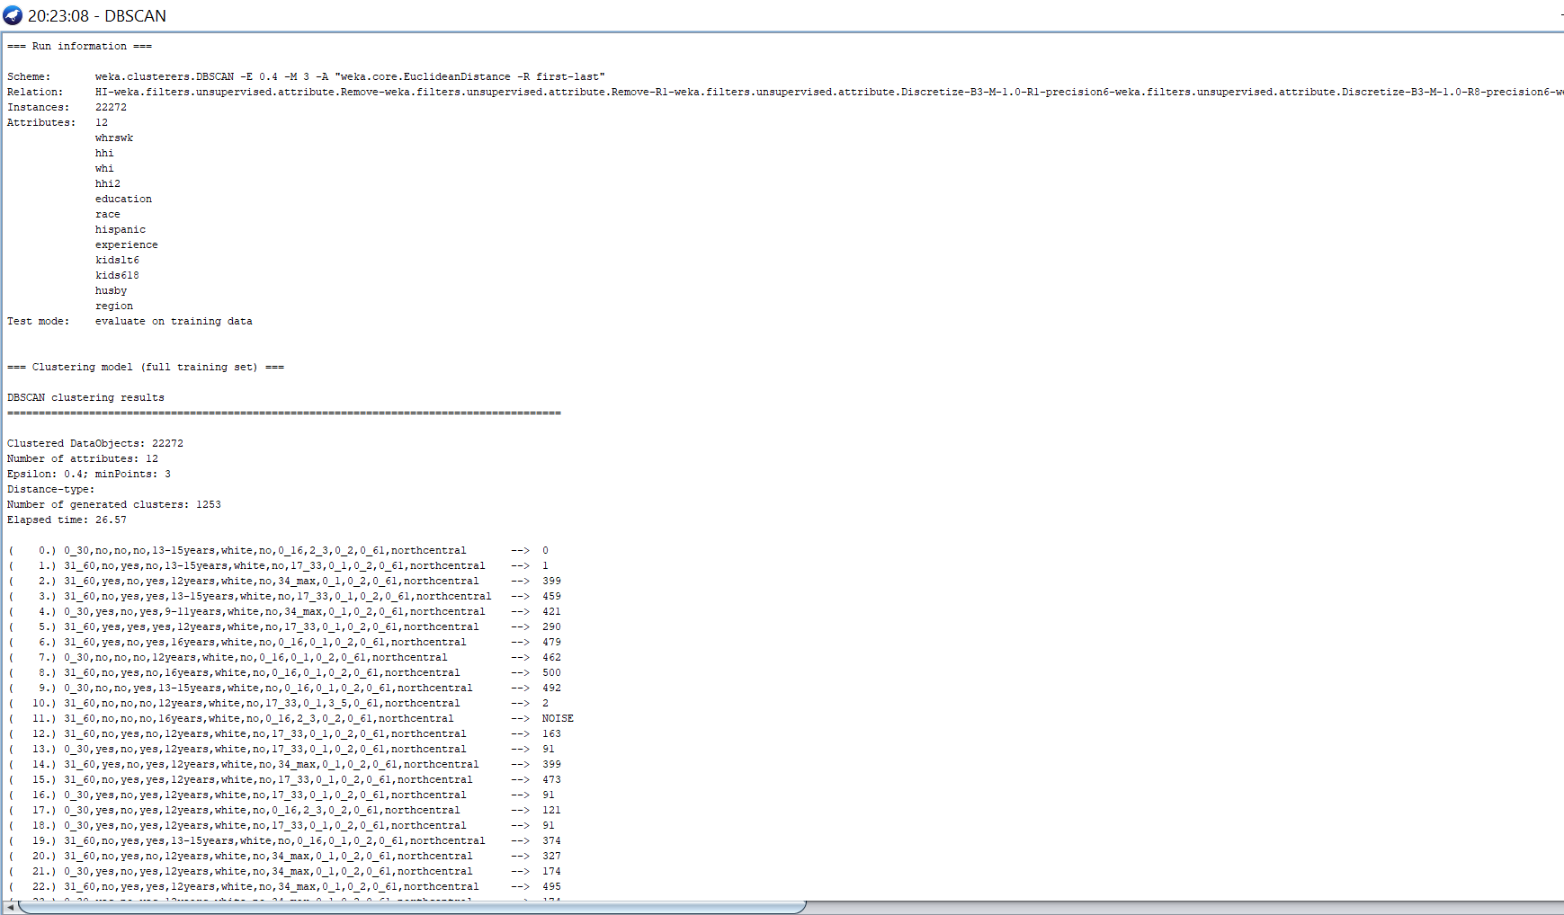

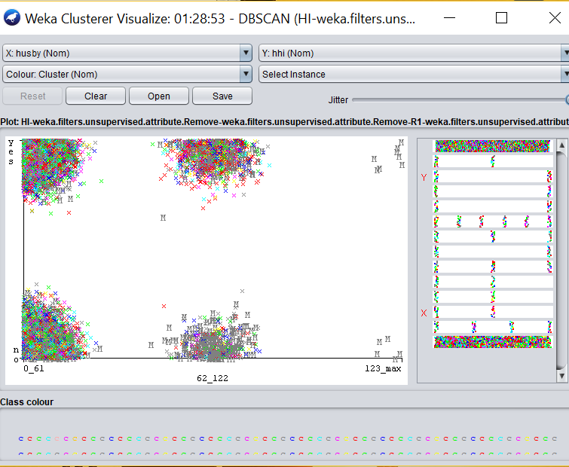

3. Epsilon: 0.3, minPoints: 2

Number of clusters generated: 1710

Number of unclustered items:1323

Screenshots:

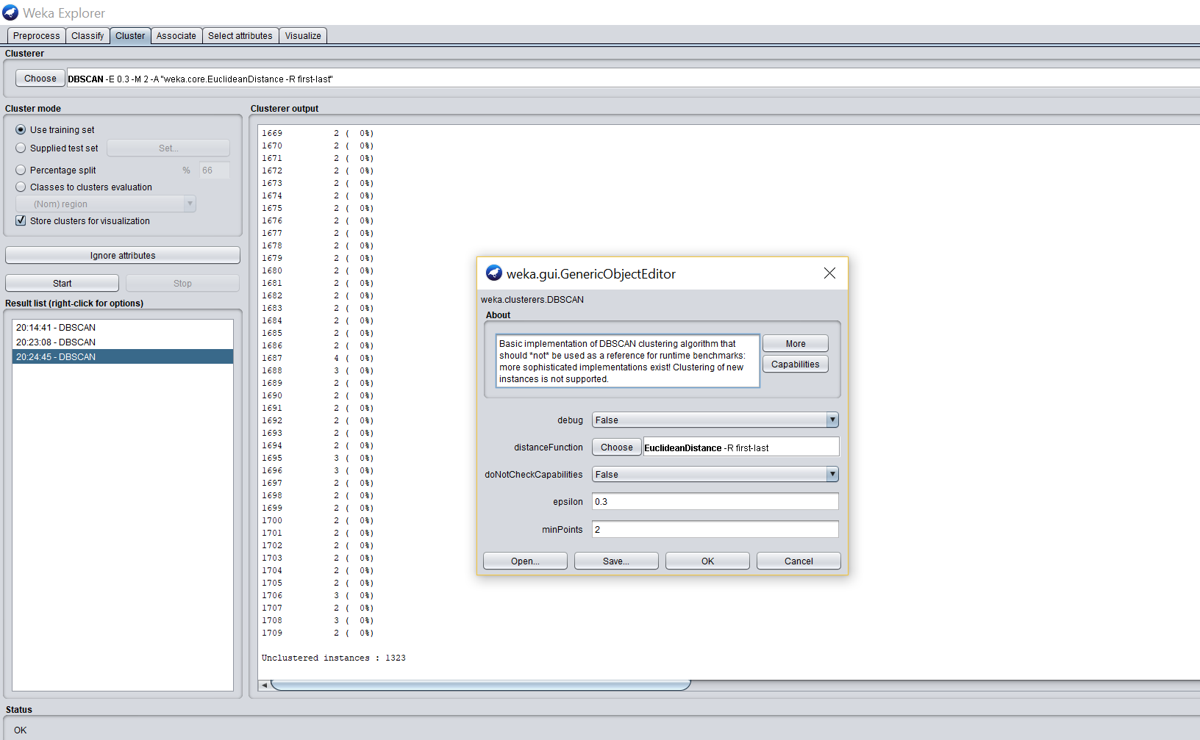

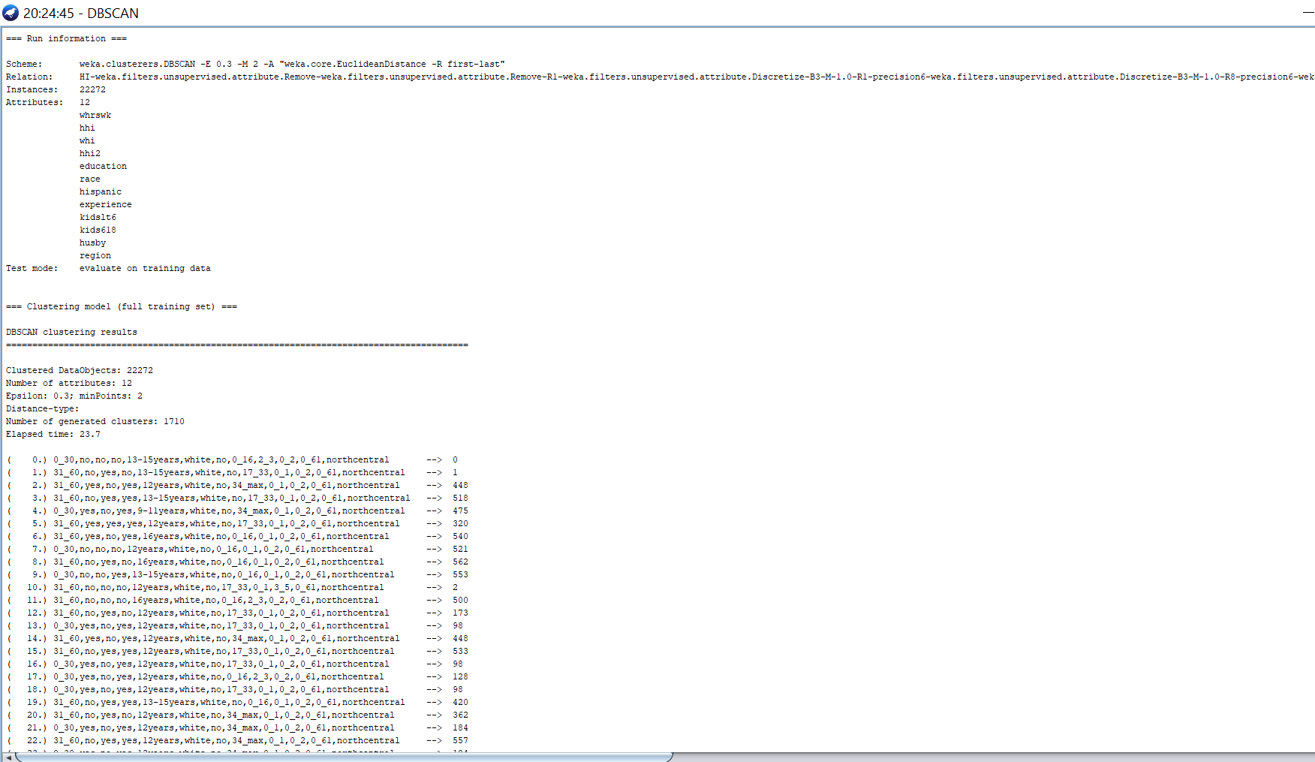

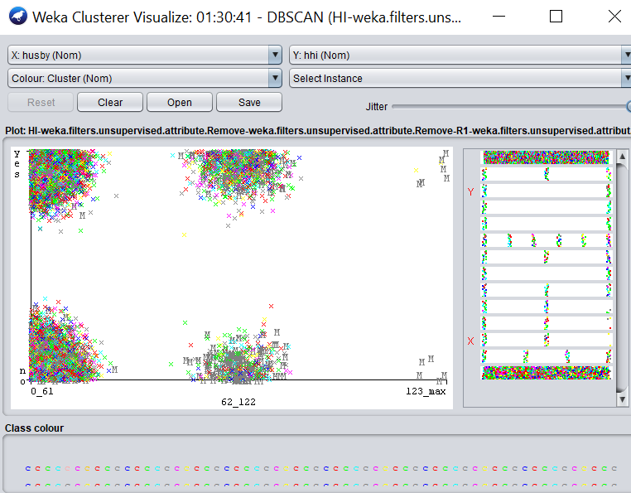

**Results/Findings**

From all our three cases, the generated clusters were more in the last case compared to other cases. But since the unclustered instances was less in the last case. The third case gives much more preferable result.

It is observed in the cluster visualization that the wives who were covered by the husband's health insurance had husband’s income in the range of 123_max(thousands of $).

The wives who were not covered were more with husband’s income in the range of 0_61(thousands of $).

**Link/References:**

How to install DB Scan for recent editions of weka

http://forums.pentaho.com/showthread.php?136243-Clusterers-(DBScan-and-Optics)-disappeared-in-version-3-7-7

# **Time Series Forecasting**

For the following task

1. Use dataset.aff as input. If adaptations are necessary clearly indicate them.

2. Write one or two paragraph analyzing the results of the forecasting. Support this analysis with screenshots of

a. The regression equation

b. Diagram of the historical values

c. Diagram of the predictions

## **7. Time Series Forecasting – 10%**

The following dataset - **“Deaths from homicide and suicides in Australia”** was used for time series forecasting. It has 3 attributes namely:

1. Year (Numeric Type): years from 1915 - 2004,
2. Homicide (Numeric Type): no. of homicides
3. Suicide (Numeric Type): no. of suicides

It has a total number of 91 instances. We decided to go along with the ‘Year’ attribute as our independent variable and ‘Homicide’ as the dependent class attribute variable to perform our regression equation with. The following parameters were used.

|  |  |  |  |  |  |
| --- | --- | --- | --- | --- | --- |
| **Target Selection** | **Number of time units to forecast** | **Time stamp** | **Periodically** | **Confidence intervals** | **Perform evaluation** |
| Homicide | 2 | Year | Yearly | 95% | Yes |

#### 

**Result of Model**

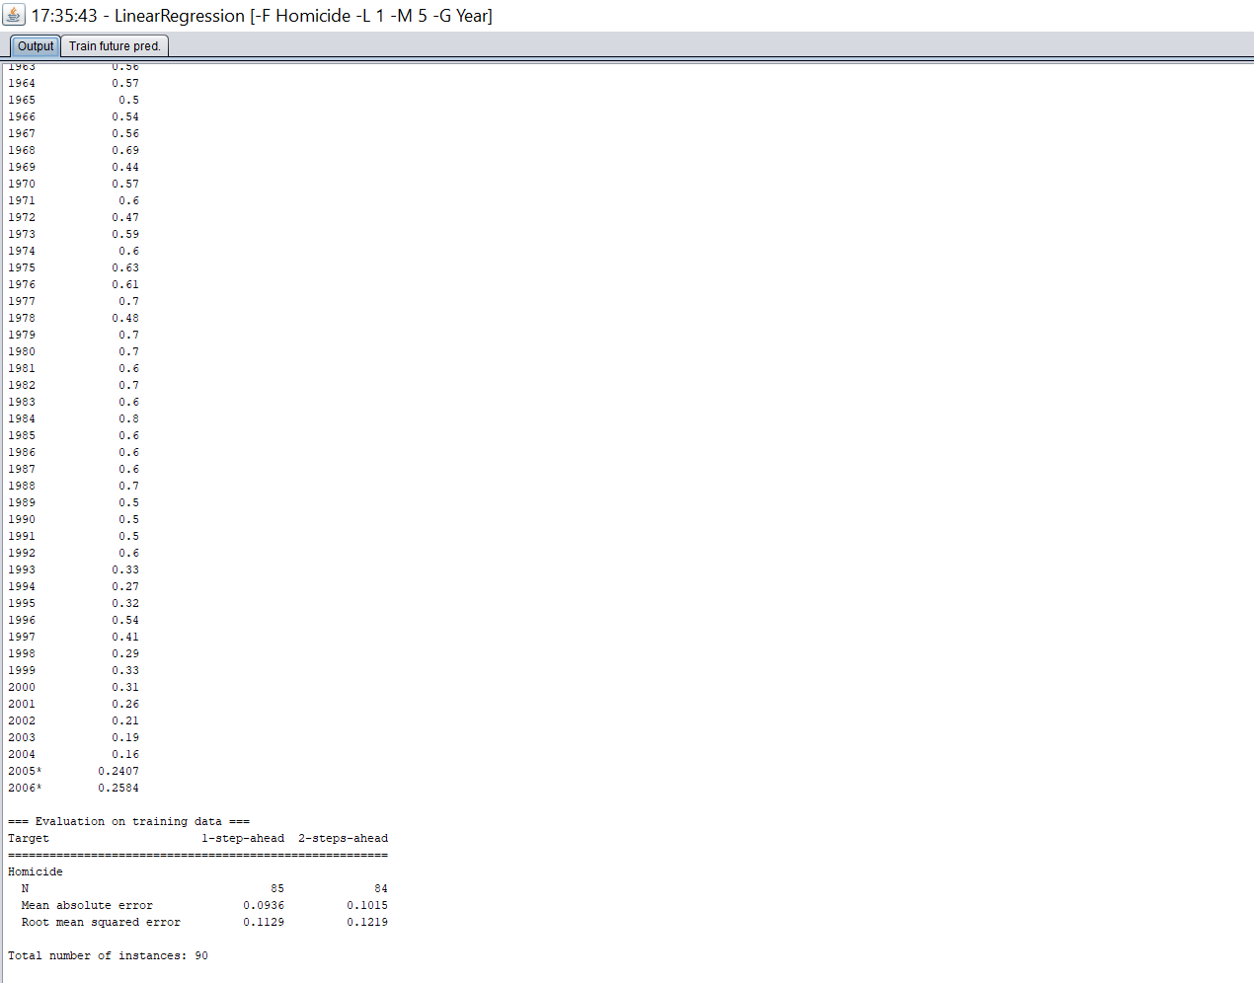

**Prediction Model**

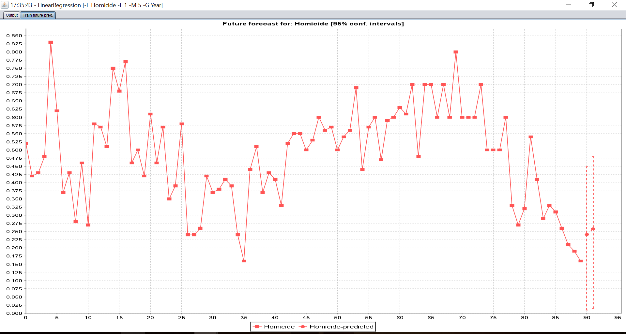

**Conclusion/ Findings**

After taking a two year level prediction for our time series forecasting, we observe that after the year 2004 that is in 2005 and 2006, the rate of homicides increase to 0.2407 in 2005 and 0.2584 in 2006. Mainly the rate of homicides was high in the beginning but decreased later. However, it increased in our predictions. Thus, revealing that in the next few years deaths from homicides will be more in Australia.

## **8. Research Publication Summary and relevance / potential relevance to your work – 20% (2-4 pages)**

Please discuss under the following headings

A. Publication and researchers:

The Paper titled, ‘DATA MINING FOR SMALL STUDENT DATA SET – KNOWLEDGE MANAGEMENT SYSTEM FOR HIGHER EDUCATION TEACHERS’ was worked by the the researchers, Srečko Natek of the International School for Social and Business Studies, Slovenia and by researcher, Moti Zwilling of the College of Law and Business, Israel. The Research article was published in a ‘Make Learn’ 2013 international conference article called ‘Active Citizenship by Management, Knowledge Management & Innovation Knowledge and Learning from 19-21 June 2013 in Zadar, Croatia.

B. Dataset

The research goal is to focus on small student data set data mining, trying to answer various teacher’s questions, using the data and data mining tools, normally available to average higher education teachers. For higher education teachers the most important outcome are relatively reliable students’ success prediction and user friendly experience. Bukowitz and Williams advocate how technology is blurring the distinction between types of knowledge from unknown knowledge to known knowledge. The study supports their conceptual model as data mining on students data sets discovered some interesting key influencer and “Final grade” prediction. Since, the dataset is focused to store more recent or previous data about students, in order to build the student data mining model; it’s build using either MS Excel Table Tools data mining procedures or by using Weka. The following attributes composed the Student dataset columns:

- Study year (2010/11, 2011/12, 2012/13)

- Student (order number 1 – 106)

- Gender (female, male)

- Student year of birth (e.g. 1988)

- Employment (no, yes)

- Status, e.g. sport etc. (no, yes)

- Registration (first, repeat)

- Type of study (full time, part time)

- Exam condition (no, yes)

- Activities points (0 – 50)

- Exam points (0 – 50)

- Final points (0 – 50)

- Final grade (1 – 10) – prediction column

C. Technique (mention any adaptations)

We were more particularly interested in building the data mining model using Weka. The Data was also built using the WEKA Data Mining tool, the following steps were conducted: -

- Create Model Data Sets:

- The data was saved as mentioned above, except from the last column ("The predicted class") - The Final Grade. This attribute was transformed into an ordinal attribute using the following index: for values between 8-10 the "High" value was assigned, For Values between 6-7 the value "Medium" was assigned and for lower values than 6 the "Low" value was assigned. (In the case of decision tree M5P the class attribute remained the same as numerical).

- Choose Data Mining Technology:

- The Weka tool was chosen.

- Choose Data Mining modeling Technique:

- 3 Decision Trees techniques: J48, M5P and RepTree were selected. (In the case of M5P no conversion of values for the class attribute was necessary and the Final grade values were remained as numbers.

- Choose Best Model – evaluate the results:

- Prediction rate accuracy for each trained model were evaluated in comparison with the related test set and the actual data respectively.

D. Major Findings

The results of the study show that student data, available to higher education teachers via export/import features, carries enough student-specific characteristics in the sense of hidden knowledge which can be successfully associated with student success rates. Despite the well-known fact that data mining algorithms work best on large data sets, the study focused on student data available to higher education teachers which is extremely limited and clearly falls into the category of a small data set. The results show that small student data sets in the specific data mining analysis did not limit the use of data mining tools. Moreover were the weka tool, that was used as comparative analysis to MS Excel, showed that by using decision tree models a high prediction accuracy (especially with the REPTree model) is obtained (the accuracy was verified during the test phase). M5P regression tree didn't perform as well as the other decision trees since it requires more assumptions the formers. In fact, The REPTree is a fast decision tree learner which builds a decision/regression tree using information gain as the splitting criterion, and prunes it using reduced error pruning. The model only sorts values for numeric attributes once. Missing values are dealt with using C4.5’s method of using fractional instances. Therefore, it may be deduced that since the predicted attribute was transformed into an ordinary value, REPTree was less sensitive to missing values than J48 thus prediction accuracy on test set was better performed. However on Train set it obtained a slightly less performance than J48 (~97% v.s. ~98%). J48 is a slightly modified C4.5 algorithm that generates a classification-decision tree for the given data-set by recursive partitioning of data. The decision is grown using Depth-first strategy. The algorithm considers all the possible tests that can split the data set and selects a test that gives the best information gain. Concerning the evaluated data J48 was less accurate than REPTree, which can be postulated since it is a more sensitive algorithm than REPTree.  
In general, the study answers the research questions and supports the promising conclusions that data mining for small data sets has a real potential to become a serious part of higher education teachers’ knowledge management systems. According to Nonaka’s process model of a knowledge-based firm (Nonaka & Toyama & Hirata, 2008, p. 27), it is very important that organisations explore tacit knowledge, not only in their employees’ heads. Sometimes it is more important to explore the knowledge hidden in an organisation’s data and transform it into explicit knowledge to improve the organisation, in our study the quality of the educational process. The authors hope that these conclusions will encourage teachers to incorporate data mining tools into their daily work.

E. Relevance / potential relevance to your work

The study explores the possibility to predict the success rate of students enrolled in a course using contemporary data mining tools normally available to higher education teachers. The research clearly proves that the available desktop data mining tools have matured in terms of their usability and ease of use, and provide usable results without extensive investment. Whereas the objective of our dataset is to estimate the relationship between a husband's health insurance benefits and his wife's labour supply decisions. Although the datasets and the data may differ, the information and insights we gain by using data mining techniques in Weka is what has the potential to make some business decisions whether it’s relatively reliable students’ success prediction and user friendly experience or it’s improving health insurance schemes with attractive benefits for working or non-working women. The Research paper dataset model and data mining model was built using MS Excel table tools, MS SQL Server data mining tools and also using Weka, we were interested in working with building the data mining model using Weka. Using Weka, three data mining techniques were applied: the J48 Tree, the REPTree and the M5P regression tree. The research dataset didn’t require any preprocessing techniques for performing the data mining algorithms. From the 3 techniques we implemented the J48 Tree and the REPTree algorithms in our dataset.

#### **Presentation**

## **9. Presentation – 10 %**

If slide are used they may be submitted but all marks are going for the presentation quality. A clear division of the marks will be given

#### **Division of Labor**

## **10. Division of Labor**

### **Summary of division of work**

Division of work : *work was evenly divided*

### **Percentage of work completed by each partner on each class / task**

|  |  |  |
| --- | --- | --- |
| **Filename / Task** | **Pronoy D’sa** | **Gaurav Singh** |
| Selection of dataset | 50% | 50% |
| Cleaning of dataset | 50% | 50% |
| Task 1 etc….. | 50% | 50% |
| Paper selection | 50% | 50% |
| Paper Review | 40% | 60% |
| Presentation Preparation | 60% | 40% |
| Presentation Delivery | 50% | 50% |